Synopsis of the Request for Quotation
Regional Agricultural Development Program-North, (RADP-North), invites qualified vendors to submit quotations for Provision of VFUs Capacity Building materials to DAI- RADP-North.
- RFQ No. | DAI-RADP North RFQ-17-0007
- Issue Date | February 23, 2017
- Title | Provision of VFUs Capacity Building materials
- Issuing Office & Email/Physical Address for Submission of Quotes | The quote must be in English and include the RFQ number, title, and closing date. The quote must be delivered to the email address: radp_procurement@dai.com  Offeror can also submit their quotation sealed in an envelope marked and signed confidential, to: RADP-North Office, Operations Department, Mazar-e-Sharif, Guzar-e-Marmul, Behind Sultan Razia High School, second street in front of IAM office, Mazar-e-Sharif, Afghanistan.
- Deadline for Receipt of Quotes. | The quote must be submitted by no later than March 01, 2017, 14:00PM (2pm) Afghanistan Local Time.
- Point of Contact | radp_procurement@dai.com
- Anticipated Award Type | An award resulting from this RFQ will be a Blanket Purchase Agreement (BPA) The Period of Performance of the (BPA) for Provision of VFUs Capacity Building materials to RADP-North in Mazar-e-Sharif will be for one year. Issuance of this RFQ in no way obligates DAI to award a subcontract or purchase order and Bidders will not be reimbursed for any costs associated with the preparation of their quote. DAI reserves the right to accept all or part of the quotations provided.
- Basis for Award | An award will be made based on the Lowest Price, Technically Acceptable Source Selection Method. The award will be issued to the responsible offeror submitting the lowest evaluated price that meets or exceeds the acceptability requirements for technical/non-cost factors described in this RFQ.  Best offer quotations are requested. It is anticipated that awards will be made solely on the basis of these original quotations. However, DAI-RADP-N reserves the right to conduct negotiations and/or request clarifications prior to award.

Request for Quotation
- General Instructions to Bidders | - Please submit your quote by no later than March 01, 2017, 14:00PM Afghanistan Local Time. Late offers will be rejected except under extraordinary circumstances at DAI’s discretion.  - Bidders shall submit quotes either physically as original hard in a sealed envelope to RADP-North Office, Operations Department, Mazar-e-Sharif, Guzar-e-Marmul, Behind Sultan Razia High School, second street in front of IAM office, Mazar-e-Sharif, Afghanistan), or electronically via procurement email (this is a strict access controlled email account set up ONLY to receive solicitation responses), or both. The hard copy and/or email and the attached quote shall include the RFQ number, title, and closing date.  - The quote submitted shall be valid for a period of at least 30 days.  - Bidders shall sign and date their quotation.  - Bidders shall complete Attachment A: Price Schedule template. Government Withholding Tax shall be included on a separate line.  - The rates quoted shall be for the complete service inclusive of all taxes and all charges for service contingent to the work.  - All prices shall be quoted in Afghanistan currency Afghani only; other currency quote will not be considered.  - In case of price discrepancy between unit price and SUBTOTAL/GRAND TOTAL, the unit price shall prevail
- Questions Regarding the RFQ | Each Bidder is responsible for reading very carefully and understanding fully the terms and conditions of this RFQ. All communications regarding this solicitation are to be made solely through the Issuing Office and must be submitted via email or delivered to the Issuing Office no later than 10:00 AM, February 25, 2017. All questions received will be compiled and answered in writing and distributed to all interested Bidders by close of business February 27, 2017.
- Technical Specifications and requirements for Technical Acceptability | See Attachment A for additional specifications.  - Offer lowest price that is fair and reasonable for Provision of VFUs Capacity Building materials as specified in Attachment A  - Provide VFUs Capacity Building materials immediately after order placement during the BPA performance period.  - Provide full and complete specification of the equipment’s in quotations.  - Construction companies and any other companies that’s not working in the relevant field will not be considered  - RADP-N has the right to reject the equipment if it is not the same quality as quoted and provided as sample  - Provide Quotation in AFN  - Local vendors encourage to apply  - Provide fixed price for duration of at least 1 month  - Accept the Terms and Conditions on page 13 of this RFQ  - Provide complete, signed, and stamped quotations  - Considered vendor should be able to provide sample(s) of the quoted item(s) within 24 hours after official notice from DAI-RADP-North procurement, (if required)  - The proposal that does not meet technical specifications will not be considered.  - The vendor should be located in one of the RADP-N targeted provinces (Balkh, Baghlan, Badakhshan, Jawzjan, Samangan or Kunduz)  - The required date for these Items/Services first delivery is March 15, 2017. (subject to negotiations)  Failure to meet any of these terms could result in disqualification from this award process.
- Determination of Responsibility | DAI will not enter into any type of agreement with a vendor prior to ensuring the vendor’s responsibility. When assessing an vendor’s responsibility, the following factors are taken into consideration:  - Provide copies of AISA License, Ministry of Commerce and Industry, Ministry of Information, Culture and Tourism, or required business licenses to operate in the host country.  - Evidence of a DUNS number (explained below and instructions contained in the Annex).  - The source, origin and nationality of the services are not from a Prohibited Country (explained below).  - Ability to comply with required or proposed delivery or performance schedules.  The offer will be considered responsive when it does not take any exception to the terms and conditions of this solicitation and meets the minimum technical specifications, delivery period and methods, in addition to any other requirements specified herein.
- Geographic Code | - Under the authorized geographic code for its contract DAI may only procure goods and services from the following countries.  - Geographic Code 937: Goods and services from the United States, the cooperating country, and "Developing Countries" other than "Advanced Developing Countries: excluding prohibited countries. A list of the "Developing Countries" as well as "Advanced Developing Countries" can be found at: http://www.usaid.gov/ads/policy/300/310.  - DAI must verify the source, nationality and origin, of goods and services and ensure (to the fullest extent possible) that DAI does not procure any services from prohibited countries listed by the Office of Foreign Assets Control (OFAC) as sanctioned countries. The current list of countries under comprehensive sanctions include: Cuba, Iran, North Korea, Libya, Sudan, and Syria. DAI is prohibited from facilitating any transaction by a third party if that transaction would be prohibited if performed by DAI.  - By submitting a quote in response to this RFQ, Bidders confirm that they are not violating the Source and Nationality requirements and that the services comply with the Geographic Code and the exclusions for prohibited countries.  - By submitting a quote in response to this RFQ, Bidders confirm that they are not violating the Source and Nationality requirements and that the services comply with the Geographic Code and the exclusions for prohibited countries.
- Data Universal Numbering System (DUNS) | All U.S. and foreign organizations which receive first-tier subcontracts/ purchase orders with a value of $25,000 and above are required to obtain a DUNS number prior to signing of the agreement. Organizations are exempt from this requirement if the gross income received from all sources in the previous tax year was under $300,000. DAI requires that Bidders sign the self-certification statement if the Bidder claims exemption for this reason. For those required to obtain a DUNS number, you may request Attachment C: Instructions for Obtaining a DUNS Number.  For those not required to obtain a DUNS number, you may request Attachment D: Self-Certification for Exemption from DUNS Requirement
- Compliance with Terms and Conditions | Bidder shall be aware of the general terms and conditions for an award resulting from this RFQ. The selected Bidder shall comply with all Representations and Certifications of Compliance listed in Attachment B.
- Procurement Ethics | By submitting a Bidder, Bidders certify that they have not/will not attempt to bribe or make any payments to DAI employees in return for preference, nor have any payments with Terrorists, or groups supporting Terrorists, been attempted. Any such practice constitutes an unethical, illegal, and corrupt practice and either the Bidders or the DAI staff may report violations to the Toll-Free Ethics and Compliance Anonymous Hotline at +1 855-603-6987, via the DAI website, or via email to FPI_hotline@dai.com.

Attachment A: Detailed Description for Provision of VFUs Capacity Building materials for RADP-North
No | Item Name | Detailed Specifications | UNIT | Qty | Unit Price (AFN) | Total Price AFN | Photo sample
1 | Training Posters | A2 Size, colorful in flex paper, Photo paper | Each | 7,800 |  |  | 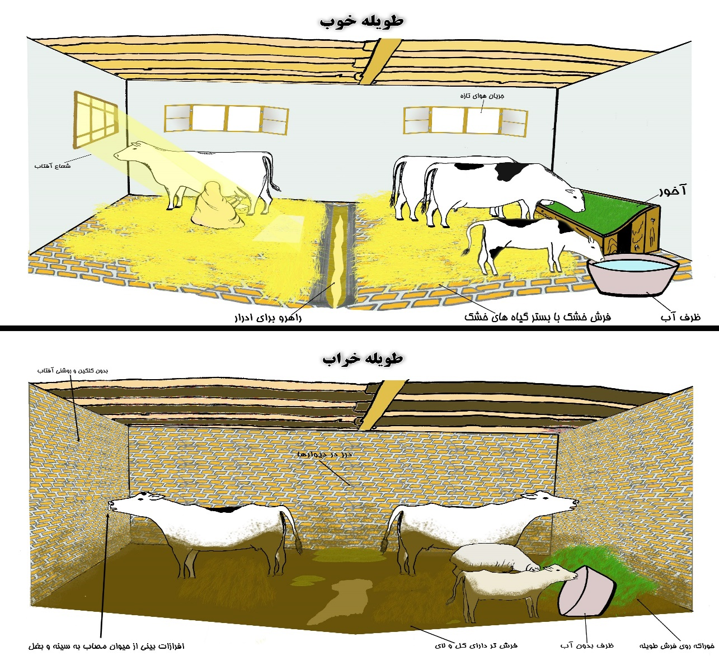
2 | Alfalfa | Wet it should be green dark color and it has more leave and fresh  Bag Size  (31 packs of alfalfa each pack having 1.5 kg weight that makes totally 46.5 kg) | Kg | 46.5 |  |  | 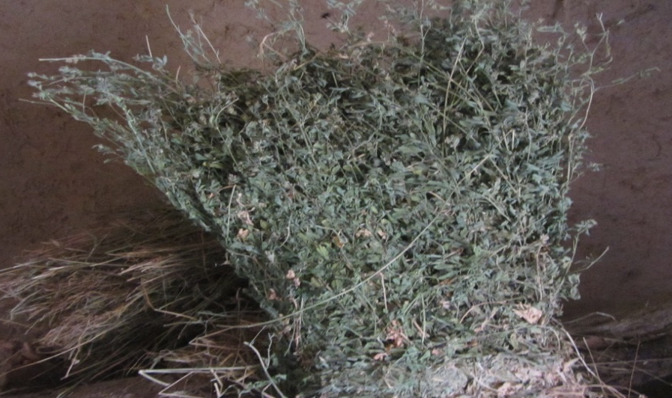
3 | Straw | Dried, the color should be golden and should be threshed.  Bag size  (31 bags of straw each bags having 2 Kgs of straw in each bags that make a total of 62 Kgs.) | Kg | 62 |  |  | 
4 | Concentrated Feed | Bag size: 31 bags each with 2 Kgs of concentrated feed that makes a total amount of 62 Kgs  Dried | Kg | 62 |  |  | 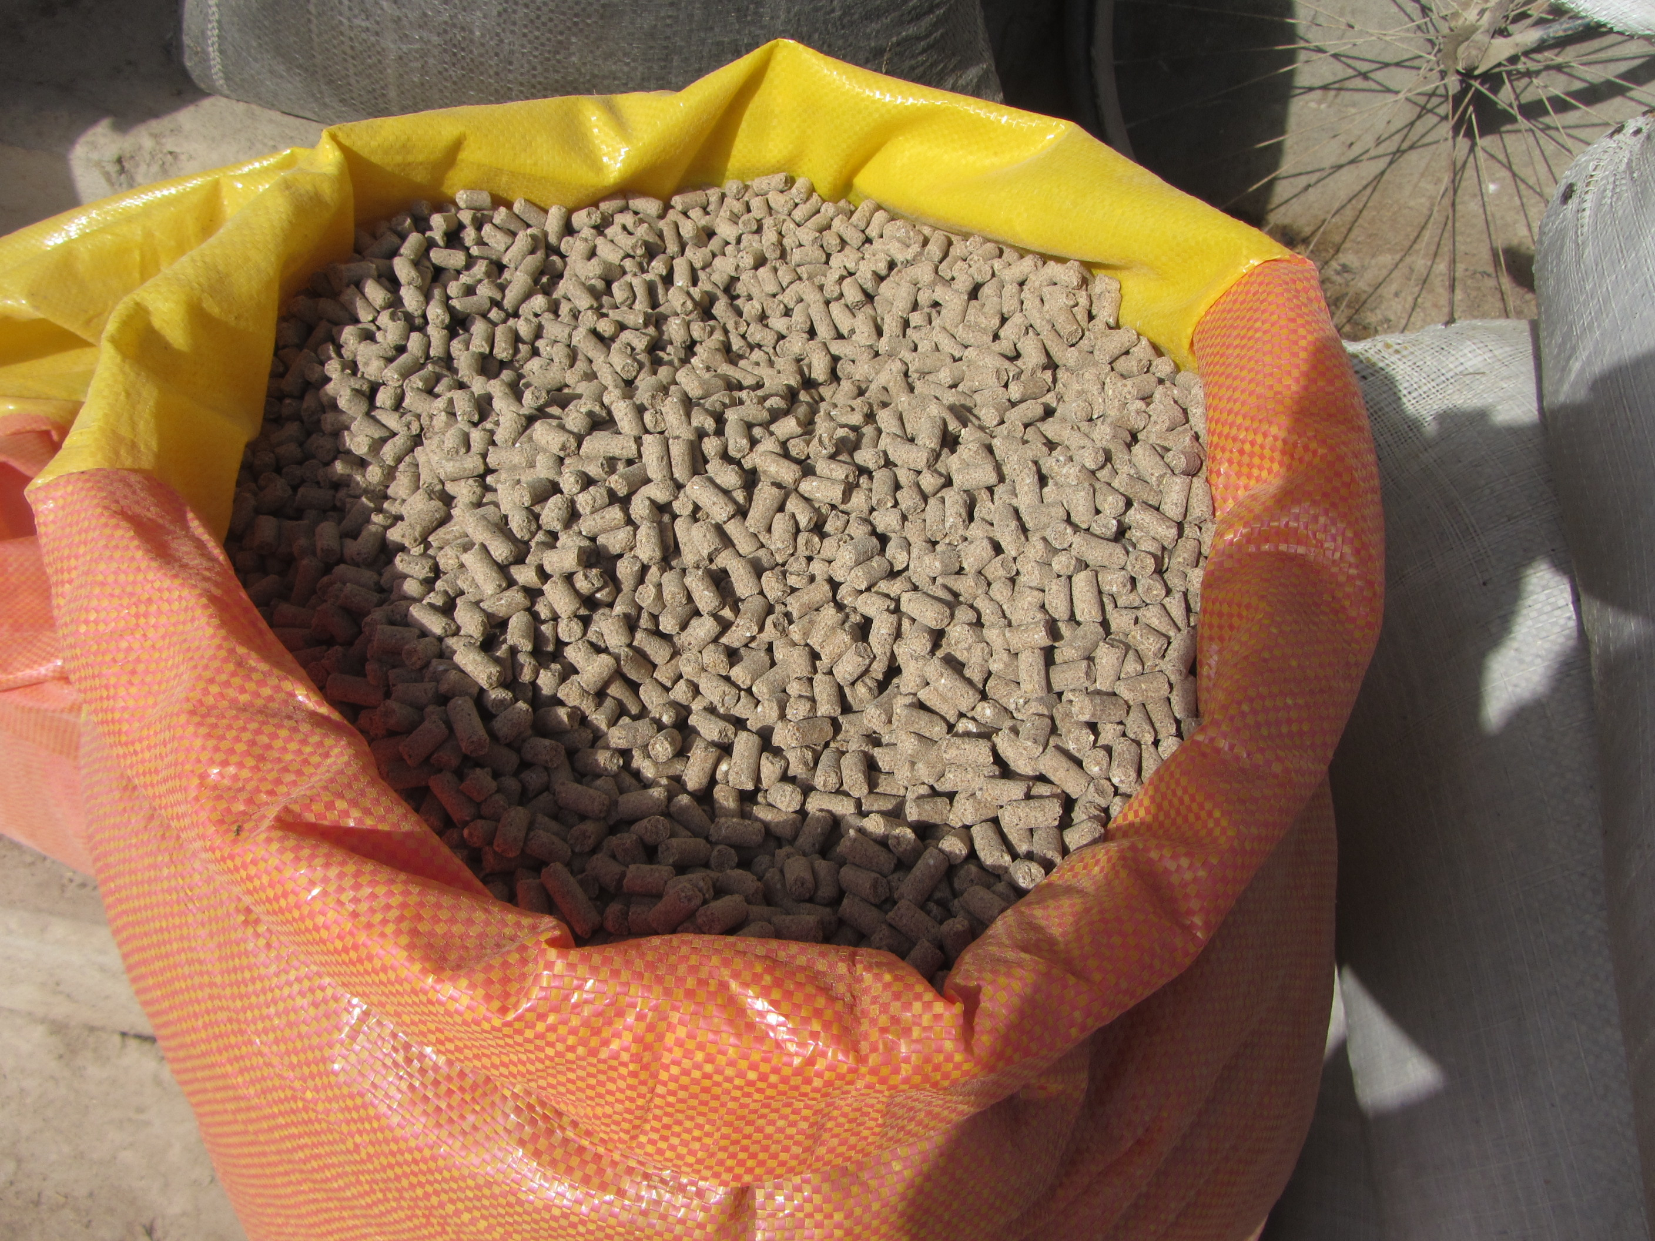
  No | Feed stuff | gr
  1 | Maize | 350
  2 | Cake | 190
  3 | Rice bran | 130
  4 | Barley | 120
  5 | Wheat bran | 80
  6 | Broken Rice kernel | 40
  7 | Mung bean | 0
  8 | Wheat | 60
  9 | Pease | 0
  10 | Vetch | 0
  11 | lime | 10
  12 | Bone | 10
  13 | Salt | 10
5 | Plastic | Polyethylene plastic, double layer, 2 meter wide, each meter is 500 gram weight.  Transparent, durable and maintains high quality | Meter | 62 |  |  | 
6 | DCP-Di Calcium phosphate Powder | It is in powder in packet.  One kg pack | Pack | 3,000
7 | Apron | Size: Large  MATERIAL : made of fabric  blue color,  Should have fixed neck tie and adjustable waist straps making it easy to tie and comfortable to wear. | Piece | 15 |  |  | 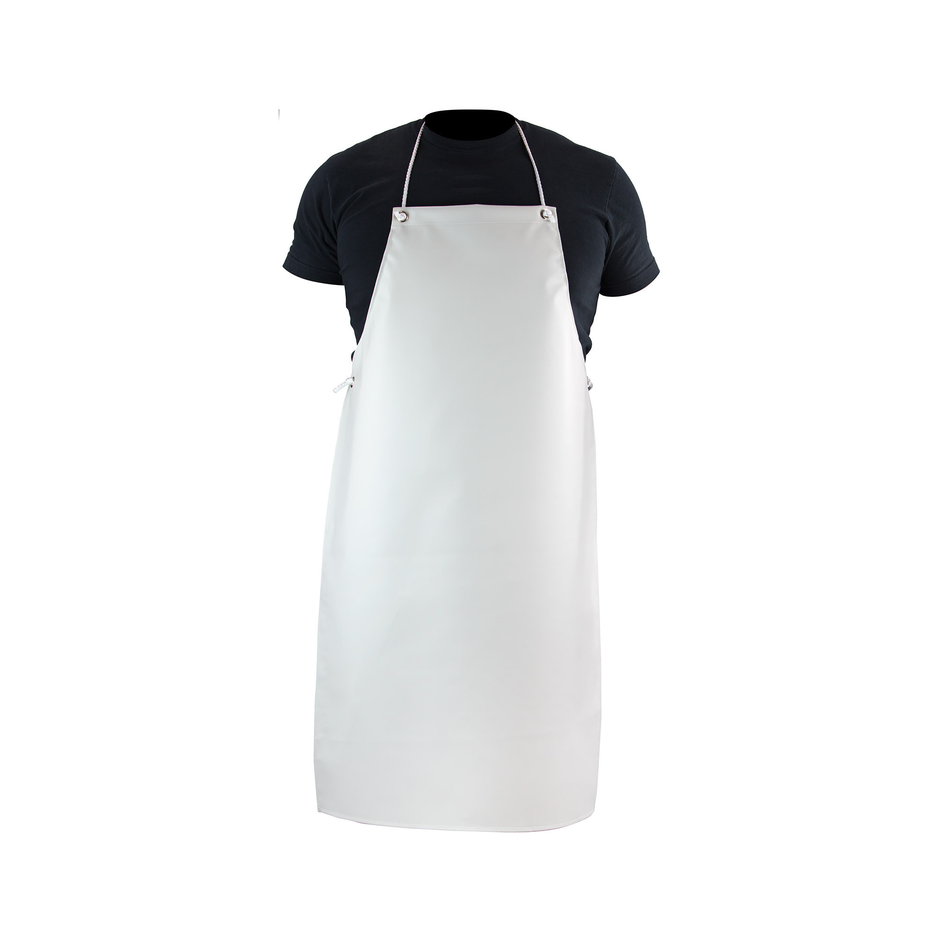
8 | goggles | Eye protective, Transparent, Made of plastic  Construction Material (Safety): polycarbonate | Piece | 15 |  |  | 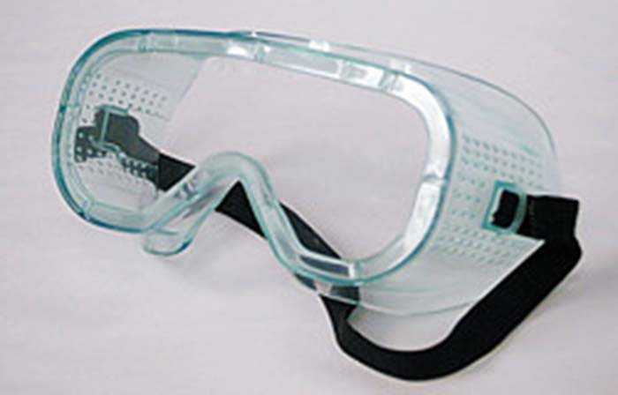
9 | Mask | Disposable mask  Size: 17.5X5 cm  Available in tie bands and Elastic Strap for proper fixing.  Every box contain of 100 masks | Box | 15 |  |  | 
10 | Gloves | Material: made of polyethylene  Color : white  Large size- 15 pc  Middle size –15 Pc | Pair | 30 |  |  | 
11 | Soap | Anti-bacterial hand washing soap  Item Weight 125 gm  Similar or equivalent specification of Dettol | Piece | 960
12 | Manger | Locally made from rubber  Thickness: 2 cm  Capacity: 30 liter  High 21 cm  Diameter 40 cm | Each | 600 |  |  | 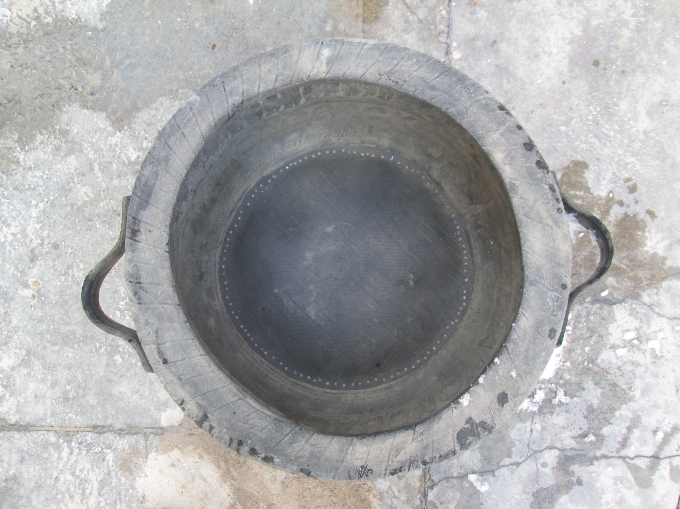
13 | Feed Block | Each feed block weight 1.5 kg  That include 0.6kg molasses, 0,3kg wheat brain, 0,15kg seedcake, 0,15kg urea, 0, 15 kg DCP, 0,075 kg salt, 0,075 kg lime. | Kg | 10,800
14 | Plastic Bucket | Material: High quality polyethylene plastic bucket with handle  Capacity: 20 liter ( 2kgs) weight  Color : Any | Piece | 600 |  |  | 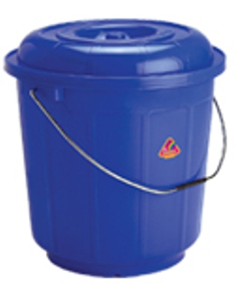
15 | Albendazole Drench (1 liter) | Bottle- 1 litter  Composition (Ingredients) : Albendazole drench 125 mg /1ml (bottle 1000 ml)  Medicine used for strategic deworming of endo-parasites in livestock.  Oral suspension for use in cattle, sheep, and goats | Bottle | 1204
16 | Piodin (50 ml) | Anti-septic for washing of umblic of neonates/new born animals)  Size: (50 ml) | Bottle | 600
17 | Gauze Bandage | Dimension: 10CM*2M  1 dozen  Material: high quality fabric | roll | 600 |  |  | 
18 | Transportation of feed block, alfalfa, concentrated feed, straw from suppliers to the VFUs to be used for demonstration and distribution to farmers. | For two times delivery  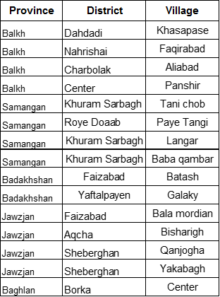 | 15 locations | 2 times delivery
GRAND TOTAL IN AFGHANI ONLY |  |  |  |  |  | ( ) AFN
Delivery Schedule: |  |  |  |  |  | Number of Calendar Days  ( )
Note: Please consider Government Withholding Tax in your quotations.

Additional requirements:
Government Withholding Tax for Afghan Based Companies
Pursuant to Article 72 in the Afghanistan Tax Law effective March 21, 2009, DAI is required to withhold "contractor" taxes from the gross amounts payable to all Afghan for-profit subcontractors/vendors. In accordance with this requirement, DAI shall withhold two percent (2%) tax from all gross invoices to Afghan subcontractors/vendors under this Agreement with active AISA or Ministry of Commerce license. For subcontractors/vendors without active AISA or Ministry of Commerce license, DAI shall withhold seven percent (7%) "Contractor" taxes per current Afghanistan Tax Law.
Before the signing of this Agreement, the subcontractor/vendor will provide a copy of the organization's AISA or Ministry of Commerce license and TIN (Tax Identification Number). Amounts deducted from the invoices will be forwarded to the Ministry of Finance (MOF) Tax Division credited to the firm's TIN. Records of payments to the MOF shall be maintained on file with DAI.

Attachment A.1: Cover Letter

On Company Cover Letter

TO: RADP-North

Date / /

We, the undersigned, provide the attached quote in accordance RFQ # _______ dated _________Our attached quote is for the total price of _____________________ (figure and in words).

I certify a validity period of ___days for the prices provided in the attached Price Schedule/Bill of Quantities. Our quote shall be binding upon us subject to the modifications.

We understand that DAI is not bound to accept any quotes it receives.

Authorized Signature: ______________________________________

Name and Title of Signatory: _________________________________

Name of Firm: _____________________________________________

Address: _________________________________________________

Telephone: _______________________________________________

Email: ___________________________________________________

DUNS #: __________________________________________________

Company Seal/Stamp:

Attachment B: Representations and Certifications of Compliance

- Federal Excluded Parties List - The Bidder Select is not presently debarred, suspended, or determined ineligible for an award of a contract by any Federal agency.

- Executive Compensation Certification- FAR 52.204-10 requires DAI, as prime contractor of U.S. federal government contracts, to report compensation levels of the five most highly compensated subcontractor executives to the Federal Funding Accountability and Transparency Act Sub-Award Report System (FSRS)

- Executive Order on Terrorism Financing- The Contractor is reminded that U.S. Executive Orders and U.S. law prohibits transactions with, and the provision of resources and support to, individuals and organizations associated with terrorism. It is the legal responsibility of the Contractor/Recipient to ensure compliance with these Executive Orders and laws. Recipients may not engage with, or provide resources or support to, individuals and organizations associated with terrorism. No support or resources may be provided to individuals or entities that appear on the Specially Designated Nationals and Blocked persons List maintained by the US Treasury (online at www.SAM.gov) or the United Nations Security Designation List (online at: http://www.un.org/sc/committees/1267/aq_sanctions_list.shtml). This provision must be included in all subcontracts/sub awards issued under this Contract.

- Trafficking of Persons – The Contractor may not traffic in persons (as defined in the Protocol to Prevent, Suppress, and Punish Trafficking of persons, especially Women and Children, supplementing the UN Convention against Transnational Organized Crime), procure commercial sex, and use forced labor during the period of this award.

- Certification and Disclosure Regarding Payment to Influence Certain Federal Transactions – The Bidder certifies that it currently is and will remain in compliance with FAR 52.203-11, Certification and Disclosure Regarding Payment to Influence Certain Federal Transactions.

- Organizational Conflict of Interest – The Bidder certifies that will comply FAR Part 9.5, Organizational Conflict of Interest. The Bidder certifies that is not aware of any information bearing on the existence of any potential organizational conflict of interest. The Bidder further certifies that if the Bidder becomes aware of information bearing on whether a potential conflict may exist, that Bidder shall immediately provide DAII with a disclosure statement describing this information.

- Prohibition of Segregated Facilities - The Bidder certifies that it is compliant with FAR 52.222-21, Prohibition of Segregated Facilities.

- Equal Opportunity – The Bidder certifies that it does not discriminate against any employee or applicant for employment because of age, sex, religion, handicap, race, creed, color or national origin.

- Labor Laws – The Bidder certifies that it is in compliance with all labor laws.

- Federal Acquisition Regulation (FAR) – The Bidder certifies that it is familiar with the Federal Acquisition Regulation (FAR) and is in not in violation of any certifications required in the applicable clauses of the FAR, including but not limited to certifications regarding lobbying, kickbacks, equal employment opportunity, affirmation action, and payments to influence Federal transactions.

- Employee Compliance – The Bidder warrants that it will require all employees, entities and individuals providing services in connection with the performance of an DAI Purchase Order to comply with the provisions of the resulting Purchase Order and with all Federal, State, and local laws and regulations in connection with the work associated therein.

By submitting a quote, bidders agree to fully comply with the terms and conditions above and all applicable U.S. federal government clauses included herein, and will be asked to sign these Representations and Certifications upon award.

Additional Information
No | Description / Question | Response
1 | Validity of Bid Price  Bid must be valid for at least 30 days. | □ 30 Days □ 90 Days □ 120 Days □ Other
2 | Payment terms  Payment will be made on monthly basis and will be processed within 30 working days from the date of correct invoice submitted. Does your company accept this? | □ Accept □ Not Accept □ Other comments
3 | Payment Method  The payment will be paid via Bank Wire Transfer. Does your company accept this? | □ Yes □ No □ Other
4 | Period of Fixed Price  The price will be fixed. Do you understand and agree that no adjustments will be made to the negotiated firm fixed price after the purchase order is issued and or Blanket Purchase Agreement (BPA) signed? | □ Yes □ No

Attachment E: Past Performance
SUMMARY OF RELEVANT CAPABILITY, EXPERIENCE AND PAST PERFORMANCE
Include projects that best illustrate your experience relevant to this (RFQ) or similar activities, sorted by decreasing order of completion date.
Projects should have been undertaken in the past three years (i.e. 2013, 2014 and 2015) Projects undertaken in the past five years may be taken into consideration at the discretion of the evaluation panel.
Item # | Project Title and  Description of Activities | Location  Province/District | Client  Name/Tel # | Cost in US$ | Start  Dates | End  Dates | Completed on Schedule  (Yes/No)Subcontractor or Prime Contractor?
1
2
3
4
5

