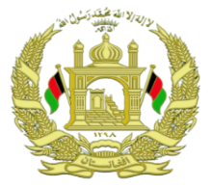
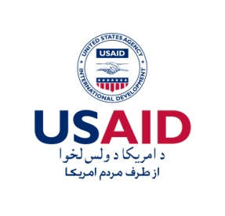
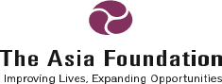

Promote Women’s Scholarship

An excellent opportunity for Afghan women! The Asia Foundation is providing 180 Master program scholarships for eligible Afghan females who:

Are currently employed of governmental or none-governmental organizations;

Have at least two years of employment history;

Have their employers' agreement to participate;

Are between the ages of 24 and 35;

Have an average grade of at least 65 percent in their four-years Bachelor's degree;

Have good English language skill.

Have family permission to study and to travel alone to India;

Eligible females can obtain the application forms starting October 23, 2017 from the Provincial Directorate of Women's Affairs (DoWA) or apply online through the following website: http://www.tafinfo.org/Scholarship/ApplicationForm_Master.aspx

