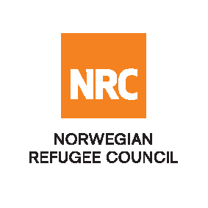
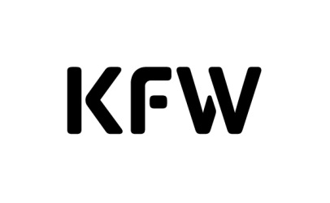

INVITATION TO OPEN TENDER

Supply of Construction materials for Durable Shelter Construction in Kabul and Kandahar Provinces funded by KFW

Reference Number: NRCSO20190001 & NRCSO20190002
The Norwegian Refugee Council (NRC) would like to invite competent suppliers to submit bids for Supply of Construction of materials for Durable Shelter Construction in Kabul and Kandahar Provinces funded by KfW Development Bank.

NRC are seeking to enter into two fixed rate, 1-year and 9 months’ framework agreement intended to commence from 1st April 2019 valued up to approximately USD 1,100,000. Whereby Kabul Provinces will be approximately USD 450,000 and Kandahar Provinces approximately USD 650,000.

Required Service
Contract Name: | Location: | ITB Reference Number:
Durable Shelter Construction Materials | Kabul Provinces | NRCSO20190001
Durable Shelter Construction Materials | Kandahar Provinces | NRCSO20190002

Essential criteria for bidders:
Interested suppliers should have previous experience in supplying and delivery of construction materials, and should be able to demonstrate this in their tender application.

Collection of tender documents:
Prospective national bidders may download tender documents from ACBAR Website link:
http://www.acbar.org/rfq/8236.jsp
Delivery of tender bids should be addressed to:
Norwegian Refugee Council (NRC) Kabul
Khurshid TV Station Street, Kolola Pushta, PD4, Kabul, Kabul Province, AFGHANISTAN
Norwegian Refugee Council (NRC) Kandahar
House no.37, Block 12, District #1, Close to Mirwaise Hospital Shari Naw, Kandahar, AFGHANISTAN
Prospective national, may send tender related questions on the following e-mail address:
af-procurement@nrc.no
Questions related to office location/direction should be enquired through telephone number: 0728932799
Submission of Bids:
Bids must be delivered in a sealed envelope before the deadline of 15:00 Hrs Afghanistan time on 26th March 2019.
NRC reserves the right to select/reject without any explanation, any bids, in part or full, as it may deem necessary. No liability or claim in that respect would be admissible or entertained whatsoever.

