Annex 2: Application Form
APPLICATION FORM

  - THE APPLICANT

- Name of applicant
(please include also acronyms, if any)

- Address of applicant
(Please include official address as well as postal address)
Official address:
Postal address:

- Registration number

- Telephone

- Fax (if applicable)

- E-mail

- Web site

- Contact person

  - PROJECT INFORMATION

1. Title of proposed project

2. Location and period

Location: [city / commune], [county]
Period: ____ months, from [month] [year] to [month] [year]

- Summary Budget
Total budget | (local currency-Afghani) | (100%)
- Amount requested | (local currency- Afghani) | (%)
- Applicant contribution | (local currency- Afghani) | (%)

  - PROJECT DESCRIPTION

- Training summary
(Please provide a brief summary of the training and any necessary background information; the summary must be no more than 1 page and should clearly address what the training will accomplish, in addition to why and how it will be implemented.)
- Course syllabi – 1.5 page maximum per syllabus
(For each course please provide the following details:
a) outcomes, b) competences to be developed, c) detailed course description with all topics to be covered, d) methods of instruction, e) expected participant activity (listening, discussions, reviews, presentations, etc.), and f) method of participant evaluation)
(Syllabi will not count towards the page limit.)

- CVs for trainer(s), in English, for each of the courses, with copies of each individual’s certification from the appropriate institution and details of similar training experience. Samples of translation work would be preferable too.
(CVs will not count towards the page limit).

  - Monitoring and evaluation

- How will you know that your project was successfully implemented? What criteria will you use to measure the achievements of your project?
(Please include the tools you will use to monitor project activities and evaluate project results)

  - Sustainability

- Describe how the activities in your project will be sustained after funding ends. How will the activities or results of your project continue?

  - PROJECT TEAM

Please list all project team members, including their position, role in the project and a short description of their assigned responsibilities. (Insert as many lines as necessary).
(Please attach CVs for key personnel involved in the project, using the template provided in Annex 5)

NO | NAME & SURNAME | POSITION | ROLE IN THE PROJECT | DESCRIPTION
1
2
3
4
5
6
7
8

  - APPLICANT CAPABILITY
Organizational capability and resources
- Annual income over the past three years, mentioning the names of your main financial contributors (where applicable)

YEAR | TOTAL ANNUAL INCOME  (in USD) | MAIN FINANCIAL CONTRIBUTORS

- Please describe the various resources at the disposal of your organization such as: equipment, offices etc.

  - PAST PERFORMANCE
Please describe no more than five major projects in which your organization was involved over the past three years, using the table below.

- Project title
- Period (months)
- Year
- Location
- Role of your organization
(leader, partner)
- Project objectives

- Project results

- Total budget (USD)
- Funding sources and types of funding (grants, contract, or other)
Please include contact information for funding sources.

  - Cost share (if any)
(Explain the cost share to the project in terms of type of contribution and value.)

  - ANNEXES
- Project activity schedule and timeline (work plan)
(Based on the activities listed in section III. above, please fill in the work plan using the template provided in Annex 3)
- GPS and location details of training sites in Kabul.
- Photographs of training class rooms and other assets and facilities (for example projectors, laptops, etc.).
- A detailed list of all appropriate and relevant equipment at the training venue. This list shall include computers, projectors, printers, and other equipment/furniture that will be used to successfully implement proposed training. NOTE – WIE will not consider any responses to the RFA that request funding for equipping training facilities (e.g. computers, office or classroom furniture, printers, or any other training commodities). Applicants must have their own equipped training facilities. Training-specific material requirements will be considered on a case-by-case basis. Similarly, WIE will not consider any responses to this RFA that include transportation for students and non-key staff positions. Refreshments based on the policy of the applicant organization may be considered. Failure to comply with these requests will automatically result in a rejection of the application.

Applicant shall complete the checklist below to ensure that all required documentation is properly submitted:

Checklist – Attached all Documents | Yes | No
Project activity schedule (work plan)
GPS location and names of proposed training venues
Photographs of classrooms and other proposed training facilities
Photographs of training equipment
List of training equipment

  - PROJECT BUDGET

Please provide a detailed budget for the entire period of the project, using the template provided in Annex 4.

  - STATEMENT OF LIABILITY

I, the undersigned, being the person responsible in the applicant organization for this project, certify that the information given in this application is true and accurate.

Name and surname:
Position:
Signature & stamp:
Date and Place:

}

Annex 3: Implementation Timeline or Work plan

Name of applicant:

Activity  # | Activity Description | Location | Month 1 |  |  |  | Month 2
 |  |  | 1 | 2 | 3 | 4 | 1 | 2

Annex 4: Budget Form

No. | Line Item | Unit | Quantity | Unit  Price  (AFN) | WIE Cost  (AFN) | Grantee  Cost  Share  (AFN) | Total  Project  Cost  (AFN) | Budget Justification and Narrative
A | Labor
1
2
 | Sub-Total
B | Office Equipment
1
2
3
 | Sub-Total
C | Travel & Transportation
1
2
 | Sub-Total
D | Communication
1
2
 | Sub-Total
E | Other Direct Costs
1
2
 | Sub-Total
 | GRAND TOTAL

Annex 5: Certifications, Assurances, Other Statements of the Recipient and Solicitation Provisions
- Federal Excluded Parties List - The Bidder Select is not presently debarred, suspended, or determined ineligible for an award of a contract by any Federal agency.

- Executive Compensation Certification- FAR 52.204-10 requires DAI, as prime contractor of U.S. federal government contracts, to report compensation levels of the five most highly compensated subcontractor executives to the Federal Funding Accountability and Transparency Act Sub-Award Report System (FSRS)

- Executive Order on Terrorism Financing- The Contractor is reminded that U.S. Executive Orders and U.S. law prohibits transactions with, and the provision of resources and support to, individuals and organizations associated with terrorism. It is the legal responsibility of the Contractor/Recipient to ensure compliance with these Executive Orders and laws. Recipients may not engage with, or provide resources or support to, individuals and organizations associated with terrorism. No support or resources may be provided to individuals or entities that appear on the Specially Designated Nationals and Blocked persons List maintained by the US Treasury (online at www.SAM.gov) or the United Nations Security Designation List (online at: http://www.un.org/sc/committees/1267/aq_sanctions_list.shtml). This provision must be included in all subcontracts/sub awards issued under this Contract.

- Trafficking of Persons – The Contractor may not traffic in persons (as defined in the Protocol to Prevent, Suppress, and Punish Trafficking of persons, especially Women and Children, supplementing the UN Convention against Transnational Organized Crime), procure commercial sex, and use forced labor during the period of this award.

- Certification and Disclosure Regarding Payment to Influence Certain Federal Transactions – The Bidder certifies that it currently is and will remain in compliance with FAR 52.203-11, Certification and Disclosure Regarding Payment to Influence Certain Federal Transactions.

- Organizational Conflict of Interest – The Bidder certifies that will comply FAR Part 9.5, Organizational Conflict of Interest. The Bidder certifies that is not aware of any information bearing on the existence of any potential organizational conflict of interest. The Bidder further certifies that if the Bidder becomes aware of information bearing on whether a potential conflict may exist, that Bidder shall immediately provide DAII with a disclosure statement describing this information.

- Business Size and Classification(s) – The Bidder certifies that is has accurately and completely identified its business size and classification(s) herein in accordance with the definitions and requirements set forth in FAR Part 19, Small Business Programs.

- Prohibition of Segregated Facilities - The Bidder certifies that it is compliant with FAR 52.222-21, Prohibition of Segregated Facilities.

- Equal Opportunity – The Bidder certifies that it does not discriminate against any employee or applicant for employment because of age, sex, religion, handicap, race, creed, color or national origin.

- Labor Laws – The Bidder certifies that it is in compliance with all labor laws..

- Federal Acquisition Regulation (FAR) – The Bidder certifies that it is familiar with the Federal Acquisition Regulation (FAR) and is in not in violation of any certifications required in the applicable clauses of the FAR, including but not limited to certifications regarding lobbying, kickbacks, equal employment opportunity, affirmation action, and payments to influence Federal transactions.

- Employee Compliance – The Bidder warrants that it will require all employees, entities and individuals providing services in connection with the performance of an DAI Purchase Order to comply with the provisions of the resulting Purchase Order and with all Federal, State, and local laws and regulations in connection with the work associated therein.

By submitting a proposal, offerors agree to fully comply with the terms and conditions above and all applicable U.S. federal government clauses included herein, and will be asked to sign these Representations and Certifications upon award.

Annex 6: CV Form

Curriculum Vitae

Proposed position in the project:

Name (First, Middle, Last):

Citizenship:

Education:
Name and location of institution | Major(s) or Degree(s) obtained:

Language proficiency – indicate proficiency on a scale of 1 (poor) to 5 (native):
Language | Reading | Speaking | Writing

Membership of NGOs or other professional bodies:

Key skills and qualifications relevant to the project (e.g. computer literacy, etc.):

Employment history:
Position Title | Employer’s name and address | Dates of employment |  | Short description  of tasks performed
 |  | From  (month, year) | To  (month, year)

Other relevant information: (e.g. publications, seminars/courses etc.):

Annex 7: Financial Capability Questionnaire

Accounting System and Financial Capability Questionnaire
For DAI Grant Recipients

The main purpose of this questionnaire is to understand the systems adopted by your institution for financial oversight and accounting of grant funds, especially those provided through the U.S. Federal Government. The questionnaire will assist DAI program and accounting staff to identify the extent to which your institution's financial systems match the requirements of the U.S. Federal Government. This information will help the program staff work with you and your institution to review any problem areas that may be identified; thereby avoiding any problems or oversights which would be reportable should an audit of the program or institution be required.

The questionnaire should be completed by the financial officer of your institution in collaboration with DAI program staff. This questionnaire is informational only, and will not have any bearing on the agreement to support your institution based on the technical merit of the proposal. Therefore, please answer all questions to the best of your knowledge.

While 22 CFR 226 does not cover awards to non-U.S. recipients, DAI shall rely on the standards established in that regulation in determining whether potential non-U.S. recipients are responsible to manage Federal funds. A determination shall be made on the potential recipient's ability, or potential ability, to comply with the following USAID and federal-wide policies:

1) 22 CFR 226.20 - 226.28 (Financial and Program Management) (See Mandatory Reference, 22 CFR 226.20 - 226.28);

2) 22 CFR 226.30 - 226.37 (Property Standards) (See Mandatory Reference, 22 CFR 226.30 - 226.37);

3) 22 CFR 226.40 - 226.49 (Procurement Standards) (See Mandatory Reference, 22 CFR 226.40 - 226.49); and

4) 22 CFR 226.50 - 226.53 (Reports and Records) (See Mandatory Reference, 22 CFR 226.50 - 226.53).

SECTION A: General Information

Please complete this section which provides general information on your institution.

Name of Institution:

Name and Title of Financial Contact Person:

Name of Person Filling out Questionnaire:

Mailing Address:

Street Address (if different)

Telephone, Fax, Email (if applicable)

Enter the beginning and ending dates of your institution's fiscal year:

From: (Month, Day) To: (Month, Day)

SECTION B: Internal Controls

Internal controls are procedures which ensure that: 1) financial transactions are approved by an authorized individual and are consistent with U.S. laws, regulations and your institution's policies; 2) assets are maintained safely and controlled; and 3) accounting records are complete, accurate and maintained on a consistent basis. Please complete the following questions concerning your institution's internal controls.

1. Does your institution maintain a record of how much time employees spend on different projects or activities?

Yes: ◻ No: ◻

2. If yes, how?

- Are timesheets kept for each paid employee?

Yes: ◻ No: ◻

- Do you maintain an employment letter or contract which includes the employee’s salary?

Yes: ◻ No: ◻

4. Do you maintain inventory records for your institution's equipment?

Yes: ◻ No: ◻ (if no, explain)

5. How often do you check actual inventory against inventory records?

6. Are all financial transactions approved by an appropriate official?

Yes: ◻ No: ◻

7. The person responsible for approving financial transactions is: ________________ Title: ______________

8. Is the person(s) responsible for approving transactions familiar with U.S. Federal Cost principles as described in OMB Circular A-122?

Yes: ◻ No: ◻

9. Does your institution use a payment voucher system or some other procedure for the documentation of approval by an appropriate official?

Yes: ◻ No: ◻

10. Does your institution require supporting documentation (such as original receipts) prior to payment for expenditures?

Yes: ◻ No: ◻

11. Does your institution require that such documentation be maintained over a period of time?

Yes: ◻ No: ◻

If yes, how long are such records kept?

12. Are different individuals within your institution responsible for approving, disbursing, and accounting of transactions?

Yes: ◻ No: ◻

13. Are the functions of checking the accuracy of your accounts and the daily recording of accounting data performed by different individuals?

Yes: ◻ No: ◻

14. Who would be responsible for financial reports? ________________________________________

SECTION C: Fund Control and Accounting Systems

Fund Control essentially means that access to bank accounts and/or other cash assets is limited to authorized individuals. Bank balances should be reconciled periodically to the accounting records. If cash cannot be maintained in a bank, it is very important to have strict controls over its maintenance and disbursement.

An Accounting System accurately records all financial transactions, and ensures that these transactions are supported by documentation. Some institutions may have computerized accounting systems while others use a manual system to record each transaction in a ledger. In all cases, the expenditure of funds provided by the USAID-funded program must be properly authorized, used for the intended purpose, and recorded in an organized and consistent manner.

1. Does your institution maintain separate accounting of funds for different projects by:

Separate bank accounts: ◻

A fund accounting system: ◻

2. Will any cash from the grant funds be maintained outside a bank (in petty cash funds, etc.)?

Yes: ◻ No: ◻

If yes, please explain the amount of funds to be maintained, the purpose and person responsible for safeguarding these funds.

4. If your institution doesn't have a bank account, how do you ensure that cash is maintained safely?

5. Does your institution have written accounting policies and procedures?

Yes: ◻ No: ◻

6. How do you allocate costs that are “shared” by different funding sources, such as rent, utilities, etc.?

7. Are your financial reports prepared on a:

Cash basis: ◻ Accrual basis: ◻

8. Is your institution's accounting system capable of recording transactions, including date, amount, and description?

Yes: ◻ No: ◻

9. Is your institution's accounting system capable of separating the receipts and payments of the grant from the receipts and payments of your institution’s other activities?

Yes: ◻ No: ◻

10. Is your institution's accounting system capable of accumulating individual grant transactions according to budget categories in the approved budget?

Yes: ◻ No: ◻

10. Is your institution's accounting system designed to detect errors in a timely manner?

Yes: ◻ No: ◻

11. How will your institution make sure that budget categories and/or overall budget limits for the grant will not be exceeded?

12. Are reconciliations between bank statements and accounting records performed monthly and reviewed by an appropriate individual?

Yes: ◻ No: ◻

13. Briefly describe your institution’s system for filing and keeping supporting documentation.

SECTION D: Audit

The grant provisions require recipients to adhere to USAID regulations, including requirements to maintain records for a minimum of three years to make accounting records available for review by appropriate representatives of USAID or DAI, and, in some cases, may require an audit to be performed of your accounting records. Please provide the following information on prior audits of your institution.

1. Is someone in your institution familiar with U.S. government regulations concerning costs which can be charged to U.S. grants (OMB Circular A-122 "Cost Principles for Nonprofit Institutions" and OMB Circular A-110 "Uniform Administrative Requirements for Grants and Agreements with Institutions of Higher Education, Hospitals and Other Non-Profit Institutions")?

Yes: ◻ No: ◻

2. Do you anticipate that your institution will have other sources of U.S. government funds during the period of this grant agreement?

Yes: ◻ No: ◻

3. Have external accountants ever performed an audit of your institution's financial statements?

Yes: ◻ No: ◻

If yes, please provide a copy of your most recent report.

4. Does your institution have regular audits?

Yes: ◻ No: ◻

If yes, who performs the audit and how frequently is it performed?

5. If you do not have a current audit of your financial statements, please provide this office with a copy of the following financial statements, if available:

a. A "Balance Sheet" for the most current and previous year; and
b. An "Income Statement" for the most current and previous year.

6. Are there any circumstances that would prevent your institution from obtaining an audit?

Yes: ◻ No: ◻

If yes, please provide details:

CHECKLIST AND SIGNATURE PAGE

DAI requests that your institution submit a number of documents along with this completed questionnaire. Complete this page to ensure that all requested information has been included.

Complete the checklist:
 Copy of your organization's most recent audit is attached.
 If no recent audit, a "Balance Sheet" "Income Statement" for the most current and previous fiscal year.
 All questions have been fully answered.
 An authorized individual has signed and dated this page.

Optional:
 Incorporation Papers or Certificate of Registration and Statute is attached.
 Information describing your institution is attached.
 Organizational chart, if available is attached (if applicable).

The Financial Capability Questionnaire must be signed and dated by an authorized person who has either completed or reviewed the form.

Approved by:

_________________________

Print Name

_________________________

Signature

__________________________
Title Date _____________

Annex 8: Instructions for Obtaining a DUNS Number - DAI’S Vendors, Subcontractors and Grantees

Note: There is a Mandatory Requirement for your Organization to Provide a DUNS number to WIE
I. SUBCONTRACTS/PURCHASE ORDERS: All domestic and foreign organizations which receive first-tier subcontracts/ purchase orders with a value of $25,000 and above are required to obtain a DUNS number prior to signing of the agreement. Your organization is exempt from this requirement if the gross income received from all sources in the previous tax year was under $300,000. Please see the self-certification form attached.
II. MONETARY GRANTS: All foreign entities receiving first-tier monetary grants (standard, simplified and FOGs) with a value equal to or over $25,000 and performing work outside the U.S. must obtain a DUNS number prior to signing of the grant. All U.S. organizations who are recipients of first-tier monetary grants of any value are required to obtain a DUNS number; the exemption for under $25,000 applies to foreign organizations only.
NO SUBCONTRACTS/POs ($25,000 + above) or MONETARY GRANTS WILL BE SIGNED BY DAI WITHOUT PRIOR RECEIPT OF A DUNS NUMBER.

Note: The determination of a successful Applicant/applicant resulting from this RFP/RFQ/RFA is contingent upon the winner providing a DUNS number to WIE. Organizations who fail to provide a DUNS number will not receive an award and USAID WIE will select an alternate vendor/subcontractor/grantee.
--------------------------------------------------------------------------------------------------------------------------
Background:
Summary of Current U.S. Government Requirements- DUNS and Reporting in FSRS Database

The Data Universal Numbering System (DUNS) is a system developed and managed by Dun and Bradstreet that assigns a unique nine-digit identifier to a business entity. It is a common standard world-wide and users include the U.S. Government, European Commission and the United Nations. The DUNS number will be used to better identify related organizations that are receiving U.S. federal funding, and to provide consistent name and address data for electronic application systems.

The U.S. Government requires that all applicants for first-tier monetary grants (i) and all first-tier subcontracts/purchase orders of $25,000 or above have a DUNS number prior to DAI issuing an award to that entity.

REQUIREMENT FOR DAI TO REPORT DATA IN THE FSRS DATABASE:

In addition, in accordance with the Federal Funding Accountability and Transparency Act of 2008; FAR 52.204-10, “Reporting Executive Compensation and First-Tier Subcontract Awards” (Revised July 2010); and Subpart 4.14—“Reporting Executive Compensation and First-Tier Subcontract Awards,” effective March 1, 2011, DAI is required to report any newly awarded first-tier subcontracts $25,000 or above in the FSRS (Functional Security Requirements Specifications) database at http://www.fsrs.gov.

In accordance with AAPD 11-01 amended, all foreign entities receiving first-tier monetary grants (standard, simplified and FOGs) with a value equal to or over $25,000 and performing work outside the U.S. must obtain a DUNS number prior to signing of the grant. All U.S. organizations who are recipients of first-tier monetary grants of any value are required to obtain a DUNS number; the exemption for under $25,000 applies to foreign organizations only. In accordance with the AAPD as well as 2 CFR Parts 25 and 170, DAI is required to report on grantees in the FSRS database. The reported information for subcontracts and grants will be available for the public to view at http://usaspending.gov.

Instructions detailing the process to be followed in order to obtain a DUNs number for your organization begin on the next page.
THE PROCESS FOR OBTAINING A DUNS NUMBER IS OUTLINED BELOW:

- Log on to the D&B (Dun & Bradstreet) DUNS registration website to begin the process of obtaining a DUNS number free of charge.
http://fedgov.dnb.com/webform/index.jsp

Please note there is a bar on the left for Frequently Asked Questions as well as emails and telephone numbers for persons at Dun & Bradstreet for you to contact if you have any questions or difficulties completing the application on-line. DAI is not authorized to complete the application on your organization’s behalf; the required data must be entered by an authorized official of your organization.

- Select the Country where your company is physically located.

- You will first be asked to search the existing DUNS database to see whether a DUNS number already exists for your organization/entity. Subcontractors/grantees who already have a DUNS number may verify/update their DUNS records.

- Potential DAI subcontractors/vendors/grantees who do not already have a DUNS number will be shown the screen below. To request a new DUNS Number, the “Request a New D-U-N-S Number” button needs to be selected.

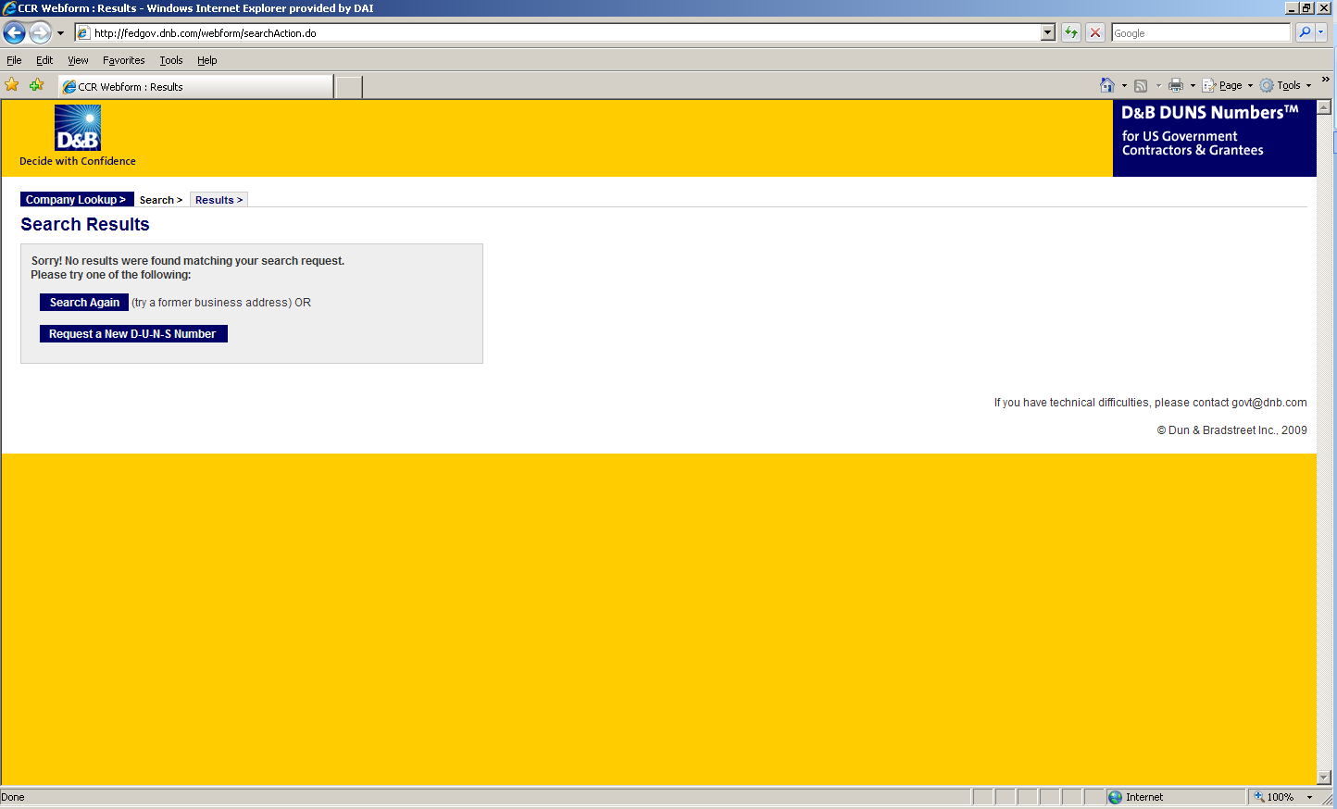

- Enter the information regarding your organization listed on the next three screens. (See screen shots below.) Make sure you have the following information available (in English) prior to beginning the process of entering this section in order to ensure successful registration.

- Legal Business Name (commas are allowed, periods are not allowed)
- Address
- Phone
- Name of Owner/Executive
- Total Number of Employees
- Annual Sales or Revenue (US Dollar equivalent)
- Description of Operations

- Note that some fields are Optional, however all other fields must be completed to proceed further with the application process. For example, all applicants must complete the Organization Information sections. The Company Name and Physical Address fields are self-populated based on information previously entered during the initial DUNS search. The question marks to the left of the field provide additional information when you click on them.
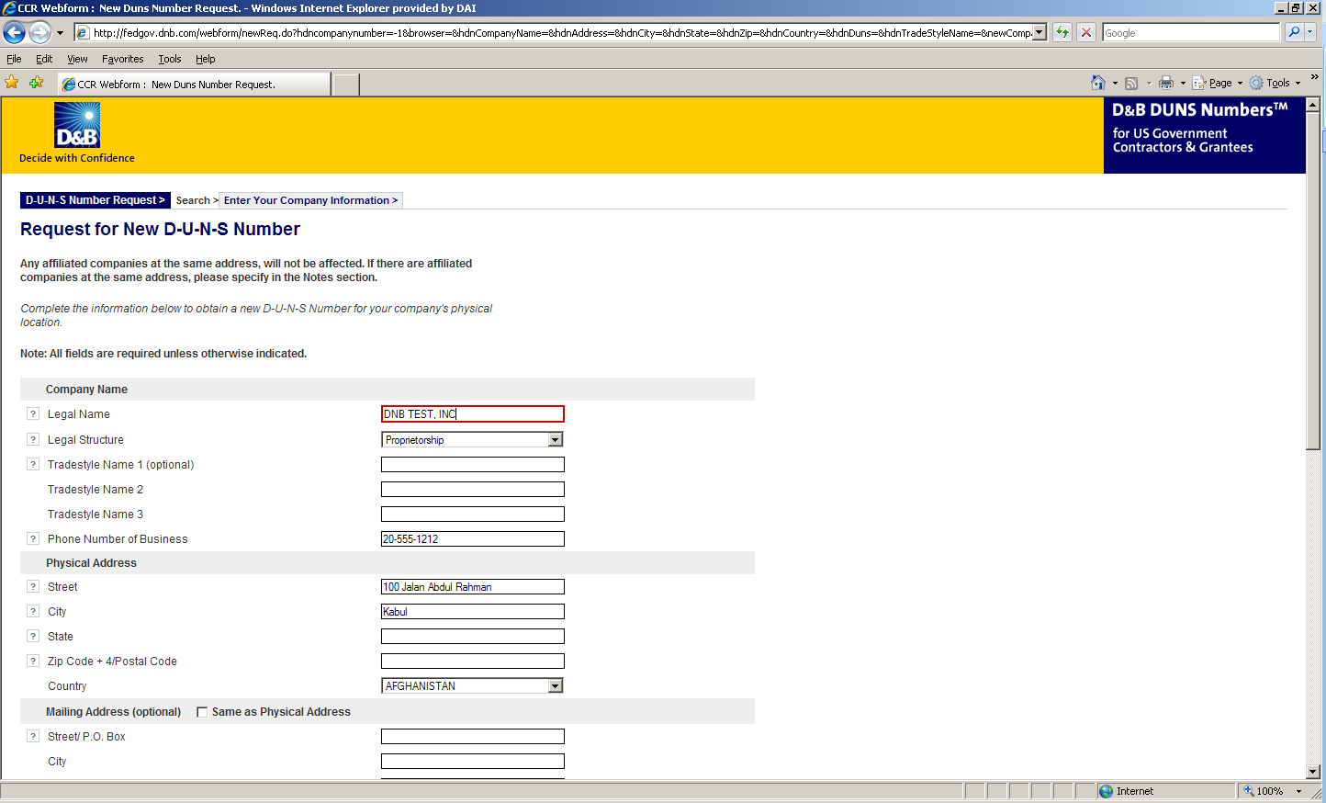

- You must select the legal structure of your organization from the pull down menu. To assist you in selecting the appropriate structure that best represents your organization, a brief description of the various types follows:

- Corporation – A firm that meets certain legal requirements to be chartered by the state/province in which it is headquartered by the filing of articles of incorporation. A corporation is considered by law to be an entity separate and distinct from its owners. It can be taxed; it can be sued; it can enter into contractual agreements.
- Government - central, province/state, district, municipal and other U.S. or local government entities. Includes universities, schools and vocational centers owned and operated by the government.
- Limited Liability Company (LLC) - This is a type of business ownership combining several features of corporation and partnership structures. It is designed to provide the limited liability features of a corporation and the tax efficiencies and operational flexibility of a partnership. Its owners have limited personal liability for the LLC’s debts and obligations, similar to the status of shareholders in a corporation. If your firm is an LLC, this will be noted on the organizations registration and licensing documents.
- Non-profit - An entity which exists for charitable reasons and is not conducted or maintained for the purpose of making a profit. Any money earned must be retained by the organization, and used for its own expenses, operations, and programs. Most organizations which are registered in the host country as a non-governmental organization (NGO) rather than as a commercial business are anon-profit entities.
Community based organizations, trade associations, community development councils, and similar entities which are not organized as a profit making organization should select this status, even if your organization is not registered formally in country as an NGO.
- Partnership- a legal form of operation in which two or more individuals carry on a continuing business for profit as co-owners. The profits and losses are shared proportionally.
- Proprietorship-These firms are owned by one person, usually the individual who has day-to-day responsibility for running the business. Sole proprietors own all the assets of the business and the profits generated by it.

- One of the most important fields that must be filled in is the Primary SIC code field. (See screen shot below.) The Primary Standard Industrial Code classifies the business’ most relevant industry and function.
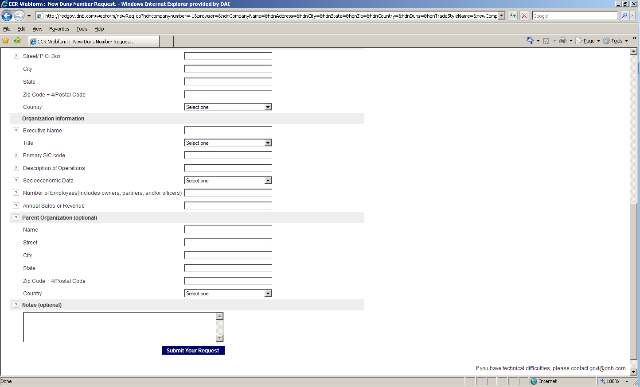
- If you are unsure of which SIC Code your organization’s core business falls under, please refer to the following website: http://www.osha.gov/oshstats/sicser.html
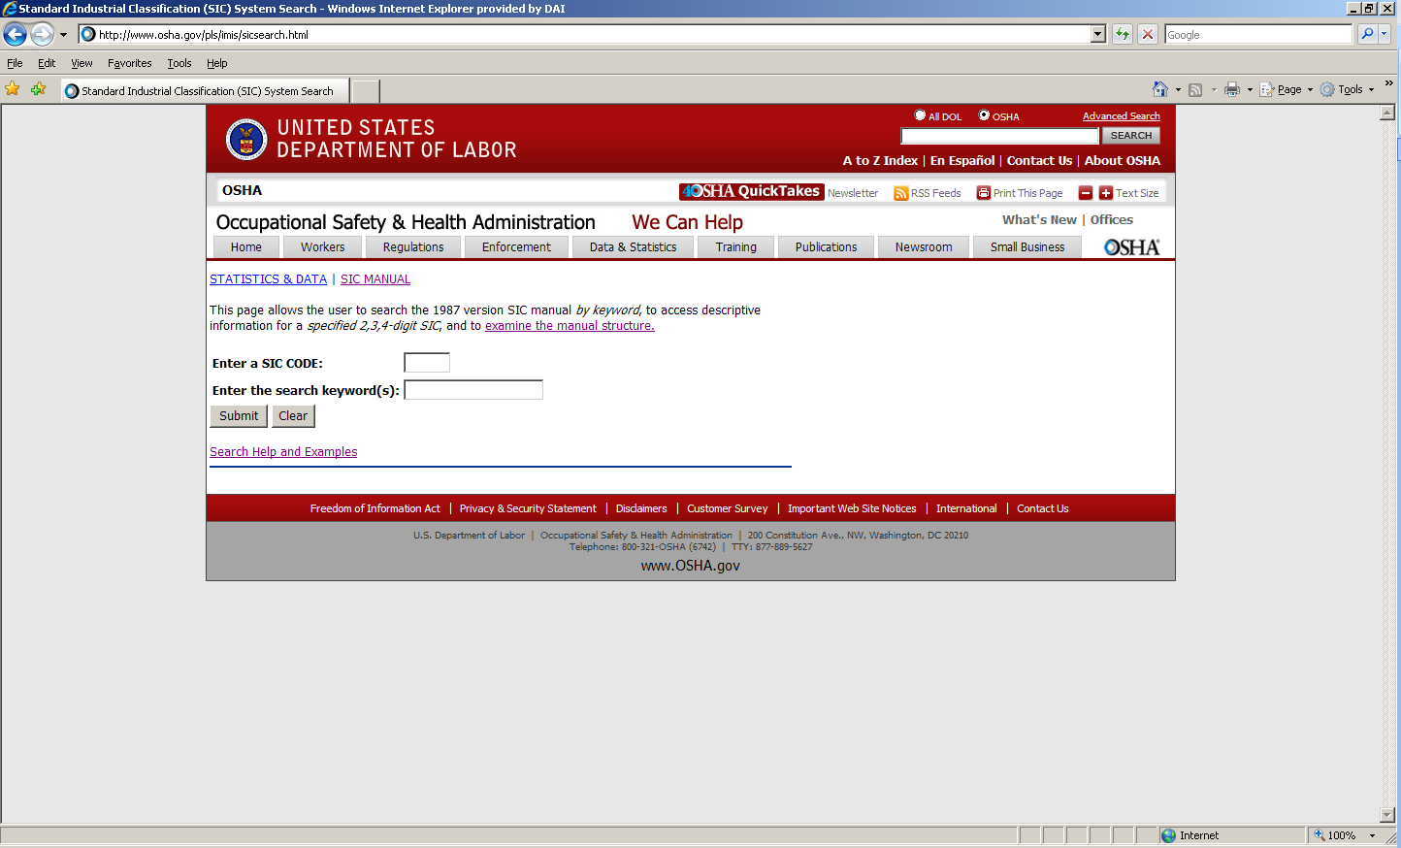

You will need to enter certain keywords to bring up the potential SIC Codes. In the case above, “Research” was entered as the keyword, and resulted in the following:
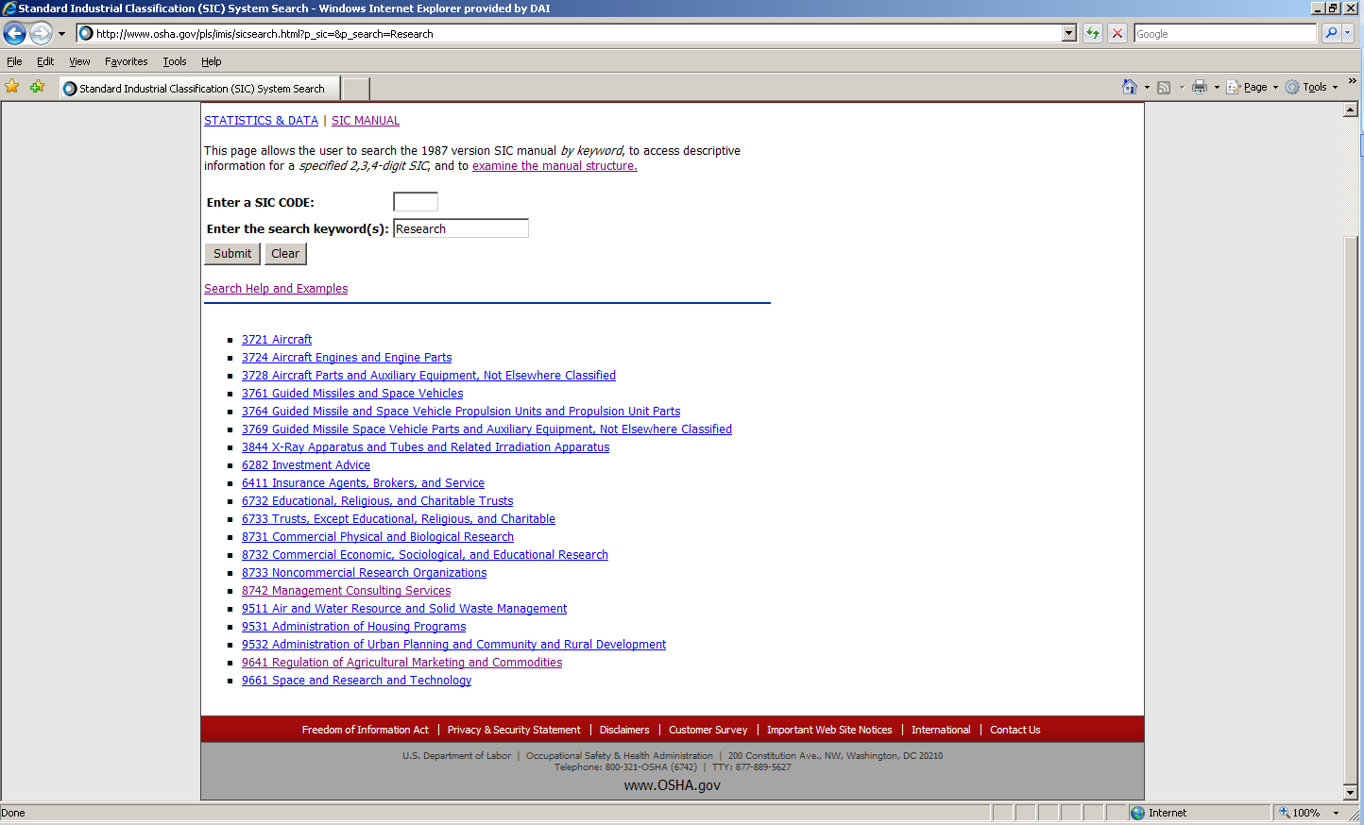

PLEASE NOTE: Many of the DAI subcontractors and grantees fall under one of the following SIC codes:
8742 Management Consulting Services
1542 General Contractors-Nonresidential Buildings, Other than Industrial Buildings and Warehouses or one of the codes within:
Industry Group 357: Computer And Office Equipment
Industry Group 355: Special Industry Machinery, Except Metalworking
Industry Group 356: General Industrial Machinery And Equipment
Industry Group 359: Miscellaneous Industrial And Commercial

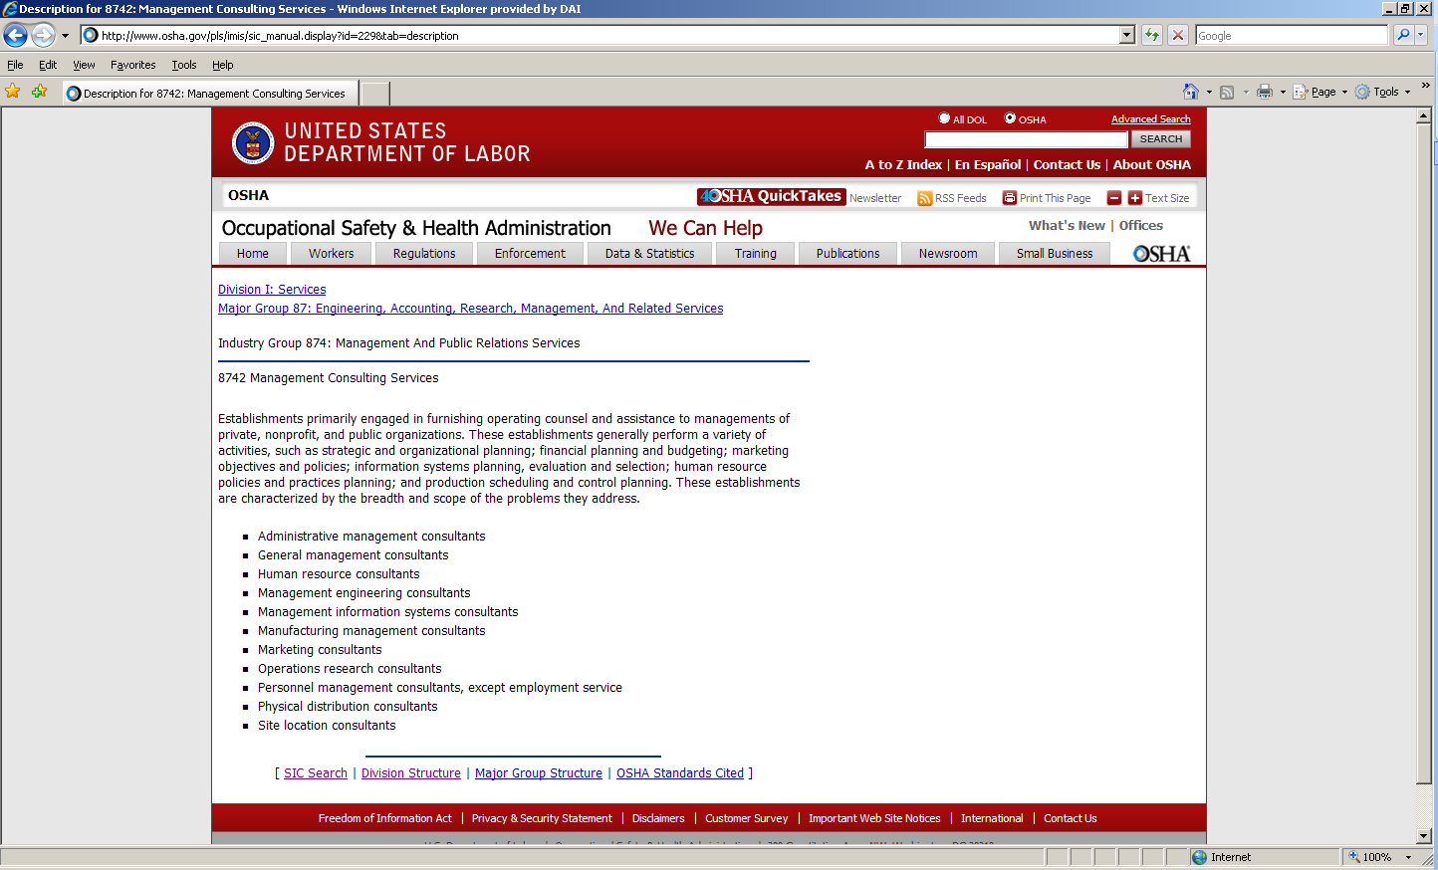

- Description of Operations- Enter a brief description of the primary services you provide the example below, “agricultural technical assistance” was chosen as the primary function of the business.
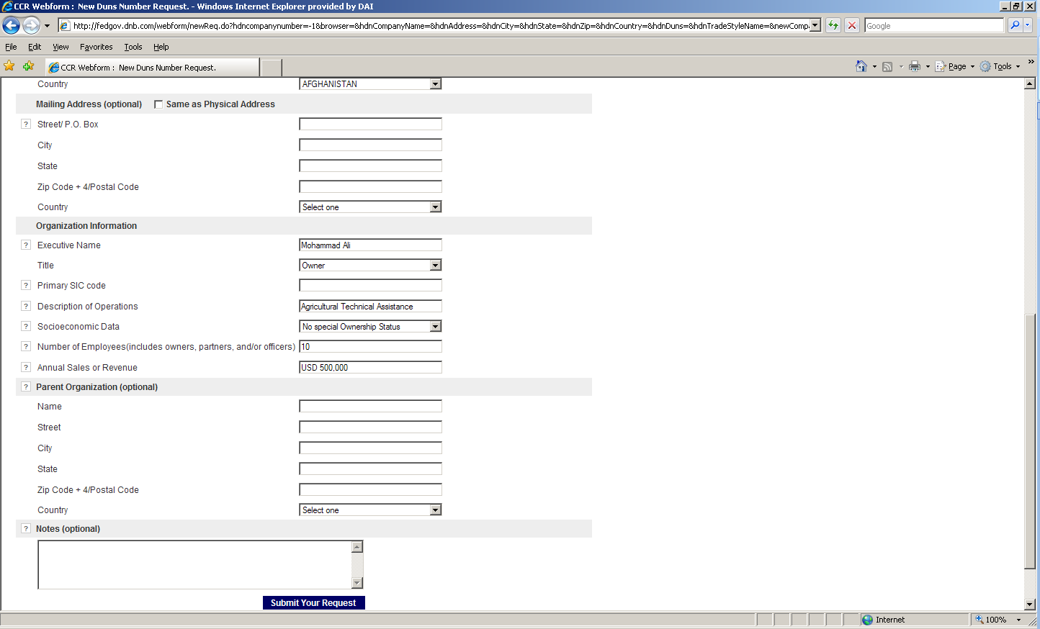

- The Annual Sales or Revenue figure should be provided in USD (US Dollar) equivalent.
- Once all of the fields have been completed, click on “Submit Your Request” to be taken to the Verification page.
- Note: Representative (Principal, Owner or Officer) needs to verify and provide affirmation regarding the accuracy of the data under criminal or civil penalties as per Title 18, Section 1001 of the US Criminal Code.
- Once “Yes, Continue” button is clicked, the registration application is sent to D&B, and a DUNS number should be available within 24-48 hours. DUNS database can be checked in 24-48 hours by entering the Business Information in the Search window – which should now display a valid result with the new DUNS number for the entity.
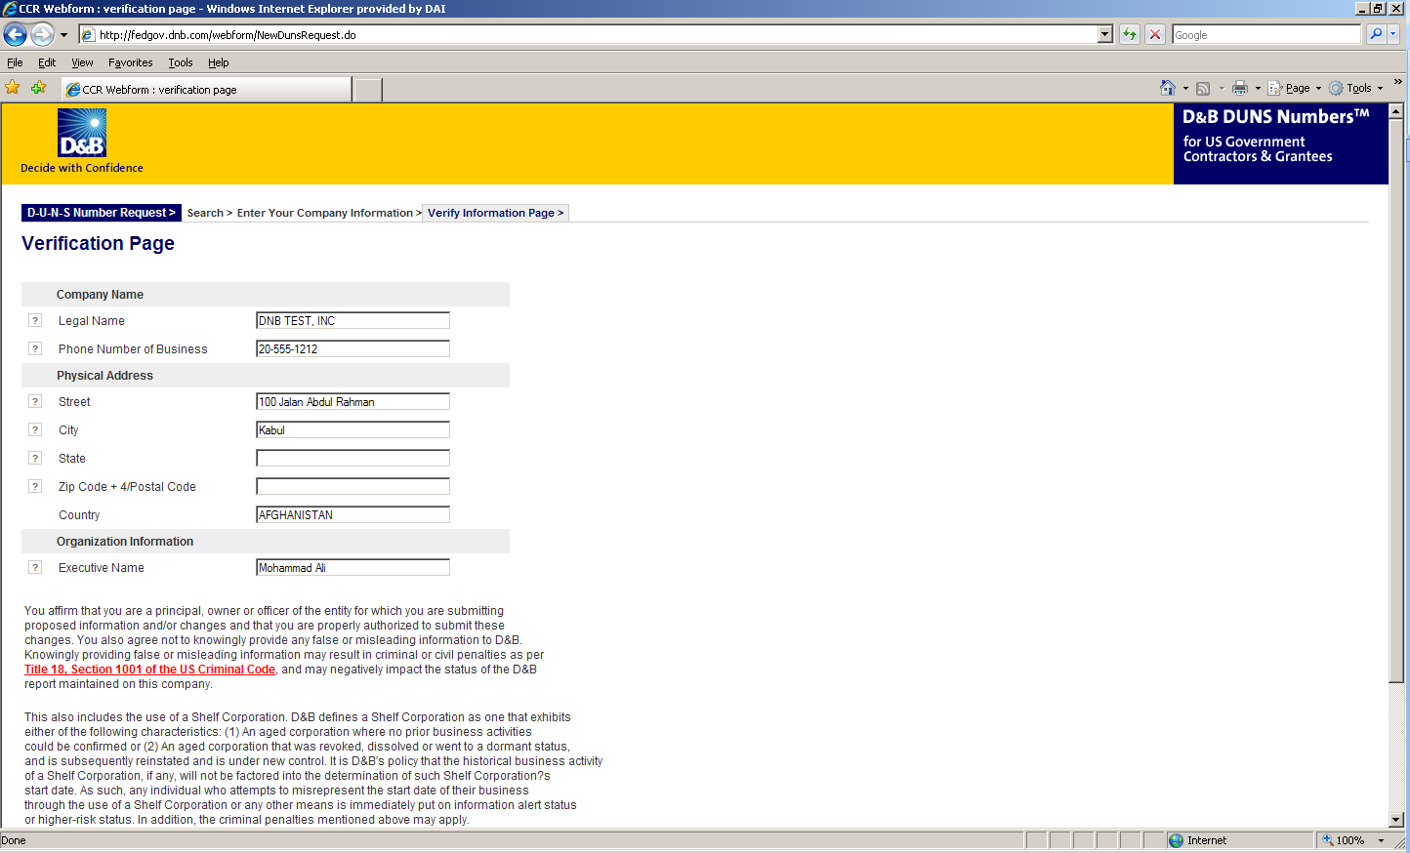

Annex 9: Self Certification for Exemption from DUNS Requirement

Self-Certification for Exemption from DUNS Requirement
For Subcontractors and Vendors

Legal Business Name:
Physical Address:
Physical City:
Physical Foreign Province (if applicable):
Physical Country:
Signature of Certifier
Full Name of Certifier (Last Name, First/Middle Names):
Title of Certifier:
Date of Certification (mm/dd/yyyy):

The sub-contractor/vendor whose legal business name is provided herein, certifies that we are an organization exempt from obtaining a DUNS number, as the gross income received from all sources in the previous tax year is under USD $300,000.

*By submitting this certification, the certifier attests to the accuracy of the representations and certifications contained herein. The certifier understands that s/he and/or the sub-contractor/vendor may be subject to penalties, if s/he misrepresents the sub-contractor/vendor in any of the representations or certifications to the Prime Contractor and/or the US Government.
The sub-contractor/vendor agrees to allow the Prime Contractor and/or the US Government to verify the company name, physical address, or other information provided herein. Certification validity is for one year from the date of certification.

Annex 10: Application Checklist

Before submitting your application, please check to make sure the following are included:

The application form (Annex 2) and all attachments are submitted in pdf format
The Implementation timeline is included (Annex 3)
The Budget is included (Annex 4)
The CV Forms are included (Annex 6)
Completed Financial Capability Questionnaire (Annex 7).
Audited Financial Reports: Copy of the applicant’s most recent financial report, which has been audited by a certified public accountant or other auditor satisfactory to DAI. If no recent audit, a “Balance Sheet” and “Income Statement” for the most current and previous fiscal year.)
The statement of liability is signed and stamped (last page of application form – Annex 2)
Incorporation Papers or Certificate of Registration and Statute
Organizational Chart
Signed Certifications, Assurances, Other Statements of the Recipient and Solicitation Provisions
Evidence of a DUNS Number or a Self Certification for Exemption from DUNS Requirement (Annex 8)
If applicable: Evidence of SAM registration

