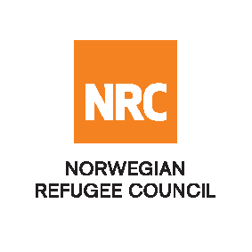

INVITATION TO OPEN TENDER

NRCHRT1901 – Construction of Zaranj Transit Center building (1600 m²) and Perimeter Wall (300 meters) in Nimruz Province funded by PATRIP Foundation

The Norwegian Refugee Council (NRC) would like to invite competent companies to submit bids for Construction of Zaranj Transit Center building (1600 m²) and Perimeter Wall (300 meters) in Nimruz Province funded by PATRIP Foundation.

Required Service
Contract Name: Construction of Zaranj Transit Center building (1600 m²) and Perimeter Wall (300 meters | Location:  In front of new University, Zaranj city, Nimruz province | ITB Reference Number: NRCHRT1901-1

Essential criteria for bidders:
Interested companies should have previous experience in infrastructure construction activities in similar projects, and should be able to demonstrate this in their tender application.

Collection of tender documents:
Prospective national bidders may collect the tender documents from NRC offices in Kabul, Nimruz or Herat between the hours of 08:00 - 13:00, Sunday-Thursday.

Norwegian Refugee Council (NRC) Kabul
Khurshid TV Station Street, Kolola Pushta, PD4
Kabul, Kabul Province, AFGHANISTAN
Tel: 0728932799

Norwegian Refugee Council (NRC) Herat
Char Rahi Zaman Jan Jade Arbab Zadeha, In front of Alqeyas Higher education institute
Herat Province, AFGHANISTAN
Tel: 0728932320

Norwegian Refugee Council (NRC) Nimruz
House #4, Hamoon 3, Gozar 5th, near previous airport, first district, Zaranj, Afghanistan
Tel: 0728932238

Prospective international bidders without an office in Afghanistan, may request bidding documents through the following e-mail address: af-procurement@nrc.no

Submission of Bids:
Bids must be delivered in a sealed envelope before the deadline of 16:00 Afghanistan time on 27th May 2019.

NRC reserves the right to select/reject without any explanation, any bids, in part or full, as it may deem necessary. No liability or claim in that respect would be admissible or entertained whatsoever.

