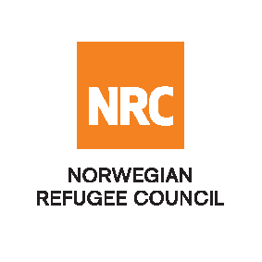

INVITATION TO OPEN TENDER

Supply of Seal of Kits (SOK)

Reference Number: NRCSO20190011

The Norwegian Refugee Council (NRC) would like to invite competent suppliers to submit bids for Supply of Seal of Kits (SOK).

NRC will be looking into signing a fixed rate and 2-year framework agreement with the successful bidder.

Required Service
Contract Name: | Location: | ITB Reference Number: | Deadline for Submission
Seal of Kits (SOK) | Kabul | NRCSO20190011 | Sunday 23 June 11:00 Hrs.

Essential criteria for bidders:
Interested suppliers should have previous experience in supplying and delivery of Seal of Kits (SOK) and should be able to demonstrate this in their tender application.

Collection of tender documents:
Prospective national bidders may download tender documents from ACBAR Website or could send an E-mail to af.procurement@nrc.no to receive:

Delivery of tender bids should be addressed to:

Norwegian Refugee Council (NRC) Kabul
Khurshid TV Station Street, Kolola Pushta, PD4, Kabul, Kabul Province, AFGHANISTAN

Prospective national companies, may send tender related questions on the following e-mail address:
af.procurement@nrc.no

Questions related to office location/direction should be enquired through telephone number: 0728932799

Submission of Bids:
Bids must be delivered in a sealed envelope before the deadline on Sunday 23 June 2019 at 11:00am
NRC reserves the right to select/reject without any explanation, any bids, in part or full, as it may deem necessary. No liability or claim in that respect would be admissible or entertained whatsoever.

