Walk-In Cold Rooms Technical Requirements
Walk-In Chiller Room (WIC) & Walk-In Freezer Room (WIF)

SECTION 1. GENERAL

- GENERAL REQUIREMENT SUMMARY INCLUDES

A Furnish and install walk-in cold rooms include; Re-assessment and re-do (if necessary) of existing rooms (Chiller and Freezer), all insulated walls, ceilings, doors, internal lights, mechanical ducting to each cold room and other ancillary items. Furnish and install each room, all NEW mechanical refrigeration systems, mechanical ducting system, PLC type control panels, gauges, new electrical wiring system, disconnect circuit, new circuit protections/breakers for a completely operational WIC and WIF.

Technical Summary Table
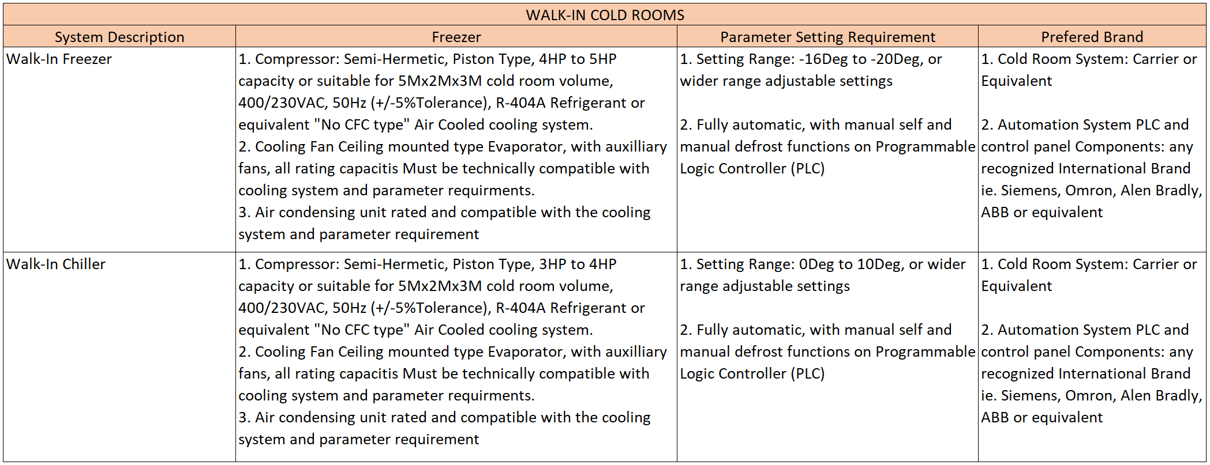

- SYSTEM DESCRIPTION

A Maintain WIC temperature between 0°C to +10°C or wider range, adjustable.

B Maintain WIF temperature between -20°C to -15°C or wider range, adjustable.

C Auto/manual defrost function.

D Humidity control will/will not be required. If required, give RH set point and acceptable variance (standard is 60% ±10%).

- SUBMITTALS

A Submit complete materials list, including catalog data of all materials, equipment, and products. Include refrigeration calculations and electrical requirements.

B Submit complete shop fabrication and installation drawings, including plans and details. Drawings shall be in the form of reproducible or photocopies.

C Submit detailed anchorage and attachment drawings and calculations provided by a qualified engineer. Rooms shall be assessed and constructed to meet the requirements for the seismic zone appropriate for the area in which construction is taking place.

D Submit record “As-Built” drawings.

E Submit complete operating and maintenance manuals that describe proper operating procedures, maintenance and replacement parts.

IV. EXTENDED GUARANTEE

A written guarantee of five (5) years for each compressor.

SECTION 2. PRODUCTS

I. ACCEPTABLE MANUFACTURERS

A World class brand, non-china, non-Iranian brand. Please refer to Technical Summary Table

B All products specified in this section shall be provided by a single manufacturer.

SECTION 3. CONTROLS

A. Each walk-in is to be provided with a control panel consisting of the following components:

1 Painted steel enclosure meeting NEMA 4 & 12 ratings.

2 Allen-Bradley Micrologix series programmable controller (PLC) including digital temperature input & Ethernet adapter or equivalent. Please refer to Technical Summary Table.

3 CMore EA7-T8C 8” color touchscreen including room temperature display, temperature setting adjustment, alarm setting adjustment, alarm monitoring, alarm logging and temperature logging to a USB drive or equivalent. Please refer to Technical Summary Table.

4 Alarm contacts for remote monitoring.

5 100Ω RTD temperature sensor(s).

6 Humidity controls

B. If refrigeration redundancy is called for, include a lead-lag controller capable of automatically switching the refrigeration systems on a daily basis and should an alarm condition occur, the stand-by system should automatically come online to maintain a constant temperature.

SECTION 4. LINGTING

A. Provide 4’ 2-tube fluorescent light fixtures suitable for the environment in each cold room. Ballasts to be T5HO with low temperature rating. A minimum light level of 60 Fc as measured 40” AFF is to be provided. Each door section shall include an interior and exterior light switch. The interior light switch to have a constant burning pilot light and the exterior switch to have an indicating pilot light.

SECTION 5. REFRIGERATION SYSTEM

A. General – the refrigeration system shall use refrigerants acceptable to the Authority having jurisdiction. Utilize R-404A refrigerant, or approved equal. No CFC type refrigerants will be acceptable.

B. All refrigeration line joints shall be brazed with Stay-Silv 15 brazing alloy. All piping shall be pressure leak tested and witnessed by the AUAF.

D. Condensing units and evaporator coils to be from the same manufacturer and be UL listed.

E Condensing units must be of adequate capacity to achieve and maintain the individual room operating temperature requirements and must be sized to handle additional loads appropriate for the application. Units to be complete in all respects including high/low pressure control, receiver, sight glass, liquid line drier, expansion valve and all other necessary equipment to achieve the cited performance. Units to be air-cooled.

F All inter-connecting piping between the evaporator coils and condensing units shall be installed under the section. Refrigeration lines shall be insulated to prevent any condensation. Insulation exposed to the weather must have additional protection from the elements. Provide seismic bracing if required.
G Condensate drain line to be run in copper tubing to nearest floor sink. To prevent condensation, drain line is to be insulated where it exits the insulated panels.

H Pressurize and leak test the entire refrigeration system.

SECTION 6. ELECTRICAL

A. All electrical components utilized within each walk-in cold room shall be UL listed.

B. A fused disconnect is to be provided at each condensing unit.

C. Exposed conduit inside the cold room shall be kept to a very minimum. Verify placement of all exposed piping and conduit with the AUAF Representative prior to installation.

D. Wiring to be THHN or THWN conductors and EMT conduit.
E. To minimize penetrations, all electrical circuits shall enter the room via a minimum number of conduits, preferably one. The conduit through the wall or roof and all conduit inside the walk-ins shall be PVC. A seal-off fitting Crouse-Hinds type or EZS or equivalent shall be placed immediately outside the room and properly sealed.

F Receptacles: Provide Carlon PVC type or equivalent, junction boxes recessed in the insulated panels with ¾” PVC conduit stubbed up through the top of the insulated ceiling panels.

SECTION 7. EXECUTION

I. SITE CONDITIONS

A. Prior to installation of walk-in cold rooms, carefully inspect the installed work and verify that all such work is complete to the point where this installation may properly commence.

B. Verify the work can be installed in strict accordance with all pertinent codes and regulations, the original design, approved submittals, and manufacturer’s recommendations.

C. In the event of a discrepancy, immediately notify the AUAF POC in writing.

II. INSTALLATION

A. Install all cold rooms in accordance with manufacturer’s written instructions and approved drawings.

B. Verify placement of all exposed piping and conduit with the AUAF Representative prior to installation.
C. Install interconnecting accessories in accordance with the manufacturer’s written recommendations and located for ease of servicing. Provide piping in accordance with good engineering practice.

D. Suction line insulation shall be sized and installed to prevent condensation.

E. Provide individual traps for condensate drains.

F. Test all equipment operation and performance of each walk-in cold room. Make all adjustments and repairs as required.

