Scope of work for Commercial Kitchen Fire Suppression System at Cafeteria International Campus
- To submit a detailed design drawing, scaled according to the provided kitchen drawing, showing all proposed Fire Suppression system layout, Dry Chemical discharge type; (refer to Fig. 1 and sample layout Fig. 2)
- System Cylinder mounting system and proposed location.
- Mechanical Control head
- Detection line enclosed in conduit
- System discharge piping
- Nozzle protecting duct
- Nozzle protecting plenum
- Appliance Nozzle (Stationary or Swivel)
- Automatic Gas Shut-Off (via Electrical or Mechanical)
- Remote manual (Optional but recommended to include)
- Electric Micro Switches (Optional but recommended to include)
- Liquid seal device for hood and duct penetration
- Corner pulley for change in directions
- Detector with fusible element
- Pneumatic control head

- All installations, specifications shall be according to UL300, and/or BFPE International, and/or according to Commercial Cooking Equipment Fire Suppression System standards, tested in accordance with NFPA 96.
- To submit a complete technical specification and product data sheet and/or samples of proposed equipment/materials for AUAF approval prior to procurement and delivery.
- Upon approval of the proposed product contractor will order and deliver the required product within 30days
- To provide wiring and cabling related to the new system.
- To keep working area clean on daily basis
- To submit the work schedule for the entire project
- To submit the weekly progress report
- To test and commission newly installed system
- To provide complete contact information list of equipment/part and name of Suppliers
- To provide one year warranty for the installed equipment.
- To provide at least one year preventive maintenance and inspection.
- To provide operations and maintenance orientation to AUAF Facilities technical team.
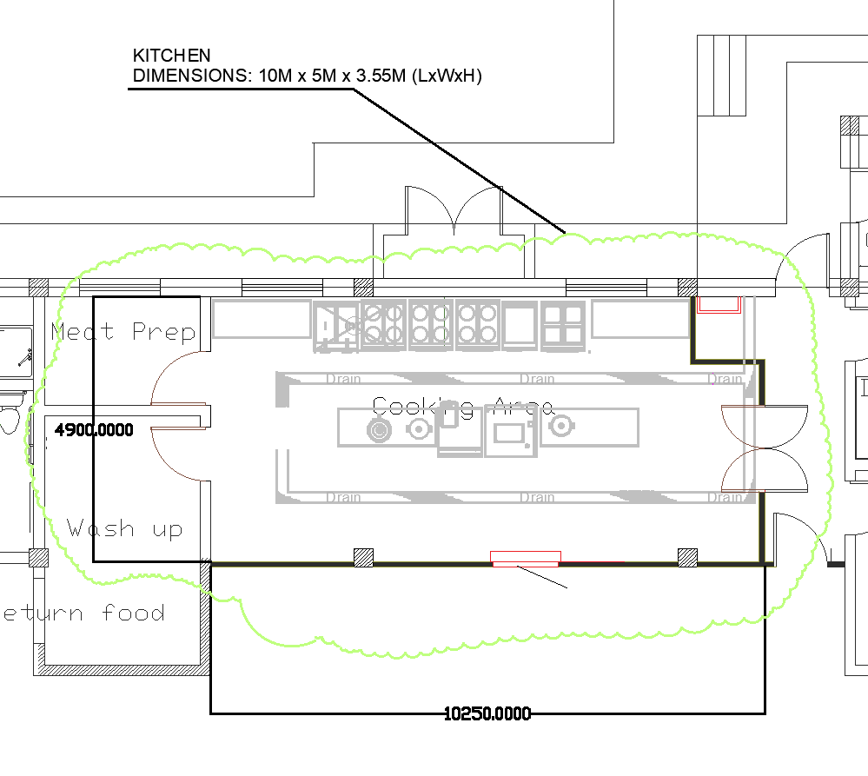
Figure 1:

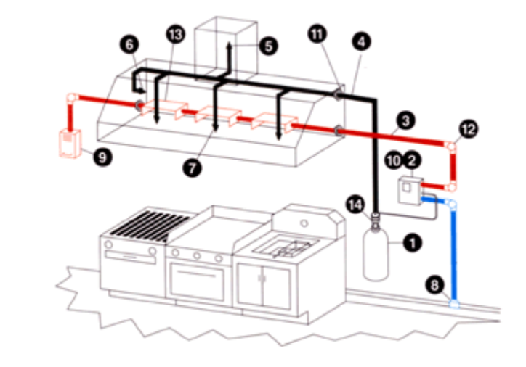
Figure 2:

