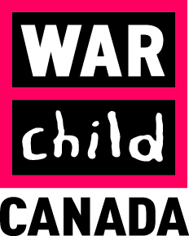

TENDER NOTICE

War Child Canada invites sealed bids from registered national suppliers for supply of Stationaries (Student Learning Kits) as per the specification below:
# | Item | Specification | Quantity | Unit Cost | Total
1 | Note Book | Single Line (60 Pages Good Quality) | 92400 Pcs
2 | Note Book | Painting (40 Pages Good Quality) | 23100 Pcs
3 | Ball Point | Linc Offix | 23100 Pcs
4 | Pencil | HB Wooden Good Quality | 138600 Pcs
5 | Sharpener | Hard Iron | 32450 Pcs
6 | Eraser | Peace AI 30 | 32450 Pcs
7 | Ruler | 30cm Plastic Flexible good quality | 22000 Pcs
8 | Student Bag | School Bags (BIAOWANG) medium Size | 11550 Pcs

Bidding documents are available at http://www.acbar.org/rfq . Submission deadline to accept sealed bids are: July 18, 2019 at 16:00 hours of Afghanistan time.

