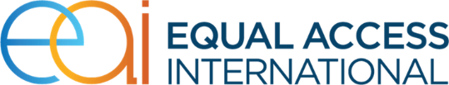

House #506, Street 8, Taimany
Kabul, Afghanistan
+93 799 868443
+93 786 161626
www.equalaccess.org

Post date: August 24 2019
Deadline: August 28 2019

Dialogic HMP 4.1 License Package

Project Objectives
Dialogic HMP 4.1 License package (Voice + IP call control + RTP G.711 + Enhanced RTP G.723, G.729)

Scope of Work

Item description | Quantity | Unit Price | Total Price
Dialogic HMP 4.1 License  DMIPS10V41L + DMIPS10I41L + DMIPS10R41L + DMIPS10E41L | 55 Port

Requirements:

- Observation of professionalism in all work procedures.
- Submission of valid legal agency license registered with Afghan Government.
- Quotation in company’s official letterhead (All Pages Stamped)

Equal Access Afghanistan
Equal Access (EA) is a communication and outreach implementing partner for the Migration Information Communication in Afghanistan project and collaborating with client and other key implementing partners (KIPs) to design specific media and outreach activities to further support project’s activities through proven methods of communication for the realization of objectives and overall goal of the project. EA will leverage its experience working in the target provinces to identify, negotiate and facilitate access to multiple media outlets and develop media and outreach activities in consultation with the EU team, disseminating important project’s messages.

Submission Guidelines:
All interested companies can submit their Quotation to Equal Access Afghanistan organization, before
August 22 2019, 2:00 pm local time through email to procurement@equalaccess.af .
All official quotations should be attached with a cover letter bearing the applicant company’s stamp and update valid license copy. The documents providing Quotations should be in English.

For delivering hardcopies please follow below address; Taimany Street#08, House#506 – Kabul – Afghanistan or call: 0786161626 for any elaborations.

