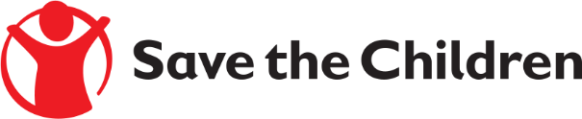
Tender Notice

Save the Children believes every child deserves a future. In [Afghanistan] and around the world, we give children a healthy start in life, the opportunity to learn and protection from harm. We do whatever it takes for children – every day and in times of crisis – transforming their lives and the future we share.

Save the Children International in (Afghanistan) is inviting submissions of tenders for procurement of school laboratory materials under reference # PR-AFG-KBL-2019-1614-Scool laboratory materials to provide the following products:

- School Lab Materials
Detailed technical specifications are included within the tender documents.
If you are interested in submitting a bid, please contact [Abdul Ahad Monib] at the following address [AFG.Tenders@savethechildren.org] to express your interest and request the tender documents. Tender documents will be sent to you by return. OR
If you are interested in submitting a bid, please collect the tender documents from the following location:
[Afghanistan Country, House #586, Street # 05, Qalai Fatullah, Kabul Afghanistan]
It is recommended to request / collect the tender documents as soon as possible. Completed tender documents are due to be submitted by 16-Oct-2019 3:00 PM Afghanistan time].
Please mention Tender Reference# in the subject line as (PR-AFG-KBL-2019-1614-school laboratory materials
and tender document will not be accepted after the closing date

