Afghanistan Value Chain (AVC) – High Value Crops
Request for Quotation (RFQ)
RFQ No. REQ-KDR-19-0061

Provision of Plastic Water Tanks, One-Burner Gas Heaters and Deep Freezers in Kandahar

Issue Date: Oct 21, 2019

WARNING: Prospective Offerors who have received this document from a source other than the AVC-HVC Project should immediately contact avc-c_procurement@dai.com and provide their name and mailing address in order that amendments to the RFQ or other communications can be sent directly to them. Any prospective Offeror who fails to register their interest assumes complete responsibility in the event that they do not receive communications prior to the closing date. Any amendments to this solicitation will be issued and posted via email.

Synopsis of the Request for Quotation
DAI, implementer of the USAID funded Afghanistan Value Chain (AVC) – High Value Crops project, invites qualified vendors to submit quotations for Saffron Drying Machine (60 gramser capacity) as follows:
- RFQ No. | REQ-KDR-19-0061
- Issue Date | Oct 21, 2019
- Title | Provision of Plastic Water Tanks, One-Burner Gas Heaters and Deep Freezers in Kandahar
- Please submit your quotation by Email | avc-c_quotation@dai.com with subject: Bidder Company Name RFQ# REQ-KDR-19-0061. Sending to other e-mail address may lead to disqualification of your bid.
- Deadline for Receipt of Quotations. | Please submit proposals by Sunday - Oct 27, 2019 by 4:00 pm local time in Afghanistan avc-c_quotation@dai.com
- Point of Contact for Questions | Any questions regarding this RFQ should be sent to:  avc-c_procurement@dai.com till 12:00am Oct 24, 2019.
- Anticipated Award Type | DAI anticipates issuing a Firm Fixed Price Purchase Order. This is only the anticipated type of award and may be changed as a result of negotiations. Issuance of this RFQ in no way obligates DAI to award a subcontract or purchase order and Bidders will not be reimbursed for any costs associated with the preparation of their quote.
- Basis for Award | An award will be made to the responsible bidder whose bid is responsive to the terms of the RFQ and is most advantageous to DAI, considering price or/and other factors included in the RFQ. To be considered for award, bidders must meet the requirements identified in Section 12, “Determination of Responsibility”. No discussions or negotiations are permitted with bidders, and therefore bidders shall submit their best and final price.
- Delivery Terms | Goods must be transported by the supplier to Kandahar (shipping cost should be included in the quotation)
- Customs clearance and in-country transportation shall be handled by | DAI AVC-HVC’s partner companies
- Expected delivery date | 04 days from the issuance of the Purchase Order (PO)
- Proffered currency of quotation | Afghani (AFN)
- Tax and Tariff on Price Quotation | Must include all applicable taxes and tariffs
- After-sales service required | Warranty for minimum period of 06 months
- All documents shall be in this language | English

- Compliance Requirements
- Determination of Responsibility | DAI will not enter into any type of agreement with a vendor prior to ensuring the vendor’s responsibility. When assessing a vendor’s responsibility, the following factors are taken into consideration:  - Provide copies of the valid business license  - Evidence of a DUNS number (explained below).  - The source, origin and nationality of the services are not from a Prohibited Country (explained below).  - Ability to comply with required or proposed delivery or performance schedules.
- Geographic Code | - Under the authorized geographic code for its contract DAI may only procure goods and services from the following countries.  - Geographic Code 935: Goods and services from any area or country including the cooperating country, but excluding Prohibited Countries.  - DAI must verify the source, nationality and origin, of goods and services and ensure (to the fullest extent possible) that DAI does not procure any services from prohibited countries listed by the Office of Foreign Assets Control (OFAC) as sanctioned countries. The current list of countries under comprehensive sanctions include: Cuba, Iran, North Korea, Sudan, and Syria. DAI is prohibited from facilitating any transaction by a third party if that transaction would be prohibited if performed by DAI.  - By submitting a quote in response to this RFQ, Bidders confirm that they are not violating the Source and Nationality requirements and that the services comply with the Geographic Code and the exclusions for prohibited countries.
- Data Universal Numbering System (DUNS) | All U.S. and foreign organizations which receive first-tier subcontracts/ purchase orders with a value of $35,000 and above are required to obtain a DUNS number prior to signing of the agreement. Organizations are exempt from this requirement if the gross income received from all sources in the previous tax year was under $300,000. DAI requires that Bidders sign the self-certification statement if the Bidder claims exemption for this reason.  For those required to obtain a DUNS number, you may request Attachment D: Instructions for Obtaining a DUNS Number.  For those not required to obtain a DUNS number, you may request Attachment B: Self-Certification for Exemption from DUNS Requirement
- Compliance with Terms and Conditions | Bidder shall be aware of the general terms and conditions for an award resulting from this RFQ. The selected Bidder shall comply with all Representations and Certifications of Compliance listed in Attachment B.
- Procurement Ethics | By submitting a Bid, Bidders certify that they have not/will not attempt to bribe or make any payments to DAI employees in return for preference, nor have any payments with Terrorists, or groups supporting Terrorists, been attempted. Any such practice constitutes an unethical, illegal, and corrupt practice and either the Bidders or the DAI staff may report violations to the Toll-Free Ethics and Compliance Anonymous Hotline at +1 855-603-6987, via the DAI website, or via email to FPI_hotline@dai.com.
- Offeror’s Agreement with Terms and Conditions | The completion of all RFQ requirements in accordance with the instructions in this RFQ and submission to DAI/Finance Inclusive of a quote will constitute an offer and indicate the Offeror’s agreement to the terms and conditions in this RFQ and any attachments hereto. Issuance of this RFQ in no way obligates DAI to award a purchase order, nor does it commit DAI to pay any costs incurred by the Offeror in preparing and submitting the quote. DAI/Finance Inclusive has the rights to increase or decrease the goods and services mentioned in this RFQ.

Attachment A:

Price Schedule (tax inclusive)
S. No | Item Name | Unit | Quantity | Unit Price | Total Price
1 | Plastic Water Tanks  (800 Liters) Local made | Each | 80
2 | One-Burner Gas Heaters  (50 in 50 inches) Local Made | Each | 30
3 | Deep Freezer  (500 Liters Capacity, Length: 140cm, Width: 63cm, Hight: 90cm)  Voltage Capacity: 280 Watts Starter and will run by 100 - 130 Watts then. | Each | 12
GRAND TOTAL IN AFN
Delivery Time (if applicable):

We, the undersigned, provide the attached quote in accordance RFQ # ___________________ dated ___________________Our attached quote is for the total price of (figure and in words)
I certify a validity period of days for the prices provided in the attached Price Schedule/Bill of Quantities. Our quote shall be binding upon us subject to the modifications.
We understand that DAI is not bound to accept any quotes it receives.
Authorized Signature:
Name and Title of Signatory:
Name of Firm:
Address:
Telephone: Email:
Company Seal/Stamp:

Attachment B:
Self-Certification for Exemption from DUNS Requirement
For Subcontractors and Vendors
Legal Business Name:
Physical Address:
Physical Country:
Signature and Stamp of Certifier
Full Name of Certifier (Last Name, First/Middle Names):
Title of Certifier:
Date of Certification (mm/dd/yyyy):

The sub-contractor/vendor whose legal business name is provided herein, certifies that we are an organization exempt from obtaining a DUNS number, as the gross income received from all sources in the previous tax year is under USD $300,000.
*By submitting this certification, the certifier attests to the accuracy of the representations and certifications contained herein. The certifier understands that s/he and/or the sub-contractor/vendor may be subject to penalties, if s/he misrepresents the sub-contractor/vendor in any of the representations or certifications to the Prime Contractor and/or the US Government.
The sub-contractor/vendor agrees to allow the Prime Contractor and/or the US Government to verify the company name, physical address, or other information provided herein. Certification validity is for one year from the date of certification.

Attachment C: Representations and Certifications of Compliance

- Federal Excluded Parties List - The Bidder Select is not presently debarred, suspended, or determined ineligible for an award of a contract by any Federal agency.

- Executive Compensation Certification- FAR 52.204-10 requires DAI, as prime contractor of U.S. federal government contracts, to report compensation levels of the five most highly compensated subcontractor executives to the Federal Funding Accountability and Transparency Act Sub-Award Report System (FSRS)

- Executive Order on Terrorism Financing- The Contractor is reminded that U.S. Executive Orders (including E.O 13224) and U.S. law prohibits transactions with, and the provision of resources and support to, individuals and organizations associated with terrorism. FAR 25.701 prohibits agencies and their contractors from acquiring any supplies or services from individuals or organization, if any proclamation, Executive Order, Office of Foreign Assets Control (OFAC) regulations, or statute administered by OFAC would prohibit such a transaction. Accordingly, the Contracting Officer must check the US Department of the Treasury’s OFAC List to ensure that the names of the Contractor and proposed subcontractors (and individuals from those organizations who have been made known to them), are not on the list. Mandatory FAR clause 52.225-13 Restrictions on Certain Foreign Purchases is included by reference in Section I.1 of this contract. By accepting this contract, the Contractor acknowledges and agrees that it is aware of the list as part of its compliance with the requirements of that clause. This clause must be included in all subcontracts/sub-awards issued under this contract. It is the legal responsibility of the Contractor/Recipient to ensure compliance with these Executive Orders and laws. Recipients may not engage with, or provide resources or support to, individuals and organizations associated with terrorism. No support or resources may be provided to individuals or entities that appear on the Specially Designated Nationals and Blocked persons List maintained by the US Treasury (online at www.SAM.gov) or the United Nations Security Designation List (online at: http://www.un.org/sc/committees/1267/aq_sanctions_list.shtml). This provision must be included in all subcontracts/sub awards issued under this Contract.

- Subcontracting Requirements (January 2012) – (a) Applicability: This section limits the number of tiers of sub-contracts to one tiers below the Vendor. The Vendor must not allow lower-tier subcontracts without the express written approval of DAI. Should exceptional circumstances warrant subcontracting below one tier, the Vendor shall promptly request approval in writing from DAI. The Vendor shall include this clause in all subcontracts, and shall require subcontractors to include this clause in all lower-tier subcontracts. The Vendor shall be responsible for compliance with this clause by all subcontracts and lower-tier subcontractors.
- Combating Trafficking of Persons (Feb 2009) – The Contractor may not traffic in persons (as defined in the Protocol to Prevent, Suppress, and Punish Trafficking of persons, especially Women and Children, supplementing the UN Convention against Transnational Organized Crime), procure commercial sex, and use forced labor during the period of this award.
(a) Definitions. As used in this clause—
“Coercion” means—(1) Threats of serious harm to or physical restraint against any person; (2) Any scheme, plan, or pattern intended to cause a person to believe that failure to perform an act would result in serious harm to or physical restraint against any person; or (3) The abuse or threatened abuse of the legal process.

“Commercial sex act” means any sex act on account of which anything of value is given to or received by any person. “Debt bondage” means the status or condition of a debtor arising from a pledge by the debtor of his or her personal services or of those of a person under his or her control as a security for debt, if the value of those services as reasonably assessed is not applied toward the liquidation of the debt or the length and nature of those services are not respectively limited and defined.

“Employee” means an employee of the Contractor directly engaged in the performance of work under the contract who has other than a minimal impact or involvement in contract performance.

“Forced Labor” means knowingly providing or obtaining the labor or services of a person—(1) By threats of serious harm to, or physical restraint against, that person or another person; (2) By means of any scheme, plan, or pattern intended to cause the person to believe that, if the person did not perform such labor or services, that person or another person would suffer serious harm or physical restraint; or (3) By means of the abuse or threatened abuse of law or the legal process.

“Involuntary servitude” includes a condition of servitude induced by means of— (1) Any scheme, plan, or pattern intended to cause a person to believe that, if the person did not enter into or continue in such conditions, that person or another person would suffer serious harm or physical restraint; or (2) The abuse or threatened abuse of the legal process.

“Severe forms of trafficking in persons” means— (1) Sex trafficking in which a commercial sex act is induced by force, fraud, or coercion, or in which the person induced to perform such act has not attained 18 years of age; or (2) The recruitment, harboring, transportation, provision, or obtaining of a person for labor or services, through the use of force, fraud, or coercion for the purpose of subjection to involuntary servitude, peonage, debt bondage, or slavery.

“Sex trafficking” means the recruitment, harboring, transportation, provision, or obtaining of a person for the purpose of a commercial sex act.

(b) Policy. The United States Government has adopted a zero tolerance policy regarding trafficking in persons. Contractors and contractor employees shall not— (1) Engage in severe forms of trafficking in persons during the period of performance of the contract; (2) Procure commercial sex acts during the period of performance of the contract; or (3) Use forced labor in the performance of the contract.

(c) Contractor requirements. The Contractor shall—
(1) Notify its employees of—
(i) The United States Government’s zero tolerance policy described in paragraph (b) of this clause; and
(ii) The actions that will be taken against employees for violations of this policy. Such actions may include, but are not limited to, removal from the contract, reduction in benefits, or termination of employment; and
(2) Take appropriate action, up to and including termination, against employees or subcontractors that violate the policy in paragraph (b) of this clause.

(d) Notification. The Contractor shall inform the Contracting Officer immediately of—
(1) Any information it receives from any source (including host country law enforcement) that alleges a Contractor employee, subcontractor, or subcontractor employee has engaged in conduct that violates this policy; and (2) Any actions taken against Contractor employees, subcontractors, or subcontractor employees pursuant to this clause.

(e) Remedies. In addition to other remedies available to the Government, the Contractor’s failure to comply with the requirements of paragraphs (c), (d), or (f) of this clause may result in—
(1) Requiring the Contractor to remove a Contractor employee or employees from the performance of the contract; (2) Requiring the Contractor to terminate a subcontract; (3) Suspension of contract payments; (4) Loss of award fee, consistent with the award fee plan, for the performance period in which the Government determined Contractor non-compliance; (5) Termination of the contract for default or cause, in accordance with the termination clause of this contract; or (6) Suspension or debarment.

(f) Subcontracts. The Contractor shall include the substance of this clause, including this paragraph (f), in all subcontracts.

(g) Mitigating Factor. The Contracting Officer may consider whether the Contractor had a Trafficking in Persons awareness program at the time of the violation as a mitigating factor when determining remedies. Additional information about Trafficking in Persons and examples of awareness programs can be found at the website for the Department of State’s Office to Monitor and Combat Trafficking in Persons at http://www.state.gov/g/tip.

- Certification and Disclosure Regarding Payment to Influence Certain Federal Transactions – The Bidder certifies that it currently is and will remain in compliance with FAR 52.203-11, Certification, and Disclosure Regarding Payment to Influence Certain Federal Transactions.
- Organizational Conflict of Interest – The Bidder certifies that will comply FAR Part 9.5, Organizational Conflict of Interest. The Bidder certifies that is not aware of any information bearing on the existence of any potential organizational conflict of interest. The Bidder further certifies that if the Bidder becomes aware of information bearing on whether a potential conflict may exist, that Bidder shall immediately provide DAII with a disclosure statement describing this information.

- Business Size and Classification(s) – The Bidder certifies that is has accurately and completely identified its business size and classification(s) herein in accordance with the definitions and requirements set forth in FAR Part 19, 60 grams Business Programs.

- Prohibition of Segregated Facilities - The Bidder certifies that it is compliant with FAR 52.222-21, Prohibition of Segregated Facilities.

- Equal Opportunity – The Bidder certifies that it does not discriminate against any employee or applicant for employment because of age, sex, religion, handicap, race, creed, color, or national origin.

- Labor Laws – The Bidder certifies that it is in compliance with all labor laws.

- Federal Acquisition Regulation (FAR) – The Bidder certifies that it is familiar with the Federal Acquisition Regulation (FAR) and is in not in violation of any certifications required in the applicable clauses of the FAR, including but not limited to certifications regarding lobbying, kickbacks, equal employment opportunity, affirmation action, and payments to influence Federal transactions.

- Employee Compliance – The Bidder warrants that it will require all employees, entities and individuals providing services in connection with the performance of an DAI Purchase Order to comply with the provisions of the resulting Purchase Order and with all Federal, State, and local laws and regulations in connection with the work associated therein.

- National Security Screening (Non-US Party Vetting) - The Purchase Order was awarded after following the procedures in the Implementing Partner Notice No. OAA-IP-2011-004 and subsequent Notices related to this matter which incorporated Mission Order No. 201.04 entitled, “National Security Screening (Non-US Party Vetting). Copies of the Implementing Partner Notice(s) and the Mission Order can be obtained from the DAI's Representative named herein. For awards that meet the Vetting threshold, USAID had issued an Eligibility Notice to DAI for the vendor prior awarding the Purchase Order. This Eligibility Notice is valid for 12 months. If the Purchase Order's Performance Period exceeds 12 months, the Vendor shall provide an updated information used in filing the Partner Information Form (PIF) to start a new vetting process to acquire a new Eligibility Notice for the Vendor. Also, during the course of the 12 months, if the information provided by the vendor has changed, the Vendor shall notify DAI at once to update the Eligibility Notice issued for the Vendor.
- Certification Regarding Provision of Support to Persons Engaged in Terrorism –
(a) By receiving this Purchase Order, the Vendor certifies, to the best of its knowledge and belief that:

(1) The Vendor, to the best of its current knowledge, did not provide, within the previous ten years, and will take all reasonable steps to ensure that it does not and will not knowingly provide, material support or resources to any individual or entity that commits, attempts to commit, advocates, facilitates, or participates in terrorism acts, or has committed, attempted to commit, facilitated, or participated in terrorist acts, as that term is defined in paragraph 3.

(2) The following steps may enable the Vendor to comply with its obligations under paragraph (1):
a. Before providing any material support or resources to an individual or entity, the Vendor will verify that the individual or entity does not (i) appear on the master list of Specially Designated nationals and Blocked Persons, which list is maintained by the U.S. Treasury’s Office of Foreign Assets Control (OFAC) and is available online at OFAC’s website: http://www.treas.gov/offices/eotffc/ofac/sdn/t11sdn.pdf, or (ii) is not included in any supplementary information concerning prohibited individuals or entities that may be provided by USAID to DAI.
b. Before providing any material support or resources to an individual or entity, the Vendor also will verify that the individual or entity has not been designated by the United Nations Security (UNSC) sanctions committee established under UNSC Resolution 1267 (1999) (the “1267 Committee”) [individuals and entities linked to the Taliban, Osama bin Laden, or the Al Qaidia Organization]. To determine whether there has been a published designation of an individual or entity by the 1267 Committee, the Subcontractor should refer to the consolidated list available online at the Committee’s website: http://www.un.org/Docs/sc/committees/1267/1267ListEng.htm.
c. Before providing any material support or resources to an individual or entity, the Vendor will consider all information about that individual or entity of which it is aware and all public information that is reasonably available to it or of which it should be aware.
d. The Vendor also will implement reasonable monitoring and oversight procedures to safeguard against assistance being diverted to support terrorist activity.

(3) For the purpose of this Certification.

a. “Material support and resources” means currency or monetary instruments or financial securities, financial services, lodging, training, expert advice, or assistance, safe houses, false documentation or identification, communications equipment, facilities, weapons, lethal substances, explosives, personnel, transportation, and other physical assets, except medicine or religious materials.

b. “Terrorist act” means –
(i) an act prohibited pursuant to one of the 12 United nations Conventions and Protocols related to terrorism (see UN terrorism conventions Internet site: http://untreaty.un.org/English /Terrorism.asp); or
(ii) an act of premeditated, politically motivated violence perpetrated against noncombatant targets by sub-national groups or clandestine agents; or
(iii) any other person not taking an active part in hostilities in situations of armed conflict, when the purpose of such act, by its nature or context, is to intimidate a population, or to compel a government or an international organization to do or to abstain from doing any act.

c. “Entity” means a partnership, association, corporation, or other organization, group, or subgroups.

d. Reference in this Certification to the provision of material support and resources shall not be deemed to include the furnishing of USAID funds or USAID-financed commodities to the unlimited beneficiaries of USAID assistance, such as recipients of food, medical care, micro-enterprise loans, shelter, etc., unless the Vendor has reason to believe that one or more of these beneficiaries commits, attempts to commit, advocates, facilitates, or participates in terrorist acts, or has committed, attempted to commit, facilitated or participated in terrorist acts.

(b) By accepting or start performing this Purchase Order, the Vendor acknowledges that it has a continuing obligation and shall notify DAI within 72 hours in writing if it has intentionally or unintentionally taken any actions that have the result and effect of being inconsistent with the certification in subsection (a).

(c) The certification in paragraph (a) of this clause and the requirement to update DAI as to a change in status as set forth in paragraph (b) are representations upon which reliance was placed when making the award. If it is later determined that the Vendor knowingly rendered an erroneous certification, or did not notify DAI in writing of a change in such certification, in addition to other remedies available to the U.S. Government and DAI, DAI may terminate this sub award for default. DAI may also cease payments due to the Vendor even if goods and services have been provided.

- Restrictions on Certain Foreign Purchases (June 2008) –
(a) Except as authorized by the Office of Foreign Assets Control (OFAC) in the Department of the Treasury, the Contractor shall not acquire, for use in the performance of this contract, any supplies, or services if any proclamation. Executive order, or statute administered by OFAC, or if OFACs implementing regulations at 31 CFR Chapter V, would prohibit such a transaction by a person subject to the authority of the United States.

(b) Except as authorized by OFAC, most transactions involving Cuba, Iran, and Sudan are prohibited, as are most imports from Burma or North Korea, into the United States or its outlying areas. Lists of entities and individuals subject to economic sanctions are included in OFAC's List of Specially Designated Nationals and Blocked Persons at http:// www.treas.gov/offices/enforcement/ofac/sdn. More information about these restrictions, as well as updates, is available in the OFAC's regulations at 31 CFR Chapter V and/or on OFAC's website at http:// www.treas.gov/offices/enforcement/ofac.

(c) The Contractor shall insert this clause, including this paragraph (c), in all sub-contracts.

(d) Before awarding any grant or similar instrument, the Contractor/Recipient shall obtain from the proposed sub-awardee the certification required under USAID's Acquisition and Assistance Policy Determination 04-14 (AAPD 04-14), "Certification Regarding Terrorist Financing Implementation E.O. 13224 (Revision 2).
By submitting a proposal, offerors agree to fully comply with the terms and conditions above and all applicable U.S. federal government clauses included herein, and will be asked to sign these Representations and Certifications upon award.

ATTACHMENT D
INSTRUCTIONS FOR OBTAINING A DUNS NUMBER
DAI’S VENDORS, SUBCONTRACTORS & GRANTEES
Note: There is a Mandatory Requirement for your Organization to Provide a DUNS number to DAI
I. SUBCONTRACTS/PURCHASE ORDERS: All domestic and foreign organizations which receive first-tier subcontracts/ purchase orders with a value of $30,000 and above are required to obtain a DUNS number prior to signing of the agreement. Your organization is exempt from this requirement if the gross income received from all sources in the previous tax year was under $300,000. Please see the self-certification form attached.
II. MONETARY GRANTS: All foreign entities receiving first-tier monetary grants (standard, simplified and FOGs) with a value equal to or over $25,000 and performing work outside the U.S. must obtain a DUNS number prior to signing of the grant. All U.S. organizations who are recipients of first-tier monetary grants of any value are required to obtain a DUNS number; the exemption for under $25,000 applies to foreign organizations only.
NO SUBCONTRACTS/POs ($30,000 + above) or MONETARY GRANTS WILL BE SIGNED BY DAI WITHOUT PRIOR RECEIPT OF A DUNS NUMBER.

Note: The determination of a successful offeror/applicant resulting from this RFP/RFQ/RFA is contingent upon the winner providing a DUNS number to DAI. Organizations who fail to provide a DUNS number will not receive an award and DAI will select an alternate vendor/subcontractor/grantee.
--------------------------------------------------------------------------------------------------------------------------
Background:
Summary of Current U.S. Government Requirements- DUNS

The Data Universal Numbering System (DUNS) is a system developed and managed by Dun and Bradstreet that assigns a unique nine-digit identifier to a business entity. It is a common standard world-wide and users include the U.S. Government, European Commission and the United Nations. The DUNS number will be used to better identify related organizations that are receiving U.S. federal funding, and to provide consistent name and address data for electronic application systems.

Instructions detailing the process to be followed in order to obtain a DUNs number for your organization begin on the next page.
THE PROCESS FOR OBTAINING A DUNS NUMBER IS OUTLINED BELOW:

- Log on to the D&B (Dun & Bradstreet) DUNS registration website to begin the process of obtaining a DUNS number free of charge.
http://fedgov.dnb.com/webform/index.jsp

Please note there is a bar on the left for Frequently Asked Questions as well as emails and telephone numbers for persons at Dun & Bradstreet for you to contact if you have any questions or difficulties completing the application on-line. DAI is not authorized to complete the application on your organization’s behalf; the required data must be entered by an authorized official of your organization.

- Select the Country where your company is physically located.

- You will first be asked to search the existing DUNS database to see whether a DUNS number already exists for your organization/entity. Subcontractors/grantees who already have a DUNS number may verify/update their DUNS records.

- Potential DAI subcontractors/vendors/grantees who do not already have a DUNS number will be shown the screen below. To request a new DUNS Number, the “Request a New D-U-N-S Number” button needs to be selected.

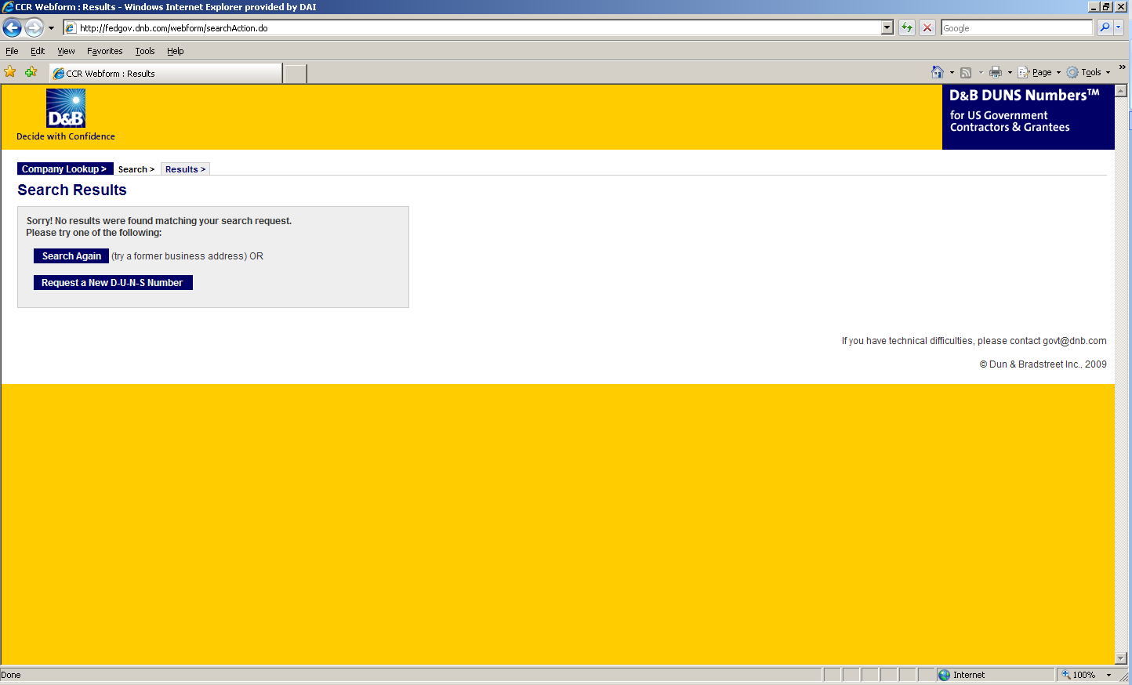

- Enter the information regarding your organization listed on the next three screens. (See screen shots below.) Make sure you have the following information available (in English) prior to beginning the process of entering this section in order to ensure successful registration.

- Legal Business Name (commas are allowed, periods are not allowed)
- Address
- Phone
- Name of Owner/Executive
- Total Number of Employees
- Annual Sales or Revenue (US Dollar equivalent)
- Description of Operations

- Note that some fields are Optional, however all other fields must be completed to proceed further with the application process. For example, all applicants must complete the Organization Information sections. The Company Name and Physical Address fields are self-populated based on information previously entered during the initial DUNS search. The question marks to the left of the field provide additional information when you click on them.
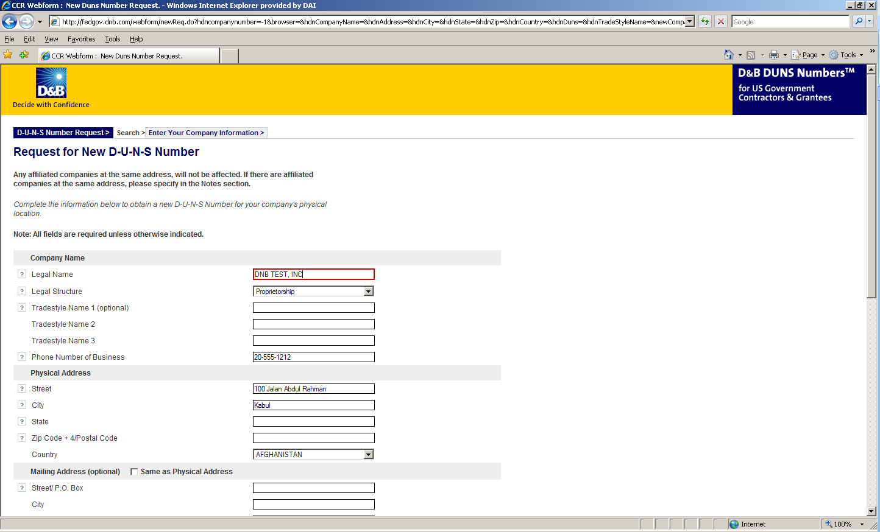

- You must select the legal structure of your organization from the pull down menu. To assist you in selecting the appropriate structure that best represents your organization, a brief description of the various types follows:

- Corporation – A firm that meets certain legal requirements to be chartered by the state/province in which it is headquartered by the filing of articles of incorporation. A corporation is considered by law to be an entity separate and distinct from its owners. It can be taxed; it can be sued; it can enter into contractual agreements.
- Government - central, province/state, district, municipal and other U.S. or local government entities. Includes universities, schools and vocational centers owned and operated by the government.
- Limited Liability Company (LLC) - This is a type of business ownership combining several features of corporation and partnership structures. It is designed to provide the limited liability features of a corporation and the tax efficiencies and operational flexibility of a partnership. Its owners have limited personal liability for the LLC’s debts and obligations, similar to the status of shareholders in a corporation. If your firm is an LLC, this will be noted on the organizations registration and licensing documents.
- Non-profit - An entity which exists for charitable reasons and is not conducted or maintained for the purpose of making a profit. Any money earned must be retained by the organization, and used for its own expenses, operations, and programs. Most organizations which are registered in the host country as a non-governmental organization (NGO) rather than as a commercial business are anon-profit entities.
Community based organizations, trade associations, community development councils, and similar entities which are not organized as a profit making organization should select this status, even if your organization is not registered formally in country as an NGO.
- Partnership- a legal form of operation in which two or more individuals carry on a continuing business for profit as co-owners. The profits and losses are shared proportionally.
- Proprietorship-These firms are owned by one person, usually the individual who has day-to-day responsibility for running the business. Sole proprietors own all the assets of the business and the profits generated by it.

- One of the most important fields that must be filled in is the Primary SIC code field. (See screen shot below.) The Primary Standard Industrial Code classifies the business’ most relevant industry and function.
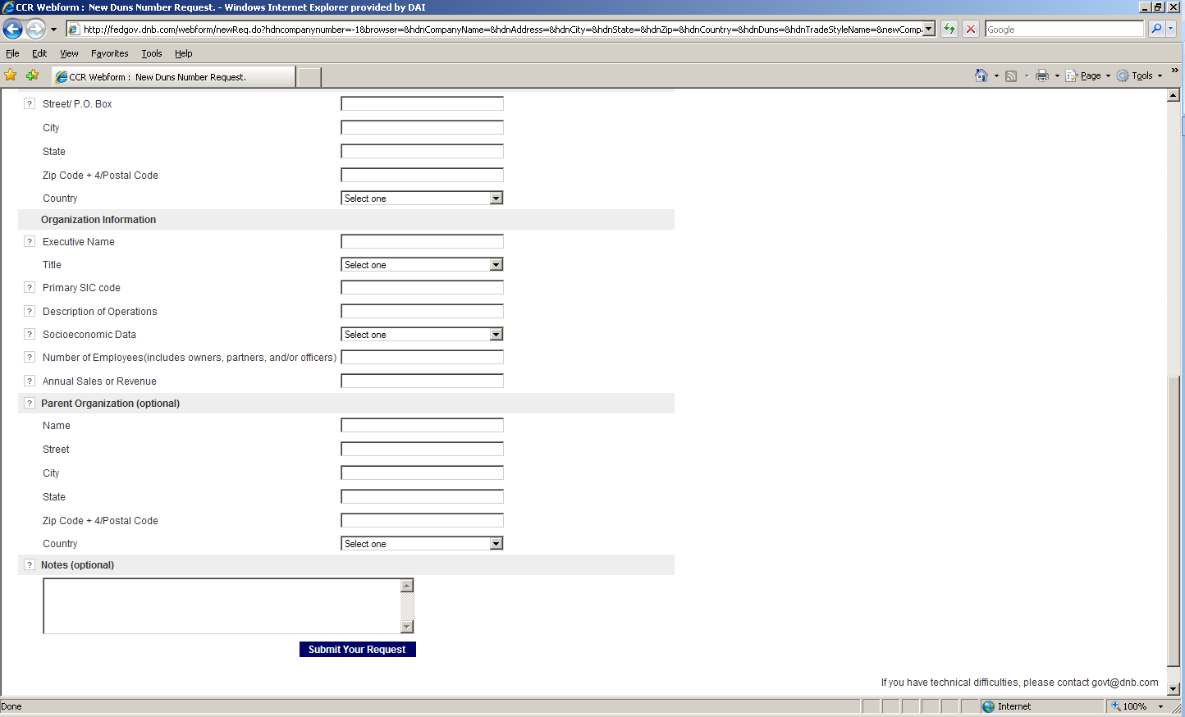
- If you are unsure of which SIC Code your organization’s core business falls under, please refer to the following website: http://www.osha.gov/oshstats/sicser.html
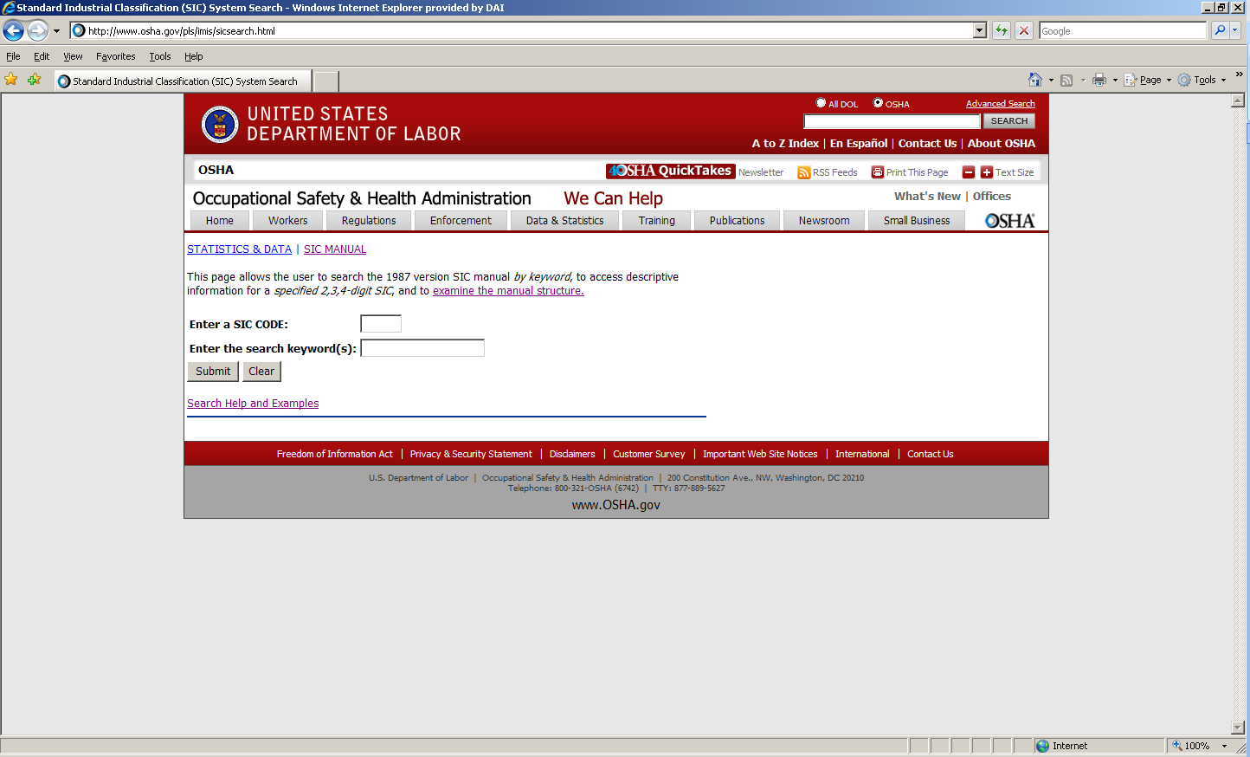

You will need to enter certain keywords to bring up the potential SIC Codes. In the case above, “Research” was entered as the keyword, and resulted in the following:
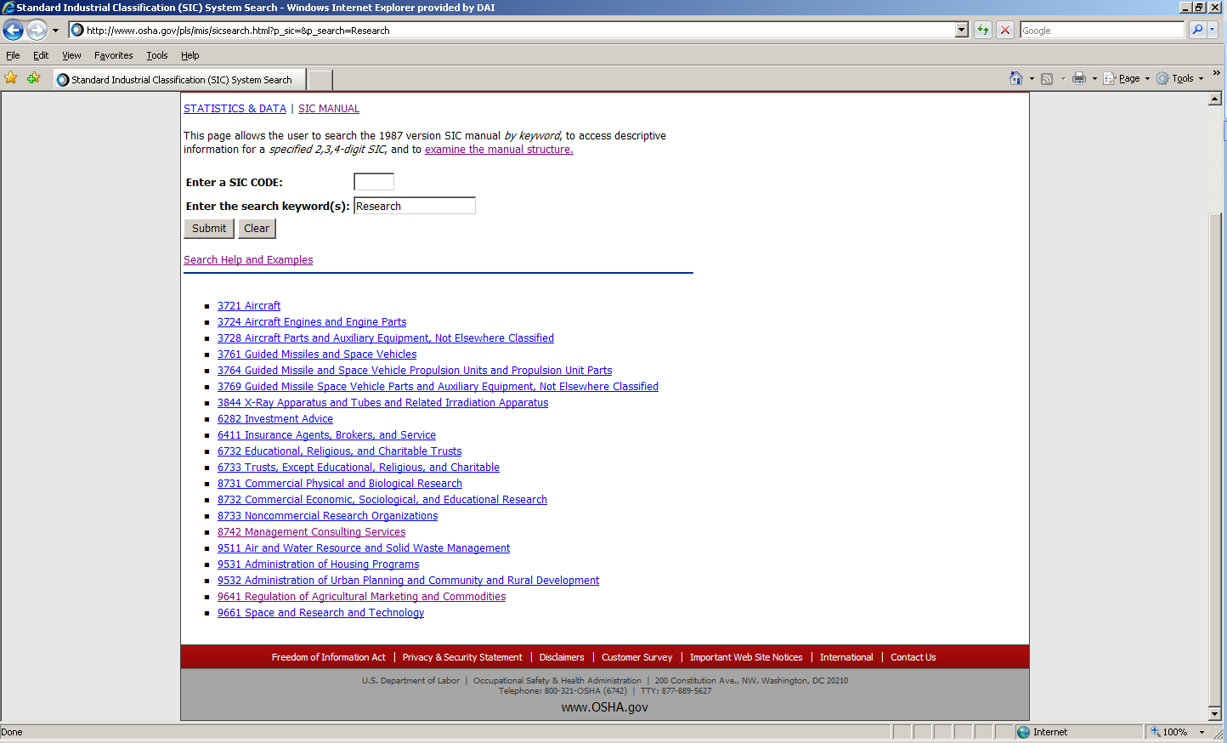

PLEASE NOTE: Many of the DAI subcontractors and grantees fall under one of the following SIC codes:
8742 Management Consulting Services
1542 General Contractors-Nonresidential Buildings, Other than Industrial Buildings and Warehouses or one of the codes within:
Industry Group 357: Computer And Office Equipment
Industry Group 355: Special Industry Machinery, Except Metalworking
Industry Group 356: General Industrial Machinery And Equipment
Industry Group 359: Miscellaneous Industrial And Commercial

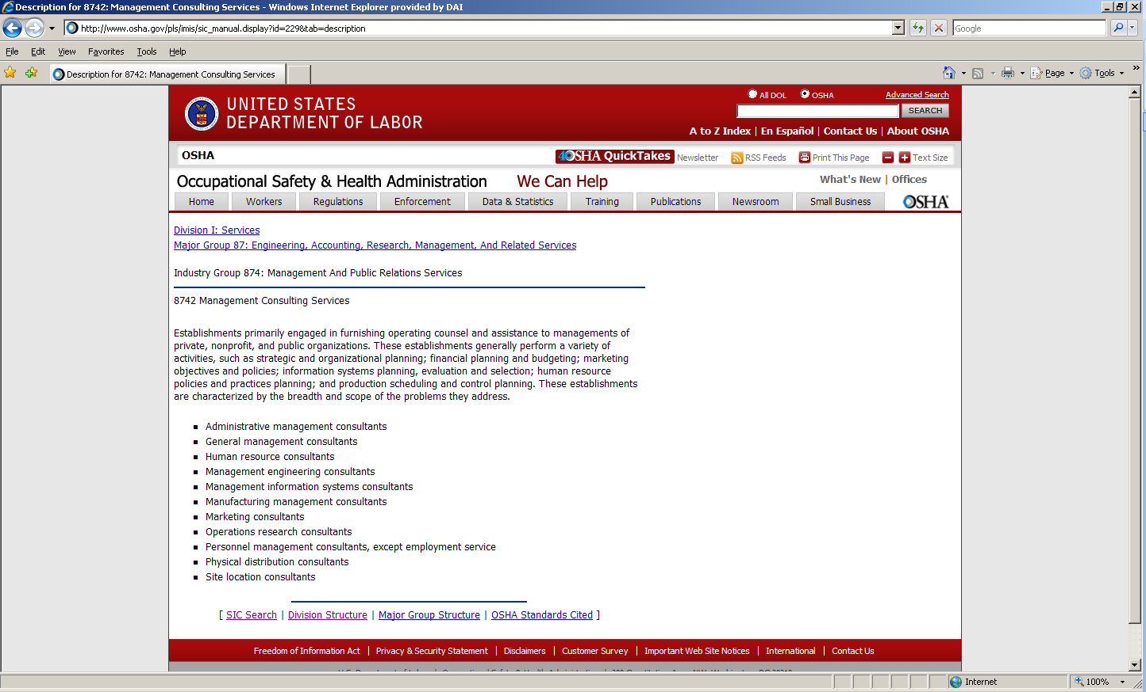

- Description of Operations- Enter a brief description of the primary services you provide the example below, “agricultural technical assistance” was chosen as the primary function of the business.
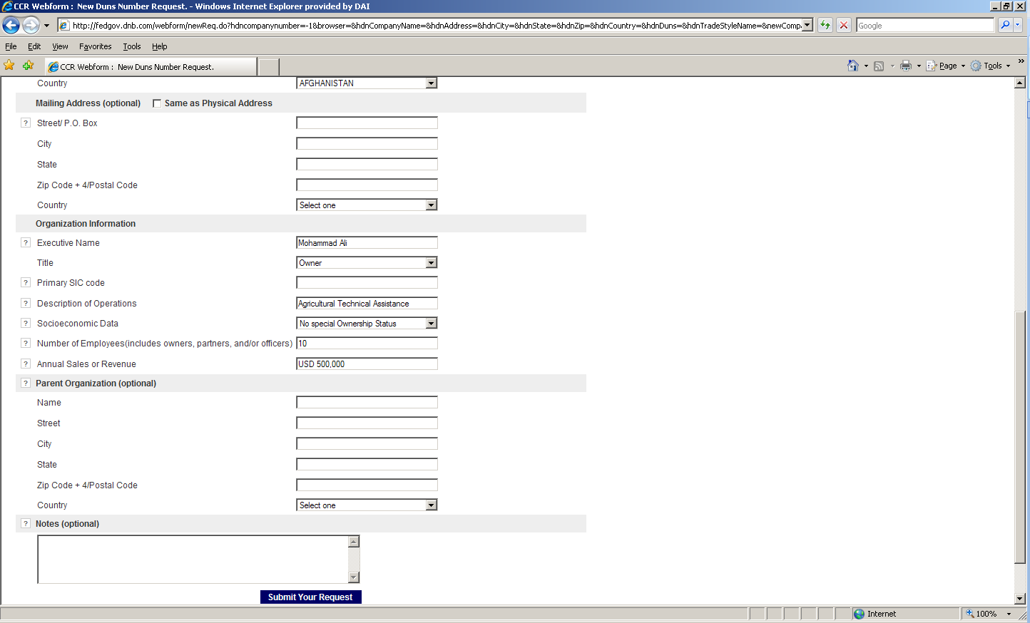

- The Annual Sales or Revenue figure should be provided in USD (US Dollar) equivalent.
- Once all of the fields have been completed, click on “Submit Your Request” to be taken to the Verification page.
- Note: Representative (Principal, Owner or Officer) needs to verify and provide affirmation regarding the accuracy of the data under criminal or civil penalties as per Title 18, Section 1001 of the US Criminal Code.
- Once “Yes, Continue” button is clicked, the registration application is sent to D&B, and a DUNS number should be available within 24-48 hours. DUNS database can be checked in 24-48 hours by entering the Business Information in the Search window – which should now display a valid result with the new DUNS number for the entity.
