Reference # PR-AFG-KBL-2019-03
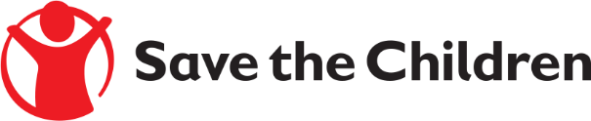
Tender Notice

Save the Children believes every child deserves a future. In Afghanistan and around the world, we give children a healthy start in life, the opportunity to learn and protection from harm. We do whatever it takes for children – every day and in times of crisis – transforming their lives and the future we share.

Save the Children International in Afghanistan is inviting submissions of tenders for 2 years (FWA) Frame Work Agreement fixed Price under reference # PR-AFG-KBL-2019-03 to provide the following products:

- Student kits for Grades 1 to 9
- Teacher Kit, Classroom Kit
- Classroom Kit
- Playing Kits (Pre-school)
- Normal hygiene kit

Detailed technical specifications are included within the tender documents.
If you are interested in submitting a bid, please contact Abdul Ahad Monib at the following address AFG.Tenders@savethechildren.org to express your interest and request the tender documents. Tender documents will be sent to you by return. OR
If you are interested in submitting a bid, please collect the tender documents from the following location:

Afghanistan Country, House #586, Street # 05, Qalai Fatullah, Kabul Afghanistan

It is recommended to request / collect the tender documents as soon as possible. Completed tender documents are due to be submitted by Dec 4, 2019 before 3:00 PM Afghanistan time
Please mention Tender Reference# in the subject line as PR-AFG-KBL-2019-003-Educational kits and tender document will not be accepted after the closing date.

