Date: 01-December-2019
ITT Ref: PR-AFG-KBL-2019-1757, 2059 and FYB-879
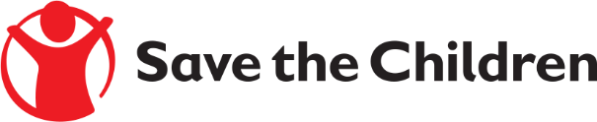
Tender Notice

Save the Children believes every child deserves a future. In Afghanistan and around the world, we give children a healthy start in life, the opportunity to learn and protection from harm. We do whatever it takes for children – every day and in times of crisis – transforming their lives and the future we share.

Save the Children International in Afghanistan is inviting submissions of tenders for two years (FWA) Frame Work Agreement fixed Price under ITT Ref: PR-AFG-KBL-2019-1757, 2059 and FYB-879 to provide the following products:

- Kitchen Kits
- Household Kit
- Shelter repairing tools kit
- Individual Items
- Hygiene kit
- Other NFI Kit

Detailed technical specifications are included within the tender documents.
If you are interested in submitting a bid, please contact Afghanistan Supply chain Department at the following address AFG.Tenders@savethechildren.org to express your interest and request the tender documents. Tender documents will be sent to you by return. OR
If you are interested in submitting a bid, please collect the tender documents from the following location:

Afghanistan Country, House #586, Street # 05, Qalai Fatullah, Kabul Afghanistan

It is recommended to request / collect the tender documents as soon as possible. Completed tender documents are due to be submitted by Dec 31 2019 before 3:00 PM Afghanistan time
Please mention Tender Reference # in the subject line as PR-AFG-KBL-2019-1757-2059 and FYB-879, (NFI Kits) and tender document will not be accepted after the closing date.

