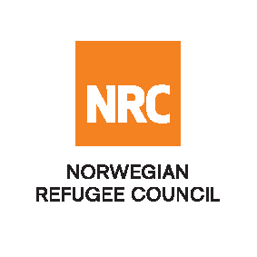

INVITATION TO OPEN TENDER

Supply and Delivery of Fuel

Reference Number: NRC-SO-2019-019

The Norwegian Refugee Council (NRC) would like to invite competent suppliers for supplying and delivery of fuel for NRC Vehicles and Generators.

NRC will be looking into signing a 1-year framework agreement with the successful bidder.

Required Service
Contract Name: | Location: | ITB Reference Number: | Deadline for Submission
Supply and Delivery of Fuel for NRC Vehicles and Generators | Kabul | NRC-SO-2019-019 | Sunday 17th December 11:00 Hrs.

Essential criteria for bidders:
Interested suppliers should have previous experience in supplying and delivery of fuel and should be able to demonstrate this in their tender application.

Collection of tender documents:
Prospective national bidders may download tender documents from ACBAR Website or could send an E-mail to af.procurement@nrc.no to receive:

Delivery of tender bids should be addressed to:

Norwegian Refugee Council (NRC) Kabul
3rd street of Qale-Fatullah, District #10, Kabul, Kabul Province, AFGHANISTAN

Questions related to office location/direction should be enquired through telephone number: 0728932799

Submission of Bids:
Bids must be delivered in a sealed envelope before the deadline on Tuesday 17th December 2019 at 11:00am
NRC reserves the right to select/reject without any explanation, any bids, in part or full, as it may deem necessary. No liability or claim in that respect would be admissible or entertained whatsoever.

