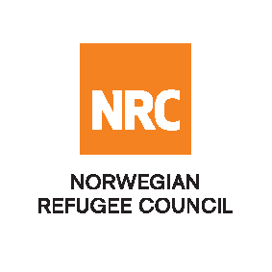
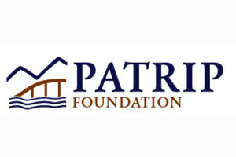

REQUEST FOR PROPOSAL

Architectural Design of School Construction and WASH facilities

The Norwegian Refugee Council (NRC) would like to invite competent service providers to submit proposals/bids for architectural design of school construction and WASH facilities located in Khost and Kunar Provinces in Afghanistan funded by PATRIP Foundation.

Required Service
Contract Name:  Provision of architectural design of school construction and WASH facilities | Location:  Khost and Kunar Provinces in Afghanistan | Reference Number:  NRC-SO-2019-018

Essential criteria for bidders:
Interested bidders should have previous experience in architectural design in similar projects are encouraged to submit their proposals or bid. For more information, please refer to the terms of reference (ToR) for this service

Submission of proposals/bids:
Bids must be delivered in a sealed envelope before the deadline of 16:00 Hrs Afghanistan time on 17th December 2019.

A pre-bid meeting (Clarification Meeting) will be held on 11st December 2019 at 11:00am in the office of NRC Kabul. During the pre-bid meeting requirements of the bid will be presented to interested companies and clarifications can be requested by bidders.
Norwegian Refugee Council (NRC) Kabul
3rd Street of Qale-Fatullah
PD 10, Kabul, Afghanistan

NRC reserves the right to select/reject without any explanation, any bids, in part or full, as it may deem necessary. No liability or claim in that respect would be admissible or entertained whatsoever.

