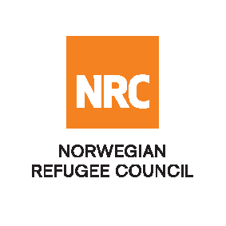

INVITATION TO OPEN TENDER

INVITATION TO TENDER FOR PROVISION OF RENTAL VEHICLE

Reference Number: NRC-KDR-2020-001

The Norwegian Refugee Council (NRC) would like to invite competent bidders to submit bids for Provision of Rental Vehicles

NRC will be looking into signing a fixed rate and 2-year framework agreement with the successful bidder

Required Service
Contract Name: | Location | ITB Reference Number: | Deadline for Submission
Provision of Rental Vehicle | Kandahar | NRC-KDR-2020-001 | Tuesday 21 Jan 2020 04:00 Hrs.

Essential criteria for bidders:
Interested suppliers should have previous experience in Provision of Rental Vehicle, and should be able to demonstrate this in their tender application.

Collection of tender documents:
Prospective national bidders may download tender documents from ACBAR Website:

Delivery of tender bids should be addressed to:

Norwegian Refugee Council (NRC) Kandahar

House No 37, Block 12, District #1,
Close to Mirwais Hospital Shari Naw

Prospective national companies, may send tender related questions on the following e-mail address:
af.procurement@nrc.no

Questions related to office location/direction should be enquired through telephone number: 0728932376

Submission of Bids:
Bids must be delivered in a sealed envelope before the deadline specified above.
NRC reserves the right to select/reject without any explanation, any bids, in part or full, as it may deem necessary. No liability or claim in that respect would be admissible or entertained whatsoever.

