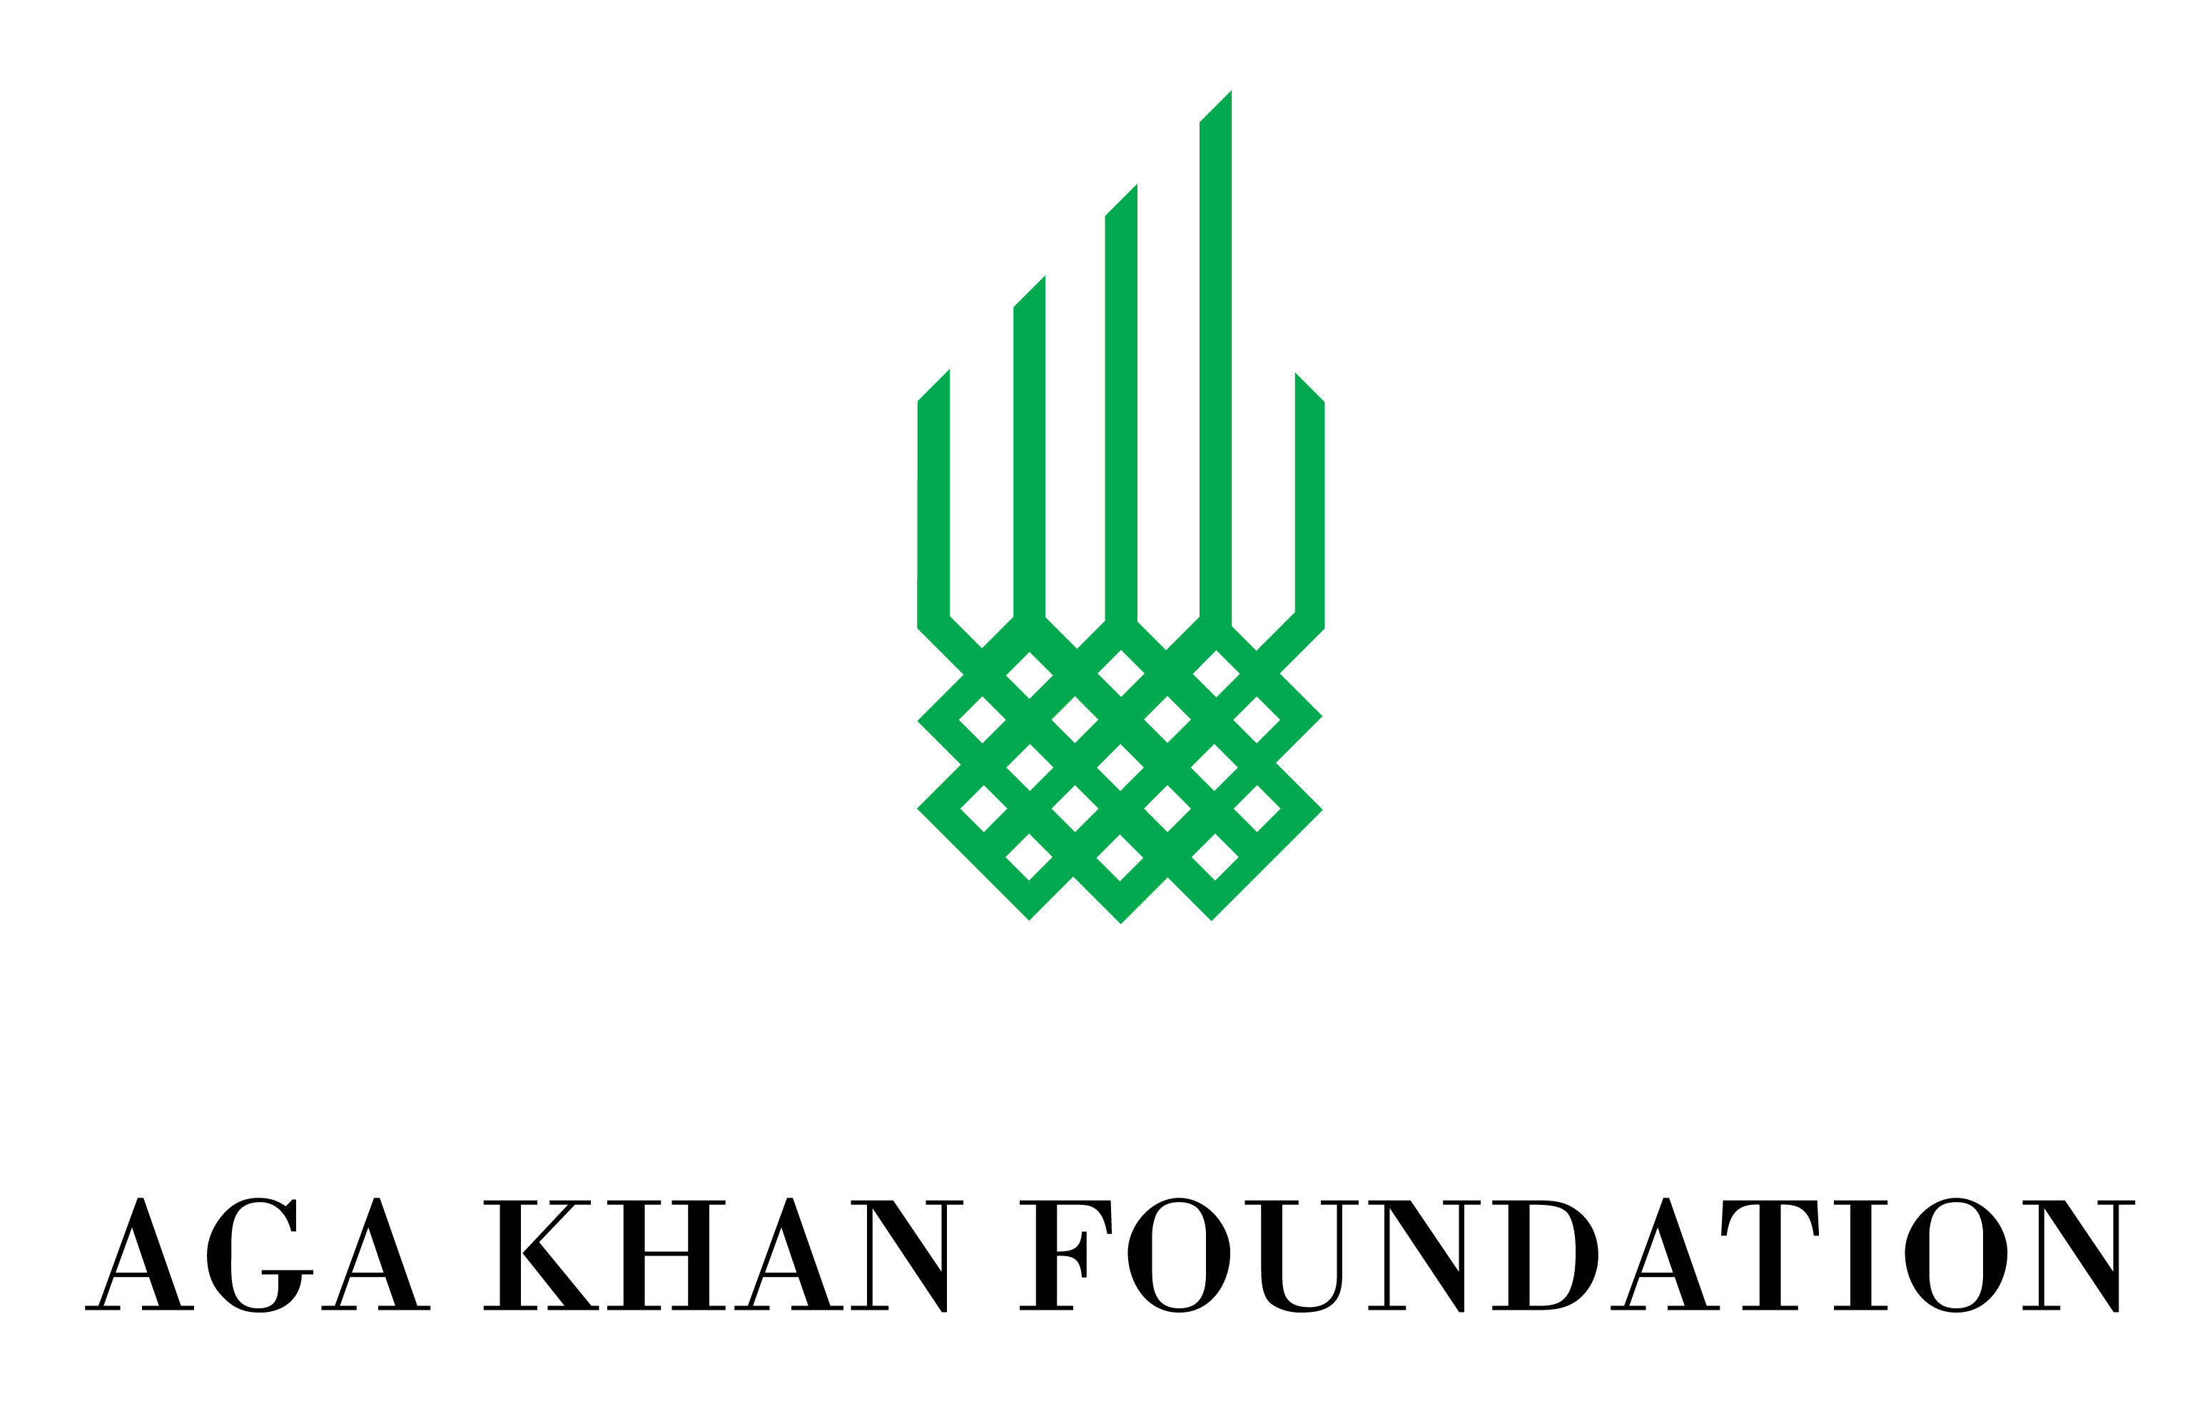
Request for Expressions of Interest:
Health Action Plan for Afghanistan (HAPA)Endline Study

- INTRODUCTION & BACKGROUND
The Health Action Plan for Afghanistan (HAPA) of the Aga Khan Development Network (AKDN) is a comprehensive multi-input project that is advancing the health of women and men, girls and boys by improving the quality of available services, strengthening health human resources, and engaging communities to support healthy practices. It is active in the provinces of Badakhshan, Baghlan, and Bamyan, and places particular emphasis on maternal, newborn, and child health (MNCH). The program is funded by the Government of Canada, Agence Française de Développement, and Aga Khan Foundation Canada (AKFC). HAPA is implemented through agencies under the AKDN, including Aga Khan Foundation Afghanistan (AKF,A), Aga Khan Health Services Afghanistan (AKHS,A), Academic Program in Afghanistan-Aga Khan University (APA-AKU), Aga Khan Agency for Habitat (AKHA), the French Medical Institute for Children (FMIC), La Chaîne de l’Espoir (CDE) and AKFC.
HAPA is in its last year of operation and is planning an endline study (study framework outlined below). AKFA is seeking Expressions of Interest from skilled and experienced firms/consultants to conduct the study between March and September 2020.

- HAPA SCOPE
HAPA is a CAD $75.22 million project that supports health system strengthening at the national and regional levels and access to services and promotes healthy practices at the community level. At the national level, HAPA (1) strengthens the capacity of the Government of Afghanistan Ministry of Public Health (MoPH), Ghazanfar Institute of Health Sciences (GIHS) and Kabul national hospitals, (2) supports the Post-Graduate Medical Education (PGME) program at the French Medical Institute for Mothers and Children (FMIC), and (3) supports the Children’s House in Kabul, which helps children from remote areas of Afghanistan access specialized services at FMIC. At the provincial level in Bamyan, Baghlan, and Badakhshan, HAPA (1) supports improvements in critical health infrastructure through renovations, (2) strengthens programs that produce qualified health professionals, focusing on nurses and midwives, (3) carries out community-level campaigns to improve healthy behaviours, (4) improves the gender-responsiveness of health services, health professionals, and health-related messaging, and (5) supports sustainable community-based programs that enhance the food security and nutritional status of targeted areas.

Under HAPA, AKDN also uses innovative approaches to creating greater access to health services, including eHealth and supporting cross-border services in Badakhshan, between Tajikistan and northern Afghanistan.

HAPA complements and supports the primary care and hospital services provided by AKDN in partnership with the provincial governments in Badakhshan and Bamyan (Sehatmandi), and through an agreement with the basic package of health services (BPHS) implementer in Baghlan.

HAPA is fully aligned with the Government of Afghanistan’s policies and priorities on water, sanitation, and hygiene (WASH) and nutrition and directly contributes to the achievement of international and national goals for gender equality and the health of women and children, in line with the Government of Afghanistan’s policies and donor priorities.

A total of 166 facilities in 37 districts in the three provinces are specifically targeted. The project directly benefits 1,264,022 people, including 495,598 women, 525,732 men, 123,773 girls and 118,919 boys (below five years of age). More than 3,700 intermediary beneficiaries have been offered training and skills development, including health workers at target facilities, as well as staff of government departments and educational institutions.

- PURPOSE OF MANDATE
The Consultants/Firm would design and oversee the overall study, including sampling, development of tools, data collection and quality control, coding/analysis and report writing.

- STUDY OBJECTIVES
There are two main objectives of the study:
- To explore the effectiveness, impact, gender responsiveness and sustainability of key areas of focus of HAPA, including:
  - Quality of MNCH service delivery
  - Access to MNCH services
  - Health promotion
  - Food security
  - Local governance and accountability
- To provide findings, conclusions and recommendations for the Ministry of Public Health, AKDN and other stakeholders to help inform and strengthen future MNCH interventions and programming.

- STUDY FRAMEWORK
The study is based on the framework outlined in Table 1 below. Key questions, sub-questions and proposed methodologies have been identified.

Table 1. HAPA Endline Study Framework
 | Key Questions | Sub-Questions | Methodologies
1. | How has HAPA affected the quality of health service delivery in project areas? | - How has HAPA affected heath human resource knowledge and availability?  - How has HAPA affected the quality of the local health systems in target districts?  - How has HAPA affected the national health system?  - Are the results of HAPA interventions sustainable, beyond the life of the project?  - Do secondary data sources show changes in health outcomes? In use of services, particularly in HAPA project areas? | - Review of secondary data health facility and Health Management Information System data  - FGDs with male and female community members  - KIIs and IDIs with local and national government
2. | Do the specific participants of the HAPA health promotion strategy interventions report any changes in knowledge, attitudes and behaviours? | - Who has been targeted by HAPA health promotion interventions? How do they report change, if any?  - How effective is targeting groups e.g. FHAG, parents group, SSAs, compared to individuals for health promotion?  - Have community perceptions around SRH, particularly related to gender equality, SGBV, women’s leadership, mobility, participation etc. changed? | - Document review  - FGDs with male and female community members and CSOs
3. | Has HAPA addressed the various barriers to access, particularly for women, to health care services? How? | - Do community members, especially women and adolescent girls, feel their barriers to accessing health services have been reduced?  - Do women feel that they have greater access to female health professionals in HAPA target areas?  - Are the results of HAPA’s interventions in addressing access sustainable? | - FGDs with male and female community members and CSOs  - Review of secondary data, particularly HMIS data
4. | Has HAPA expanded access to nutritious foods, enhancing food security? How? | - How do men and women perceive the nutritious crops, fruits, and vegetables introduced to the areas that were non existent before?  - What are men’s and women’s knowledge attitudes, beliefs and practices related to balanced and nutritious diets? | - FGDs with male and female Farmer Field Schools participants  - KIIs and IDIs with government stakeholders
5. | Have the social audits and citizen report cards been effective in improving the quality of health service delivery? | - Do men and women in community groups who have used social audits or citizen report cards feel that this intervention has resulted in improved quality of care? How? How is this different for men and women?  - What have been the gender responsive health service delivery issues identified in the social audits and citizen report cards? How have these been addressed, if at all?  - Are the results of the social audits and citizen reports cards sustainable beyond the life of HAPA? | - FGDs with male and female community members and community organizations  - Secondary review of other studies

- KEY ACTIVITIES AND DELIVERABLES
The key activities and deliverables expected from the Consultants/Firm for this assignment are as follows:
- Review all relevant documents, studies and other data sources related to HAPA
- A detailed study plan/inception report and work plan is to be produced including the following elements:
  - Study design and methodology, including all data collection tools
  - Sampling strategy, including selection criteria
  - Data collection activities and approach, including quality control measures
  - Detailed work plan that includes all tasks by the Consultants/Firm (and all team members).
  - Level of effort of each team member
  - Ethical and gender responsive considerations
  - Acknowledgement of security related issues and risk mitigation measures
  - Detailed study budget including professional fees, expected reimbursables, etc.
  - Tools for data collection and plan for translation and/or back translation
- Finalization of data collection tools following the review and piloting of tools
- Orientation with AKFA and other AKDN implementing agencies through inception meetings
- Facilitator guidelines and protocols for data collection developed
- Coordinate/Conduct facilitator training following a detailed agenda and outlining study protocols
- Oversee/monitor collection of data including supervision of field activities and ensure quality control measures are implemented
- Provide updates to AKF on field work challenges and progress
- Oversee translation and transcription of data
- Oversee data protectin/security (i.e. maintaining confidentiality through data security measures)
- Oversee analysis/Analyze data
- Facilitate internal and external data interpretation workshops with AKDN agencies and government and other stakeholders
- Develop draft and final endline study reports to be submitted in both Word and PDF versions with all annexes. A suggested Table of Contents (ToC) will be provided by AKF.
- Share all raw data files including audio recordings in password protected files/storage.
- Summarize results for external audiences after finalization of the report
- Copies of original and cleaned data sets including any field notes are to be submitted to AKF with the draft report.

- TIME FRAME
The period of the contract will be from March 27, 2020 to September 25, 2020. The expected timeframe is outlined in Table 2 below.

Table 2. HAPA Endline Study Timeframe
TASK/OUTPUT | EXPECTED TIME FRAME
Document Review and Literature Review
Inception Meeting | 27 March 2020
Develop draft Inception Report/Study Plan | 10 April 2020
Final Study Plan following comments from all relevant stakeholders | 24 April 2020
Submit Protocol for ethical approval | 24 April 2020
Develop recruitment guidance for facilitators and note takers | 24 April 2020
Preparation for Data Collection including facilitator and note taker guidelines and templates | 15 May 2020
Recruit and train data collectors/facilitators | 29 May -12 June, 2020
Recruit transcribers/translators | 29 May 2020
Pilot and adapt tools | 15-19 June 2020
Data Collection | 21 June – 31 July 2020
Coding/Analysis | 2-14 Aug 2020
Draft End Line Study Report | 21 Aug 2020
Internal data interpretation with AKDN stakeholders | 28 Aug 2020
External data interpretation with government and other stakeholders | 4 Sept 2020
Incorporate feedback and comments of organization and submit Final Report, including summary materials to share with stakeholders | 25 Sept 2020

- QUALIFICATIONS OF CONSULTANTS/FIRM
- Minimum of 10 years of experience in administering studies, training qualitative facilitators, collecting and analysing qualitative data and producing quality study reports, preferably for international non-profit organizations or multilateral agencies.
- Excellent facilitation skills and ability to recruit and manage facilitators for qualitative studies.
- Experience conducting studies and evaluations in Afghanistan.
- Knowledge and experience in gender responsive methods and ethical considerations in studies, as well as conducting studies on gender equality issues.
- Knowledge and experience with maternal, neonatal, child health issues in Afghanistan.
- Fluency in English is mandatory and Dari an asset.
- Ability to produce high quality work under tight timeframes.

- EXPRESSION OF INTEREST REQUIREMENTS
Qualified and interested parties are asked to submit a letter of interest (max. 4 pages) expressing the following:
- Consulting Firm profile (if applicable).
- An overview of relevant skills and experience that the firm/consultants have for the assignment.
- A brief description of the proposed approach for the study, including data collection methodology and overall management mechanism.
- Names and contact information of two previous clients who can be contacted regarding relevant experience.

Consultants are also expected to disclose any conflict of interest related to this mandate with AKF.

Short-listed applicants will be contacted to develop full technical and financial proposals for the assignment.

Expressions of Interest (EOI) should be submitted only electronically to: jobs.afghanistan@akdn.org with the subject line of: ‘HAPA Endline Study EOI’

Closing date for submission of the EOI is end of business day on 27 Feb 2020.

Questions related to aspects of this assignment will be accepted before 25 Feb 2020 and should be directed to Dr. Rahim Azami at rahim.azami@akdn.org

- DISCLOSURE OF INFORMATION
Include disclosure of information as well as noting that consultant should disclose any potential conflict of interest.
It is understood and agreed that the Consultant(s) shall, during and after the effective period of the contract, treat as confidential and not divulge, unless authorized in writing by AKF, any information obtained in the course of the performance of the Contract. Information will be made available for the consultants on a need-to-know basis. Any necessary field visits will be facilitated by AKF. The selected consultant will commit to respect AKF Policies.
- Gender Equality Policy, Inclusion and Safeguarding
AKF is committed to advancing gender equality and inclusion through our programming and operations. AKF requires all consultants to review and abide by the AKF Gender Equality Policy. All projects should use gender sensitive approaches and integrate relevant gender equality information. A copy of the Policy will be provided to the selected applicant.
AKF recognizes the importance of safeguarding and is committed to ensuring it manages a wide range of risks such that beneficiaries, staff, other associates and the organization as a whole are kept safe from harm.

FGDs: Focus Group Discussions; KIIs: Key Informant Interviews; IDIs: In-Depth Interviews
Distance, cost, gender and social norms
Timelines will need to be coordinated with AKF country office.
Prior to the inception meeting all relevant project documents will be provided to the successful candidate.
All deliverables under this consultancy will be reviewed and approved by AKFA and AKFC
including previous involvement in the project and/or relationship with a staff member/Board member

