Synopsis of the Request for Quotation
DAI, implementer of the USAID-funded RADP-E Project invites qualified vendors to submit quotations for the provision of Veterinary Lab basic testing equipment.
- RFQ No. | RFQ-RADP-E-KBL-20-0016
- Issue Date | June 23, 2020
- Title | Provision of Dairy Processing Equipment.
- Issuing Office & Email/Physical Address for Submission of Quotes | RADP-E procurement  Submit electronic copy to:  ProcurementRADP_East_Inbox@dai.com  Or hard copy (sealed envelope) to RADP-E office  Darya Village, Hawashenasy road, Khwaja Rawash Kabul.
- Deadline for Receipt of Quotes. | July 09, 2020 04:00PM (Local Time-Kabul)
- Point of Contact | ProcurementRADP_East@dai.com  Note: Questions/comments regarding the RFQ should be submitted to this email ONLY by the due date/time specified in section 10. Please see section 10 for details. Questions/comments submitted to other emails (unless specified otherwise) may not be entertained.
- Anticipated Award Type | Fixed unite price purchase order (FUPPO)  An award resulting from this RFQ is anticipated to be a fixed unit price purchase order.  The anticipated specific terms and conditions are as follows:  Payment will be made by bank wire transfer to the company’s Bank Account, after complete supply and delivery to the specified location, and confirmation by the relevant RADP-E staff member and grantee. Issuance of this RFQ in no way obligates DAI to award a subcontract or purchase order and bidders will not be reimbursed for any costs associated with the preparation of their bid.  Government Withholding Tax for Afghan Based Companies  Pursuant to Article 72 in the Afghanistan Tax Law, effective March 21, 2009, DAI is required to withhold "contractor" taxes from the gross amounts payable to all Afghan for-profit subcontractors/vendors. In accordance with this requirement, DAI shall withhold two percent (2%) tax from all gross invoices to Afghan subcontractors/vendors under this Agreement with active AISA or Ministry of Commerce license. For subcontractors/vendors without an active AISA or Ministry of Commerce license, DAI shall withhold seven percent (7%) "Contractor" taxes per current Afghanistan Tax Law. Before signing the purchase order, the vendor will provide a copy of the organization's AISA or Ministry of Commerce license and TIN (Tax Identification Number). Amounts deducted from the invoices will be forwarded to the Ministry of Finance (MoF) Tax Division credited to the firm's TIN. Records of payments to the MOF shall be maintained on file with DAI.
- Basis for Award | An award will be made to the responsible bidder whose bid is responsive to the terms of the RFQ and is most advantageous to DAI, considering best value and/or other factors included in the RFQ. To be considered for award, bidders must meet the requirements identified in Section 12, “Determination of Responsibility”. No discussions or negotiations will be conducted with bidders, and therefore bidders shall submit their best and final price.

Request for Quotation
- General Instructions to Bidders | - Final quotations are due by 04:00 pm local time Kabul on (July 09, 2020). Late offers will be rejected except under extraordinary circumstances at DAI’s discretion.  - Quotation validity date is 90 days from the date of submission  Bidders shall submit quotations via email to ProcurementRADP_East_Inbox@dai.com with the RFQ number in the subject line. Or hard copy (sealed envelope) to RADP-E office  - Hawa Shenasy, Road Darya Village Hotel and Business Park, Khowaja Rawash, Kabul.  - Bidders shall confirm in writing that the Bidder fully understands the terms and conditions of the RFQ.  - Bidders shall complete Attachment A: Price Schedule and submit any other required attachments.  - Bidders shall sign, date, and stamp the Price Schedule, in lieu of a formal cover letter  - All prices shall be quoted in US$, however the vendor will be paid in AFN by the daily exchange rate of the day of the payment.  - The rates quoted shall be for complete service or goods, inclusive of all taxes and all charges for service contingent to the work.  - DAI has the right to decrease or increase the goods and services mentioned in this RFQ  - Bidder must have at least similar past performance or relevant experience providing the same service/goods.  - Bidder should fill out Attachment A, B and D.  - In addition, the bidder is responsible to provide the operation manual for the proposed machine at the time of delivery.  - The requested machines must have, brand, model and serial number.  - Vendor should provide full address of the manufacturer and machine Origin.  - Incomplete bid will be automatically disqualifying from the bidding process.  - Bidder should submit document requested in Attachment D.  - Its bidder responsibility to deliver, install the requested equipment in Street 64, House Ex-Livestock Building, District 1, Mehtarlam City, Laghman Province. It should be noted that the payment will be processed after installation with a positive result.
- Questions Regarding the RFQ | Questions are due no later than 3:00 PM local time Kabul on June 30, 2020. Each Bidder is responsible for reading very carefully and understanding fully the terms and conditions of this RFQ. All communications regarding this solicitation are to be made solely through the Issuing Office and must be submitted via email to the Issuing Office no later than the date specified above. All questions received will be compiled and answered in writing and will be posted on ACBAR website.
- Technical Specifications and requirements for Technical Acceptability | - Bidder’s must have similar past performance/relevant in-country experience providing the same service.  - Bidders must have documented ability to meet the required Service.  - The bidder is responsible to provide original and branded Veterinary Lab basic testing equipment mentioned in the RFQ to RADP-E  - Bidder is responsible to deliver the requested equipment to the following address:  Street 64, House Ex-Livestock Building, District 1, Mehtarlam City, Laghman Province.  - The bidders are responsible to provide in writing warranty assurance for the quoted machines,  - bidder is responsible to provide new and branded equipment mentioned above according to the name, specs given in attachment A of this RFQ if not matched will be rejected and will not be paid, and its bidder responsibility to replace the mentioned machines ASAP.  - Bidder must have the capability to deliver the requested Veterinary Lab basic testing equipment during the agreed delivery period in the purchase order.  - Its bidder responsibility to install, run and train the grantee on the requested machine after the complete delivery to the grantee location.
- Determination of Responsibility | DAI will not enter into any type of agreement with a vendor prior to ensuring the vendor’s responsibility. When assessing the vendor’s responsibility, the following factors are taken into consideration:  - Provide copies of the required business licenses to operate in the host country (such as AISA license or Ministry of Commerce business license).  - Ability to comply with required or proposed delivery or performance schedules.  - Pursuant to USAID Mission Order 201.04 (4-14.001), RADP-E is required to vet all non-US parties selected for the award of a subcontract/procurements equal to or in excess of the Afghani equivalent to USD$25,000. Please be prepared to complete and submit the PIF (see attachment) and provide all supporting documentation to the procurement unit if requested to do so. The vetting process may take up to 4 weeks to complete.  - Evidence of a DUNS number if required (explained below).  - The source, origin and nationality of the services are not from a Prohibited Country (explained below).  - Having adequate financial resources to deliver goods/Service or the ability to obtain financial resources.  - Ability to comply with required or proposed delivery or performance schedules.  - Have a satisfactory record of integrity and business ethics.  - Be qualified and eligible to perform work under applicable laws and regulations.
- Geographic Code | - Under the authorized geographic code for its contract, DAI may only procure goods and services from the following countries.  - Geographic Code 937: Goods and services from the United States, the cooperating country, and "Developing Countries" other than "Advanced Developing Countries: excluding prohibited countries. A list of the "Developing Countries" as well as "Advanced Developing Countries" can be found at http://www.usaid.gov/policy/ads/300/310maa.pdf and http://www.usaid.gov/policy/ads/300/310mab.pdf respectively.  - Geographic Code 935: Goods and services from any area or country including the cooperating country, but excluding Prohibited Countries.  - DAI must verify the source, nationality and origin, of goods and services and ensure (to the fullest extent possible) that DAI does not procure any services from prohibited countries listed by the Office of Foreign Assets Control (OFAC) as sanctioned countries. The current list of countries under comprehensive sanctions include Cuba, Iran, North Korea, Sudan, and Syria. DAI has prohibited from facilitating any transaction by a third party if that transaction would be prohibited if performed by DAI.  - By submitting a quote in response to this RFQ, Bidders confirm that they are not violating the Source and Nationality requirements and that the services comply with the Geographic Code and the exclusions for prohibited countries.
- Data Universal Numbering System (DUNS) | All U.S. and foreign organizations, which receive first-tier subcontracts / purchase orders with a value of $25,000 and above, are required to obtain a DUNS number prior to signing of the agreement. Organizations are exempt from this requirement if the gross income received from all sources in the previous tax year was under $300,000. DAI requires that Bidders sign the self-certification statement if the Bidder claims exemption for this reason.  For those required to obtain a DUNS number, you may request Attachment B: Instructions for Obtaining a DUNS Number.  For those not required to obtain a DUNS number, you may request Attachment B: Self-Certification for Exemption from DUNS Requirement
- Compliance with Terms and Conditions | Bidder shall be aware of the general terms and conditions for an award resulting from this RFQ. The selected Bidder shall comply with all Representations and Certifications of Compliance listed in Attachment
- Procurement Ethic | By submitting a Bidder, Bidders certify that they have not/will not attempt to bribe or make any payments to DAI employees in return for preference, nor have any payments with Terrorists, or groups supporting Terrorists, been attempted. Any such practice constitutes an unethical, illegal, and corrupt practice and either the Bidders or the DAI staff may report violations to the Toll-Free Ethics and Compliance Anonymous Hotline at +1 855-603-6987, via the DAI website, or via email to FPI_hotline@dai.com.

Attachment A: Price Schedule
The bidder shall prepare unit quotations for the following. Bidder should confirm the availability of the requested Veterinary Lab basic testing equipment delivery to DAI.
# | Item Description* | Unit | QTY | Unit Price (USD) | Total price (USD) | Offered Brand
1 | Milk Homogenization Unit  Specification:  - Capacity 500-1000LPH  - Triple stage homogenization  - Working pressure 200 bar  - Inflow and outflow of product is made of stainless steel  - Piston: 3 pieces 25mm diameter stork length 60mm  - Electricity power 380volts, 15kw motor capacity,  - Liquid cooling piston system  - Analogue pressure indicator  - Extra device for security of pipe line  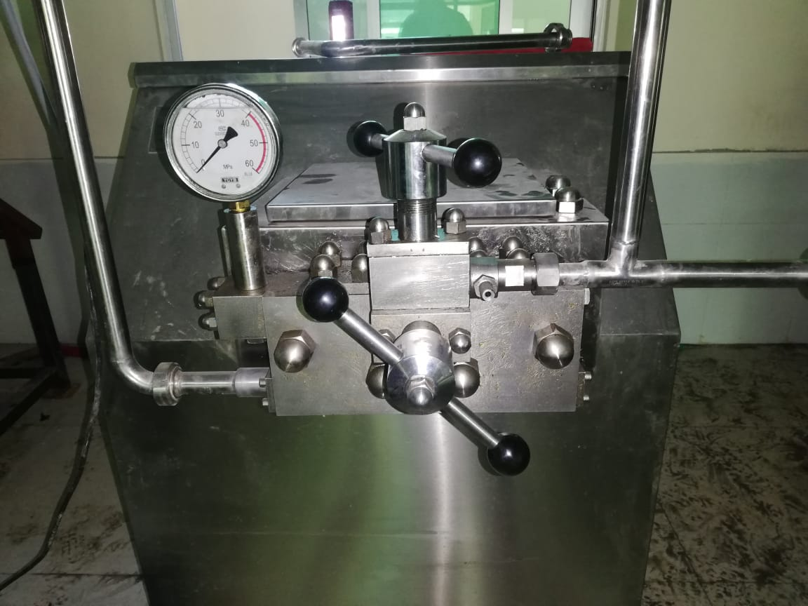 | Each | 1
2 | Two Milk Analyzer Machines:  Specifications:  - Ultrasonic technology  - Portable design  - Peristaltic pump  - Large graphic display  - Low power consumption  - Very small quantity of milk  - ESC POS printer support  - Clock (time and date)  - No. acid or other Chemical are used  - MEASURING RANGE ACCURACY Fat: 0% -  - 25% ±0.1% Solids-non-fat (SNF) 3% - 15% ±0.15%  - Density 1015 – 1160 kg/m³ ±0.3kg/m³  - Protein 2% - 7% ±0.15%  - Lactose 0,01% - 6% ±0.2%  - Solid 0,4% - 1,5% ±0.05%  - Added water 0% - 70% ±3%  - Freezing point -0,400% to -0,700°C 0,002°C  - Sample temperature 5 - 40°C ±1°C  KIT  - Milk Analyzer  - Power supply cable 220v  - Power supply adapter 1-piece  - Serial cable to PC 1-piece Sample cup  2-piece Cleaning Concentrate User’s manual  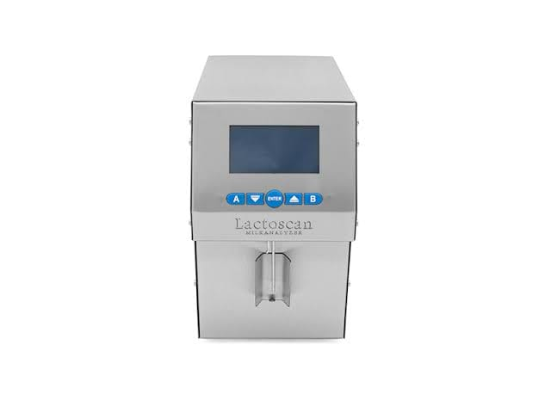 | Each | 2
3 | Butter Churn Machine  Specifications:  - Capacity 100kg  - Butter Tank Made from Stainless Steel (304)  - Gear box and frame made from M.S  - Electric power motor 2HP  - 3phase, 380v, 50Hz  - 3 Speeds gear for best churning result  - 1st gear slow churn  - 2nd gear fast churn  - 3rd gear for butter press  - Fat loss reduce to international leave .05%  - Butter press install inside tank Air tight tank lid with gas kit  - Stainless steel valve 38mm for reducing air Safety Guard  - Auto worker installed for even and Homogeneous Consistency Sight glass for observation Polish and finishing as per I.D.E. Standard  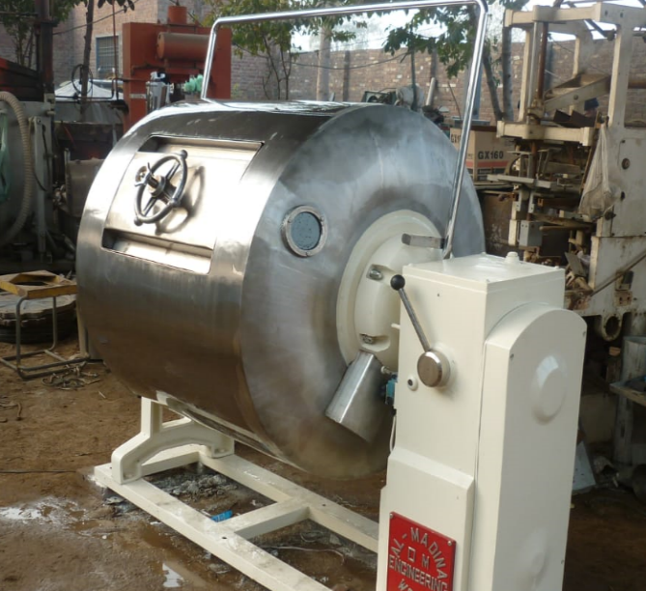 | Each | 1
4 | SS Butter Pad Machine:  Specifications:  - Semi auto butter packing machine  - Capacity 400-500 peace’s per hr.  - Packaging 250grm, 500grm, 1000grm.  - Butter tub Stainless steel inner shell thickness 2.5 mm AISI (304) L Food grade  - butter tub Stainless steel outer shell thickness 1.5 mm Installation,  - Polyurethane foam 27-38mm thickness  - stainless steel worms 2.5mm thick  - Butter Roller (Teflon)  - Butter Pad Machine M.S pipe chilling unit for maintain butter temperature during pad Refrigerant Control  - Thermostatic Expansion valve Danfoss.  - Air Cooled Condenser.  - Energy efficient statically/dynamically balanced fan motor assembly. 1.0 HP capacity –  - Hermetic Reciprocating compressor, 1 phase, 220 Volt – 50 hertz rating.  - Bristol /Copland Contactor /overload relays from MG France/Equivalent Potential relay from EU.  - Starting capacitor from FUJI.LP/HP Switch, Filter driver and sight glass from Danfoss.  - Power supply 440v, 3 phase, 50Hz Capacity:  - make 10 pads of same size and weight at a time stainless steel cutting wires for easy cutting of pads two auto worms for squeezing of butter Gear Box slow speed,  - M.S Material (Made in Al-Madina Engg.) Stainless steel Cubical housing for the Cooling machine for protection.  - Maintain butter Fat 85% Electric control panel emergency switch Stainless Steel Name Plate (manufacturer)  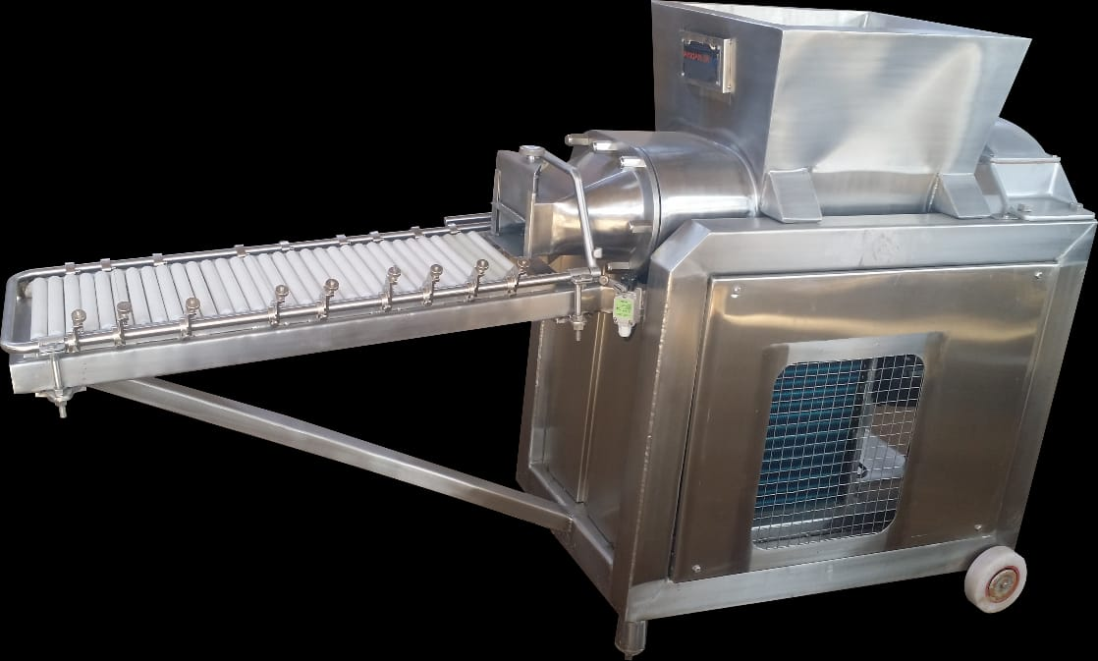 | Each | 1
5 | SS Milk Reception unit with pump and filter  Specifications:  - Capacity 500 liter  - Stainless Steel food grade material 304 L  - SS Sheet martial thickness 2.5mm  - Milk strainer for milk filtration fitted on reception tank Neck milk outlet dia 51mm  - SS butterfly valve for milk discharge  - Milk centrifugal pump capacity 1,000-liter  - Model MSP-E-10 SS  - Milk Loading Pump Capacity 10,000 liter/per hr.  - Electric motor capacity 1.5HP  - Material SS AISI (304) L.  - food grade Connection Suction 51mm  - Connection discharge 51mm  - Flow Rate 1,000 L/H RPM – 2800 380Volt, 50Hz  - Stainless steel Safety cover for Motor  - Stainless steel handle for holding  - MILK INLINE FILTER The SS inline filter tube type having  - SS filter mesh properly clamped line filter pipe dimensions 100mm x 400mm silicon type O ring rubber seal  - stainless steel material 304L  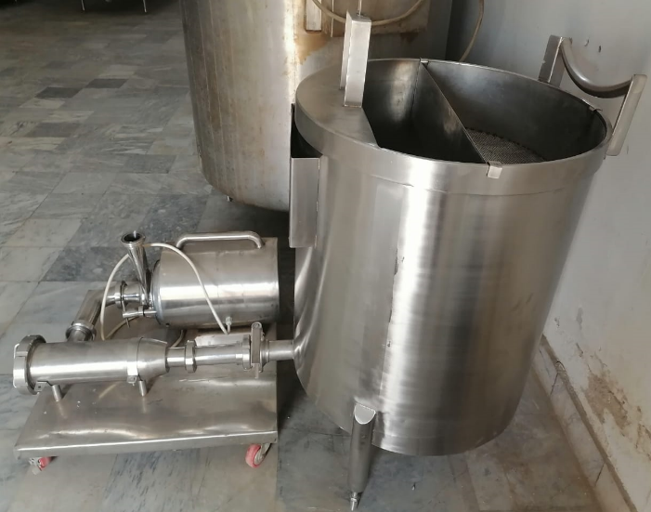  - food grade material The in-line strainer should be complete with  - SS nozzle with 51 mm unions on both ends. | Each | 1
6 | Culture Mixing Tank Cap. 500 Liter/hr  Specifications:  - Culture mixing tank capacity 500 Lt.  - S.S Sheet 2.0mm AISI (304) L for tank Shell.  - S.S Sheet 1.5mm AISI (304) L for outer Shell.  - Half lid will be open  - S.S Butterfly Valve 38mm for Outlet Qty.  - 1 Inlet size 38mm 0.5 Hp Agitator,  - Stainless steel blade driven by slow speed agitator, 32-40 RPM  - Qty.1 S.S Legs with adjustable feet (material 2.0mm)  - S.S Argon Welding Complete for Milk Tanker.  - Milk Tanker Completely Grinding and Buffing  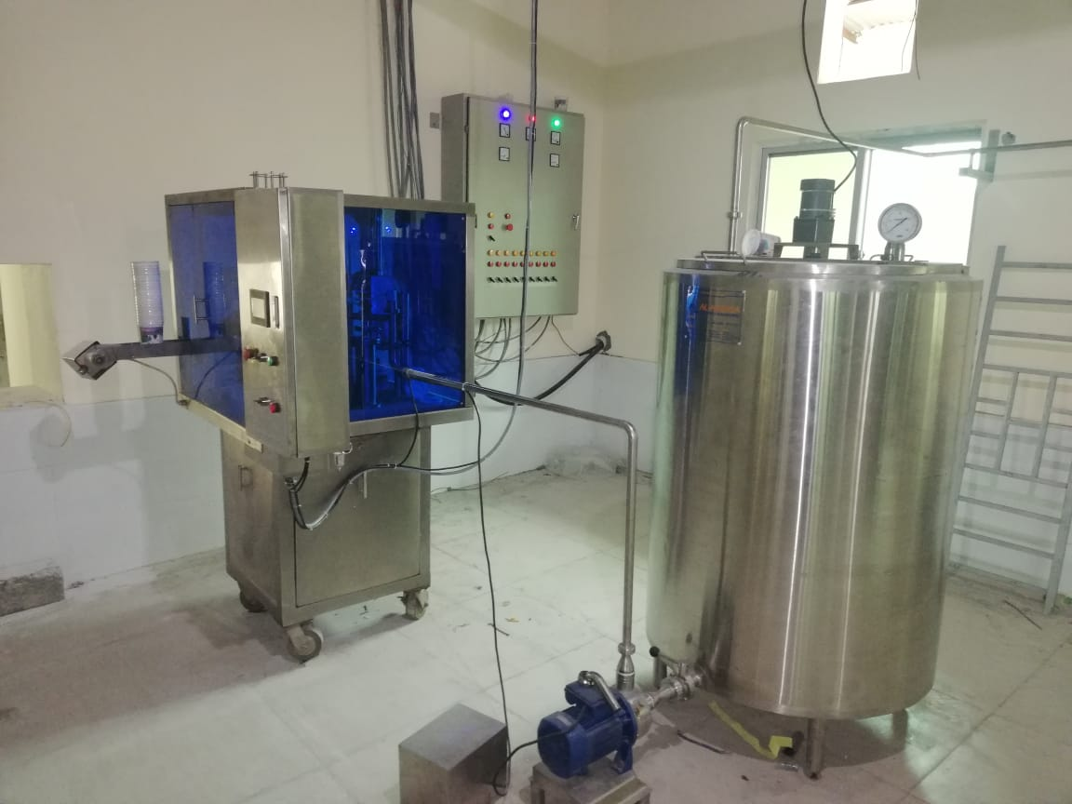 | Each | 1
7 | Milk boiler (direct heating system) capacity 300Ltr Specifications:  - Capacity 300Lt.  - Stainless steel sheet for inner shell 2.5mm (304) L food grade  - Stainless steel sheet for middle layer 2.0mm (304) L food grade  - Stainless steel sheet for outer shell 1.5mm (201)  - Stainless steel for lid 1.0mm (304) L food grade  - Glass wool insulation 51mm thickness  - Triple jacketed tank Stainless steel butterfly valve 38mm Agitator with  - S.S worker Analog temperature gauge 4 inch for milk temperature  - S.S legs with adjustable bolt  - S.S pipe handle 25mm Utility sources LPG gas  - Gas burner material G.I Water inlet/outlet 25mm  - Auto trip gas and pilot switch Stainless steel pipe for heat exhaust.  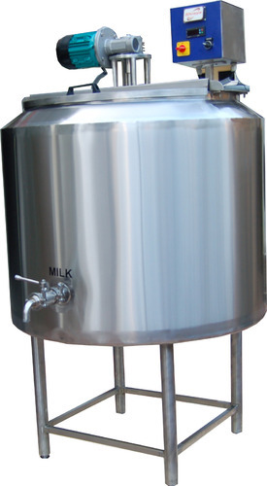 | Each | 1
 | Grand Total
 | Please mentioned delivery time here:

*Note: The pictures in the above table are just for familiarity of the vendor; while RADP-E is focusing to get the quality equipment as per the technical specification provided above.

We, the undersigned, provide the attached quote in accordance RFQ-RADP-E-KBL-20-0016 for Provision of Dairy Processing equipment, July 09, 2020. Our attached quote is for the total price of _____________________ (figure and in words). We confirm that unit pricing is inclusive of all costs for final delivery to RADP-East.

I certify a validity period of ninety (90) days for the prices provided in the attached Price Schedule/Bill of Quantities. Our quote shall be binding upon us subject to the modifications.

We understand that DAI is not bound to accept any quotes it receives.

Authorized Signature:
Name and Title of Signatory:
Name of Firm:
Address:
Telephone:
Email: Company Seal/Stamp:

Attachment B: Past Performance Chart

Include projects that best illustrate your experience providing transportation services in or outside of Kabul for international NGOs or contractors.
Projects should have been undertaken in the past three years.

# | Project Title | Description of Activities |  | Client Name, Contact Name & Tel/Email  Funding Agency if applicable | Location  City/ | Cost in AFN | Period of Performance | Type of Agreement, Subcontract, Grant, PO (fixed price, cost reimbursable)
1
2
3
4
5

Attachment C: Representations and Certifications of Compliance
- Federal Excluded Parties List - The Bidder Select is not presently debarred, suspended, or determined ineligible for an award of a contract by any Federal agency.

- Executive Compensation Certification- FAR 52.204-10 requires DAI, as prime contractor of U.S. federal government contracts, to report compensation levels of the five most highly compensated subcontractor executives to the Federal Funding Accountability and Transparency Act Sub-Award Report System (FSRS)

- Executive Order on Terrorism Financing- the Contractor is reminded that U.S. Executive Orders and U.S. law prohibits transactions with, and the provision of resources and support to, individuals and organizations associated with terrorism. It is the legal responsibility of the Contractor/Recipient to ensure compliance with these Executive Orders and laws. Recipients may not engage with, or provide resources or support to, individuals and organizations associated with terrorism. No support or resources may be provided to individuals or entities that appear on the Specially Designated Nationals and Blocked persons List maintained by the US Treasury (online at www.SAM.gov) or the United Nations Security Designation List (online at: http://www.un.org/sc/committees/1267/aq_sanctions_list.shtml). This provision must be included in all subcontracts/sub awards issued under this Contract.

- Trafficking of Persons – The Contractor may not traffic in persons (as defined in the Protocol to Prevent, Suppress, and Punish Trafficking of persons, especially Women and Children, supplementing the UN Convention against Transnational Organized Crime), procure commercial sex, and use forced labor during the period of this award.

- Certification and Disclosure Regarding Payment to Influence Certain Federal Transactions – The Bidder certifies that it currently is and will remain in compliance with FAR 52.203-11, Certification and Disclosure Regarding Payment to Influence Certain Federal Transactions.

- Organizational Conflict of Interest – The Bidder certifies that will comply FAR Part 9.5, Organizational Conflict of Interest. The Bidder certifies that is not aware of any information bearing on the existence of any potential organizational conflict of interest. The Bidder further certifies that if the Bidder becomes aware of information bearing on whether a potential conflict may exist, that Bidder shall immediately provide DAII with a disclosure statement describing this information.

- Prohibition of Segregated Facilities - The Bidder certifies that it is compliant with FAR 52.222-21, Prohibition of Segregated Facilities.

- Equal Opportunity – The Bidder certifies that it does not discriminate against any employee or applicant for employment because of age, sex, religion, handicap, race, creed, color or national origin.

- Labor Laws – The Bidder certifies that it is in compliance with all labor laws..

- Federal Acquisition Regulation (FAR) – The Bidder certifies that it is familiar with the Federal Acquisition Regulation (FAR) and is in not in violation of any certifications required in the applicable clauses of the FAR, including but not limited to certifications regarding lobbying, kickbacks, equal employment opportunity, affirmation action, and payments to influence Federal transactions.

- Employee Compliance – The Bidder warrants that it will require all employees, entities and individuals providing services in connection with the performance of an DAI Purchase Order to comply with the provisions of the resulting Purchase Order and with all Federal, State, and local laws and regulations in connection with the work associated therein.

By submitting a quote, bidders agree to fully comply with the terms and conditions above and all applicable U.S. federal government clauses included herein, and will be asked to sign these Representations and Certifications upon award.
RADP-East SPECIAL CLAUSES
- Authorized Geographic Code
The authorized geographic code for procurement of goods and services under this contract is 937. To support USAID activities and programs in Afghanistan a Source / Nationality waiver was signed by USAID Mission Director on June 22, 2016. This waiver is effective from July 24, 2016 through July 24, 2018, which permits procurement of goods and services from Geographic Code 935 for USAID programs and activities in Afghanistan.
- Insurance
The Vendor agrees that if DAI should legally incur any reasonable cost whatsoever resulting from the lack of the insurance aforementioned in Article 16, on the part of the Vendor while engaged in work, the Vendor will, to the extent permitted by applicable law, indemnify, and hold harmless DAI and the Client Organization from any such costs which they may legally be required to pay.
- Government Withholding Tax
Pursuant to Article 72 in the Afghanistan Tax Law effective March 21, 2009, DAI is required to withhold "contractor" taxes from the gross amounts payable to all Afghan for-profit subcontractors/vendors with aggregate amounts of $1,000.00 US Dollars or greater and transfer this to the Ministry of Finance. In accordance with this requirement, DAI shall withhold two percent (2%) tax from all gross invoices to Afghan subcontractors/vendors under this Agreement with active AISA or Ministry of Commerce license. For subcontractors/vendors without active AISA or Ministry of Commerce license, DAI shall withhold seven percent (7%) "Contractor" taxes per current Afghanistan Tax Law.
Before the signing of this Agreement, the subcontractor/vendor will provide a copy of the organization's AISA or Ministry of Commerce license and TIN (Tax Identification Number). Amounts deducted from the invoices will be forwarded to the Ministry of Finance (MOF) Tax Division credited to the firm's TIN. Records of payments to the MOF shall be maintained on file with DAI.

- Executive Order on Terrorism Financing
The Contractor is reminded that U.S. Executive Orders (including E.O. 13224) and U.S. law prohibit transactions with, and the provision of resources and support to, individuals and organizations associated with terrorism. FAR 25.701 prohibits agencies and their contractors and subcontractors from acquiring any supplies or services from individuals or organizations, if any proclamation, Executive Order, Office of Foreign Assets Control (OFAC) regulations, or statute administered by OFAC would prohibit such a transaction. Accordingly, the Contracting Officer must check the U.S. Department of the Treasury’s OFAC List to ensure that the names of the Contractor and proposed subcontractors (and individuals from those organizations who have been made known to them), are not on the list. Mandatory FAR clause 52.225-13 Restrictions on Certain Foreign Purchases is included by reference in Section I.1 of this contract.
By accepting the contract, the Contractor acknowledges and agrees that it is aware of the list as part of its compliance with the requirements of that clause. This clause must be included in all subcontracts/sub-awards issued under the contract.

5. Subcontracting Requirements (JAN 2012)
(a) Applicability: This section limits the number of tiers of sub-contracts to one tiers below the Vendor. The Vendor must not allow lower-tier subcontracts without the express written approval DAI. Should exceptional circumstances warrant subcontracting below one tier, the Vendor shall promptly request approval in writing from DAI. The Vendor shall include this clause in all subcontracts, and shall require subcontractors to include this clause in all lower-tier subcontracts. The Vendor shall be responsible for compliance with this clause by all subcontractors and lower-tier subcontractors.
- Combating Trafficking in Persons (MAR 2015)
(a) Definitions. As used in this clause—
“Agent” means any individual, including a director, an officer, an employee, or an independent contractor, authorized to act on behalf of the organization.
“Coercion” means—
(1) Threats of serious harm to or physical restraint against any person;
(2) Any scheme, plan, or pattern intended to cause a person to believe that failure to perform an act would result in serious harm to or physical restraint against any person; or
(3) The abuse or threatened abuse of the legal process.
“Commercially available off-the-shelf (COTS) item” means—
(1) Any item of supply (including construction material) that is—
(i) A commercial item (as defined in paragraph (1) of the definition at FAR 2.101);
(ii) Sold in substantial quantities in the commercial marketplace; and
(iii) Offered to the Government, under a contract or subcontract at any tier, without modification, in the same form in which it is sold in the commercial marketplace; and
(2) Does not include bulk cargo, as defined in http://uscode.house.gov/http://uscode.house.gov/46 U.S.C. 40102(4), such as agricultural products and petroleum products.
“Commercial sex act” means any sex act on account of which anything of value is given to or received by any person.
“Debt bondage” means the status or condition of a debtor arising from a pledge by the debtor of his or her personal services or of those of a person under his or her control as a security for debt, if the value of those services as reasonably assessed is not applied toward the liquidation of the debt or the length and nature of those services are not respectively limited and defined.
“Employee” means an employee of the Contractor directly engaged in the performance of work under the contract who has other than a minimal impact or involvement in contract performance.
“Forced Labor” means knowingly providing or obtaining the labor or services of a person—
(1) By threats of serious harm to, or physical restraint against, that person or another person;
(2) By means of any scheme, plan, or pattern intended to cause the person to believe that, if the person did not perform such labor or services, that person or another person would suffer serious harm or physical restraint; or
(3) By means of the abuse or threatened abuse of law or the legal process.
“Involuntary servitude” includes a condition of servitude induced by means of—
(1) Any scheme, plan, or pattern intended to cause a person to believe that, if the person did not enter into or continue in such conditions, that person or another person would suffer serious harm or physical restraint; or
(2) The abuse or threatened abuse of the legal process.
“Severe forms of trafficking in persons” means—
(1) Sex trafficking in which a commercial sex act is induced by force, fraud, or coercion, or in which the person induced to perform such act has not attained 18 years of age; or
(2) The recruitment, harboring, transportation, provision, or obtaining of a person for labor or services, through the use of force, fraud, or coercion for the purpose of subjection to involuntary servitude, peonage, debt bondage, or slavery.
“Sex trafficking” means the recruitment, harboring, transportation, provision, or obtaining of a person for the purpose of a commercial sex act.
“Subcontract” means any contract entered into by a subcontractor to furnish supplies or services for performance of a prime contract or a subcontract.
“Subcontractor” means any supplier, distributor, vendor, or firm that furnishes supplies or services to or for a prime contractor or another subcontractor.
“United States” means the 50 States, the District of Columbia, and outlying areas.
(b) Policy. The United States Government has adopted a policy prohibiting trafficking in persons including the trafficking-related activities of this clause. Contractors, contractor employees, and their agents shall not—
(1) Engage in severe forms of trafficking in persons during the period of performance of the contract;
(2) Procure commercial sex acts during the period of performance of the contract;
(3) Use forced labor in the performance of the contract;
(4) Destroy, conceal, confiscate, or otherwise deny access by an employee to the employee’s identity or immigration documents, such as passports or drivers' licenses, regardless of issuing authority;
(5)(i) Use misleading or fraudulent practices during the recruitment of employees or offering of employment, such as failing to disclose, in a format and language accessible to the worker, basic information or making material misrepresentations during the recruitment of employees regarding the key terms and conditions of employment, including wages and fringe benefits, the location of work, the living conditions, housing and associated costs (if employer or agent provided or arranged), any significant cost to be charged to the employee, and, if applicable, the hazardous nature of the work;
(ii) Use recruiters that do not comply with local labor laws of the country in which the recruiting takes place;
(6) Charge employees’ recruitment fees;
(7)(i) Fail to provide return transportation or pay for the cost of return transportation upon the end of employment—
(A) For an employee who is not a national of the country in which the work is taking place and who was brought into that country for the purpose of working on a U.S. Government contract or subcontract (for portions of contracts performed outside the United States); or
(B) For an employee who is not a United States national and who was brought into the United States for the purpose of working on a U.S. Government contract or subcontract, if the payment of such costs is required under existing temporary worker programs or pursuant to a written agreement with the employee (for portions of contracts performed inside the United States); except that—
(ii) The requirements of paragraphs (b)(7)(i) of this clause shall not apply to an employee who is—
(A) Legally permitted to remain in the country of employment and who chooses to do so; or
(B) Exempted by an authorized official of the contracting agency from the requirement to provide return transportation or pay for the cost of return transportation;
(iii) The requirements of paragraph (b)(7)(i) of this clause are modified for a victim of trafficking in persons who is seeking victim services or legal redress in the country of employment, or for a witness in an enforcement action related to trafficking in persons. The contractor shall provide the return transportation or pay the cost of return transportation in a way that does not obstruct the victim services, legal redress, or witness activity. For example, the contractor shall not only offer return transportation to a witness at a time when the witness is still needed to testify. This paragraph does not apply when the exemptions at paragraph (b)(7)(ii) of this clause apply.
(8) Provide or arrange housing that fails to meet the host country housing and safety standards; or
(9) If required by law or contract, fail to provide an employment contract, recruitment agreement, or other required work document in writing. Such written work document shall be in a language the employee understands. If the employee must relocate to perform the work, the work document shall be provided to the employee at least five days prior to the employee relocating. The employee’s work document shall include, but is not limited to, details about work description, wages, prohibition on charging recruitment fees, work location(s), living accommodations and associated costs, time off, roundtrip transportation arrangements, grievance process, and the content of applicable laws and regulations that prohibit trafficking in persons.
(c) Contractor requirements. The Contractor shall—
(1) Notify its employees and agents of—
(i) The United States Government's policy prohibiting trafficking in persons, described in paragraph (b) of this clause; and
(ii) The actions that will be taken against employees or agents for violations of this policy. Such actions for employees may include, but are not limited to, removal from the contract, reduction in benefits, or termination of employment; and
(2) Take appropriate action, up to and including termination, against employees, agents, or subcontractors that violate the policy in paragraph (b) of this clause.
(d) Notification.
(1) The Contractor shall inform the Contracting Officer and the agency Inspector General immediately of—
(i) Any credible information it receives from any source (including host country law enforcement) that alleges a Contractor employee, subcontractor, subcontractor employee, or their agent has engaged in conduct that violates the policy in paragraph (b) of this clause (see also 18 U.S.C. 1351, Fraud in Foreign Labor Contracting, and 52.203-13(b)(3)(i)(A), if that clause is included in the solicitation or contract, which requires disclosure to the agency Office of the Inspector General when the Contractor has credible evidence of fraud); and
(ii) Any actions taken against a Contractor employee, subcontractor, subcontractor employee, or their agent pursuant to this clause.
(2) If the allegation may be associated with more than one contract, the Contractor shall inform the contracting officer for the contract with the highest dollar value.
(e) Remedies. In addition to other remedies available to the Government, the Contractor’s failure to comply with the requirements of paragraphs (c), (d), (g), (h), or (i) of this clause may result in—
(1) Requiring the Contractor to remove a Contractor employee or employees from the performance of the contract;
(2) Requiring the Contractor to terminate a subcontract;
(3) Suspension of contract payments until the Contractor has taken appropriate remedial action;
(4) Loss of award fee, consistent with the award fee plan, for the performance period in which the Government determined Contractor non-compliance;
(5) Declining to exercise available options under the contract;
(6) Termination of the contract for default or cause, in accordance with the termination clause of this contract; or
(7) Suspension or debarment.
(f) Mitigating and aggravating factors. When determining remedies, the Contracting Officer may consider the following:
(1) Mitigating factors. The Contractor had a Trafficking in Persons compliance plan or an awareness program at the time of the violation, was in compliance with the plan, and has taken appropriate remedial actions for the violation, that may include reparation to victims for such violations.
(2) Aggravating factors. The Contractor failed to abate an alleged violation or enforce the requirements of a compliance plan, when directed by the Contracting Officer to do so.
(g) Full cooperation.
(1) The Contractor shall, at a minimum—
(i) Disclose to the agency Inspector General information sufficient to identify the nature and extent of an offense and the individuals responsible for the conduct;
(ii) Provide timely and complete responses to Government auditors' and investigators' requests for documents;
(iii) Cooperate fully in providing reasonable access to its facilities and staff (both inside and outside the U.S.) to allow contracting agencies and other responsible Federal agencies to conduct audits, investigations, or other actions to ascertain compliance with the Trafficking Victims Protection Act of 2000 (22 U.S.C. chapter 78), E.O. 13627, or any other applicable law or regulation establishing restrictions on trafficking in persons, the procurement of commercial sex acts, or the use of forced labor; and
(iv) Protect all employees suspected of being victims of or witnesses to prohibited activities, prior to returning to the country from which the employee was recruited, and shall not prevent or hinder the ability of these employees from cooperating fully with Government authorities.
(2) The requirement for full cooperation does not foreclose any Contractor rights arising in law, the FAR, or the terms of the contract. It does not—
(i) Require the Contractor to waive its attorney-client privilege or the protections afforded by the attorney work product doctrine;
(ii) Require any officer, director, owner, employee, or agent of the Contractor, including a sole proprietor, to waive his or her attorney client privilege or Fifth Amendment rights; or
(iii) Restrict the Contractor from—
(A) Conducting an internal investigation; or
(B) Defending a proceeding or dispute arising under the contract or related to a potential or disclosed violation.
(h) Compliance plan.
(1) This paragraph (h) applies to any portion of the contract that—
(i) Is for supplies, other than commercially available off-the-shelf items, acquired outside the United States, or services to be performed outside the United States; and
(ii) Has an estimated value that exceeds $500,000.
(2) The Contractor shall maintain a compliance plan during the performance of the contract that is appropriate—
(i) To the size and complexity of the contract; and
(ii) To the nature and scope of the activities to be performed for the Government, including the number of non-United States citizens expected to be employed and the risk that the contract or subcontract will involve services or supplies susceptible to trafficking in persons.
(3) Minimum requirements. The compliance plan must include, at a minimum, the following:
(i) An awareness program to inform contractor employees about the Government’s policy prohibiting trafficking-related activities described in paragraph (b) of this clause, the activities prohibited, and the actions that will be taken against the employee for violations. Additional information about Trafficking in Persons and examples of awareness programs can be found at the website for the Department of State’s Office to Monitor and Combat Trafficking in Persons at http://www.state.gov/j/tip/http://www.state.gov/j/tip/.
(ii) A process for employees to report, without fear of retaliation, activity inconsistent with the policy prohibiting trafficking in persons, including a means to make available to all employees the hotline phone number of the Global Human Trafficking Hotline at 1-844-888-FREE and its email address at help@befree.org.
(iii) A recruitment and wage plan that only permits the use of recruitment companies with trained employees, prohibits charging recruitment fees to the employee, and ensures that wages meet applicable host-country legal requirements or explains any variance.
(iv) A housing plan, if the Contractor or subcontractor intends to provide or arrange housing that ensures that the housing meets host-country housing and safety standards.
(v) Procedures to prevent agents and subcontractors at any tier and at any dollar value from engaging in trafficking in persons (including activities in paragraph (b) of this clause) and to monitor, detect, and terminate any agents, subcontracts, or subcontractor employees that have engaged in such activities.
(4) Posting.
(i) The Contractor shall post the relevant contents of the compliance plan, no later than the initiation of contract performance, at the workplace (unless the work is to be performed in the field or not in a fixed location) and on the Contractor's Web site (if one is maintained). If posting at the workplace or on the Web site is impracticable, the Contractor shall provide the relevant contents of the compliance plan to each worker in writing.
(ii) The Contractor shall provide the compliance plan to the Contracting Officer upon request.
(5) Certification. Annually after receiving an award, the Contractor shall submit a certification to the Contracting Officer that—
(i) It has implemented a compliance plan to prevent any prohibited activities identified at paragraph (b) of this clause and to monitor, detect, and terminate any agent, subcontract or subcontractor employee engaging in prohibited activities; and
(ii) After having conducted due diligence, either—
(A) To the best of the Contractor's knowledge and belief, neither it nor any of its agents, subcontractors, or their agents is engaged in any such activities; or
(B) If abuses relating to any of the prohibited activities identified in paragraph (b) of this clause have been found, the Contractor or subcontractor has taken the appropriate remedial and referral actions.
(i) Subcontracts.
(1) The Contractor shall include the substance of this clause, including this paragraph (i), in all subcontracts and in all contracts with agents. The requirements in paragraph (h) of this clause apply only to any portion of the subcontract that—
(A) Is for supplies, other than commercially available off-the-shelf items, acquired outside the United States, or services to be performed outside the United States; and
(B) Has an estimated value that exceeds $500,000.
(2) If any subcontractor is required by this clause to submit a certification, the Contractor shall require submission prior to the award of the subcontract and annually thereafter. The certification shall cover the items in paragraph (h)(5) of this clause.
(End of clause).
- National Security Screening (Non-US Party Vetting):
The Purchase Order was awarded after following the procedures in the Implementing Partner Notice No. OAA-IP-2011-004 and subsequent Notices related to this matter which incorporated Mission Order No. 201.04 entitled, “National Security Screening (Non-US Party Vetting). Copies of the Implementing Partner Notice(s) and the Mission Order can be obtained from the DAI's Representative named herein. For awards that meet the Vetting threshold, USAID had issued an Eligibility Notice to DAI for the vendor prior awarding the Purchase Order. This Eligibility Notice is valid for 12 months. If the Purchase Order's Performance Period exceeds 12 months, the Vendor shall provide an updated information used in filing the Partner Information Form (PIF) to start a new vetting process to acquire a new Eligibility Notice for the Vendor. Also, during the course of the 12 months, if the information provided by the vendor has changed, the Vendor shall notify DAI at once to update the Eligibility Notice issued for the Vendor.
- Certification Regarding Provision of Support to Persons Engaged in Terrorism:
(a) By receiving this Purchase Order, the Vendor certifies, to the best of its knowledge and belief that:
(1) The Vendor, to the best of its current knowledge, did not provide, within the previous ten years, and will take all reasonable steps to ensure that it does not and will not knowingly provide, material support or resources to any individual or entity that commits, attempts to commit, advocates, facilitates, or participates in terrorism acts, or has committed, attempted to commit, facilitated, or participated in terrorist acts, as that term is defined in paragraph 3.
(2) The following steps may enable the Vendor to comply with its obligations under paragraph (1):
a. Before providing any material support or resources to an individual or entity, the Vendor will verify that the individual or entity does not (i) appear on the master list of Specially Designated nationals and Blocked Persons, which list is maintained by the U.S. Treasury’s Office of Foreign Assets Control (OFAC) and is available online at OFAC’s website: http://www.treas.gov/offices/eotffc/ofac/sdn/t11sdn.pdf, or (ii) is not included in any supplementary information concerning prohibited individuals or entities that may be provided by USAID to DAI.
b. Before providing any material support or resources to an individual or entity, the Vendor also will verify that the individual or entity has not been designated by the United Nations Security (UNSC) sanctions committee established under UNSC Resolution 1267 (1999) (the “1267 Committee”) [individuals and entities linked to the Taliban, Osama bin Laden, or the Al Qaidia Organization]. To determine whether there has been a published designation of an individual or entity by the 1267 Committee, the Subcontractor should refer to the consolidated list available online at the Committee’s website: http://www.un.org/Docs/sc/committees/1267/1267ListEng.htm.
c. Before providing any material support or resources to an individual or entity, the Vendor will consider all information about that individual or entity of which it is aware and all public information that is reasonably available to it or of which it should be aware.
d. The Vendor also will implement reasonable monitoring and oversight procedures to safeguard against assistance being diverted to support terrorist activity.
(3) For the purpose of this Certification.
a. “Material support and resources” means currency or monetary instruments or financial securities, financial services, lodging, training, expert advice or assistance, safe houses, false documentation or identification, communications equipment, facilities, weapons, lethal substances, explosives, personnel, transportation, and other physical assets, except medicine or religious materials.
b. “Terrorist act” means –
(i) an act prohibited pursuant to one of the 12 United nations Conventions and Protocols related to terrorism (see UN terrorism conventions Internet site: http://untreaty.un.org/English /Terrorism.asp); or
(ii) an act of premeditated, politically motivated violence perpetrated against noncombatant targets by sub-national groups or clandestine agents; or
(iii) any other person not taking an active part in hostilities in situations of armed conflict, when the purpose of such act, by its nature or context, is to intimidate a population, or to compel a government or an international organization to do or to abstain from doing any act.
c. “Entity” means a partnership, association, corporation, or other organization, group or subgroups.
d. Reference in this Certification to the provision of material support and resources shall not be deemed to include the furnishing of USAID funds or USAID-financed commodities to the unlimited beneficiaries of USAID assistance, such as recipients of food, medical care, micro-enterprise loans, shelter, etc., unless the Vendor has reason to believe that one or more of these beneficiaries commits, attempts to commit, advocates, facilitates, or participates in terrorist acts, or has committed, attempted to commit, facilitated or participated in terrorist acts.
(b) By accepting or start performing this Purchase Order, the Vendor acknowledges that it has a continuing obligation and shall notify DAI within 72 hours in writing if it has intentionally or unintentionally taken any actions that have the result and effect of being inconsistent with the certification in subsection (a).
(c) The certification in paragraph (a) of this clause and the requirement to update DAI as to a change in status as set forth in paragraph (b) are representations upon which reliance was placed when making the award. If it is later determined that the Vendor knowingly rendered an erroneous certification, or did not notify DAI in writing of a change in such certification, in addition to other remedies available to the U.S. Government and DAI, DAI may terminate this sub award for default. DAI may also cease payments due to the Vendor even if goods and services have been provided.
9. Restrictions on Certain Foreign Purchases (JUNE 2008)
(a) Except as authorized by the Office of Foreign Assets Control (OFAC) in the Department of the Treasury, the Contractor shall not acquire, for use in the performance of this contract, any supplies or services if any proclamation. Executive order, or statute administered by OFAC, or if OFACs implementing regulations at 31 CFR Chapter V, would prohibit such a transaction by a person subject to the jurisdiction of the United States.
(b) Except as authorized by OFAC, most transactions involving Cuba, Iran, and Sudan are prohibited, as are most imports from Burma or North Korea, into the United States or its outlying areas. Lists of entities and individuals subject to economic sanctions are included in OFAC's List of Specially Designated Nationals and Blocked Persons at http:// www.treas.gov/offices/enforcement/ofac/sdn. More information about these restrictions, as well as updates, is available in the OFAC's regulations at 31 CFR Chapter V and/or on OFAC's website at http:// www.treas.gov/offices/enforcement/ofac.
(c) The Contractor shall insert this clause, including this paragraph (c), in all sub-contracts.
(d) Before awarding any grant or similar instrument, the Contractor/Recipient shall obtain from the proposed sub-awardee the certification required under USAID's Acquisition and Assistance Policy Determination 04-14 (AAPD 04-14), "Certification Regarding Terrorist Financing Implementation E.O. 13224 (Revision 2).

Attachment D: Proposal Checklist

Offeror: __________________________________________________________________________
Have you?
Submitted your proposal to DAI/RADP-E to ProcurementRADP_East_Inbox@dai.com as specified in General Instructions above?
The proposal must have the following.
Signed Price Schedule (use template in Attachment A) if different from the specification given in the attachment A, bidder must provide full detail and specification on their official letter.
Copy of current and valid business license from Ministry of Commerce and Industry to operate.
Evidence of a DUNS Number, if applicable
Attachment B: Past Performance Chart

