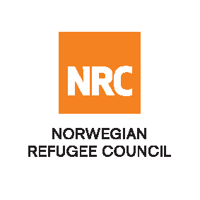

INVITATION TO BID

The Norwegian Refugee Council (NRC) is a non-governmental, humanitarian organization with 60 years of experience in helping to create a safer and more dignified life for refugees and internally displaced people. NRC advocates for the rights of displaced populations and offers assistance within Shelter, Education, Emergency Food Security and Livelihoods, Legal Assistance, Water Sanitation and Hygiene Sectors.

NRC has been present in Afghanistan since 2003, gradually expanding their presence and the organization currently maintains presence in 18 provinces, with five key regional offices in Kabul, Kandahar, Herat, Jalalabad and Mazar-e-Sharif with adjacent field offices in Badghis, Faryab, Tirin Kot, Khost, Maimana, Kunduz, Saripul and Nimroz.

The Norwegian Refugee Council (NRC) Office in Afghanistan invites eligible and interested bidders to participate on the tender below.

RFQ 246796 - NRC AFG/08/001/2020 - Hygiene Kit - COVID - 19

New Suppliers to register via CTM link: https://eu.eu-supply.com/login.asp?B=NRC

For registered suppliers you can access the tender on the link provided below
http://www.globalesourcing.eu/

