OHW: INVITATION TO BID

(OHW-South-Kandahar ITB-20-05) Electronic Equipment

Announcement No. OHW-South-ITB-20-05

Issue Date: 21-SEP-2020

Deadline for Receipt: 05-OCT-2020

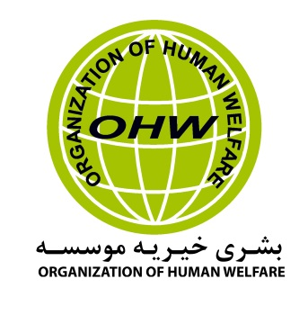

Request for Invitation to Bid

1. ITB No. | OHW-South-Kandahar ITB-20-05- Electronic Equipments
2. Issue Date | 21-SEP-2020
3. Services | Electronic Equipments
4. Issuing Office & Physical Address for Submission of ITB’s | Bid should submit to OHW Kabul main office before the closing date. The address is as following:  OHW-Kabul main Office: House # 40, St # 01 from Saleem-e-Karwan Square in front of Sehat Afghan Clinic, Kabul, Afghanistan.  Or  Contact Email: For any kind information.  Email Address: info@ohw.org.af – logistics.kbl@ohw.org.af
5. Deadline for Receipt of Quotes. | 04:00 PM local time Kabul, on 05 OCT-2020  All bids should be sending in a sealed envelope with tender NO written on the outside of the envelope and physically putting the bids in tender box. As soon as possible after the closing date all the bids will be opened and the best bid selected according to the award criteria and scoring base on below.  - Price 70 %  - Technical/ Quality 10 %  - Legal valid document 10%  - Relevant experiences 10%
6. Anticipated Award Type | Purchase Order
7. Basis for Award | An award will be made to the responsible bidder whose bid is  Responsive to the terms of the ITB and is most advantageous to OHW, considering price or/and other factors included in the ITB. To be considered for award, bidders must meet the requirements identified in Section, “Determination of Responsibility”.  The contract will be awarded on the basis of best value for money, according to the principles and objectives of humanitarian aid. This means that not only the amount of electronic equipment will be taken but also the quality.
8. General Instructions to  Bidders | • Final Bids due by 04:00 PM local time Kabul, 05-OCT-2020  • Include a statement that the vendor fully understands that their bid must be valid for a period of ten (60) days.  • Bidders shall sign and date their Bids.  • Bidders shall complete Attachment A: Price Schedule (Electronic Equipments)  • The payment will be made upon submission and acceptance of an invoice at the end of complete delivery of electronic equipments.  • The amount will be transfer through Bank payments.  • Organization of Human Welfare (OHW) reserves the rights to cancel or terminate the Agreement if the company is not able to provide the satisfactory services.
9. Technical Specifications and requirements for Technical Acceptability And terms of condition | Quality  The electronic equipments should not be in the lest quality it should have best quality according OHW specialist team.  Bidder will be requested for sample check to provide sample check to OHW procurement committee team and quality control team.  Bidders  The Bidders shall provide the bid of electronic equipments to the Organization of Human Welfare (OHW) Kandahar main Offices in a good quality with guarantee and shall be responsible for ensuring the seeds to be ready as required.  - Delivery of the required seeds at the below location in Kandahar province office to below address.  Old Gudam area, Street No 2, DoRR street , Gudam Area, PD 1 Kandahar Afghanistan.  - Income Taxes and any governmental penalties will be withheld by “OHW” as per Afghanistan tax law and will be paid to Afghanistan Tax department.  - The Contractor will be responsible for providing of legal documentation regarding supply of seeds such as illegal supplied items, Customs Clearance or any issue/ penalty raise against the supplied equipments.  - The contractor is responsible to satisfy “OHW” for the documentations of the proposed electronic equipment, in accordance to the rules and regulations of OHW announced in Advertisement.  - The electronic equipment should be ready and delivered 5 working days after finalizing supplier.  - Bidders will be required for sample check.  Documents should provide with bids: The successful bidder will need to provide the following documents.  - Company valid license.  - Bank account detail.  - Identifications documents proving ownership and copy of national ID of the owner.  - Registration of the legal license that Proves he is able to do business  - Valid License copy of business.  - Any other document as may be required by the OHW authority.  Payment and invoicing:  - Payment will be done in AFN and will be transfer by Bank TT-Form into the supplier’s bank account or Cheque at the end of finished complete delivery by the providing complete items in desired location in Kandahar office.
10. Determination of  Responsibility | OHW will not enter into any type of agreement with a vendor prior to ensuring the vendor’s responsibility. When assessing an vendor’s responsibility, the following factors are taken into consideration:  1. Provide copies of the required license/ Documents from Afghanistan ministry of commerce.  2. Ability to comply with required or proposed delivery or performance schedule.

Attachment A: Cover Letter

Date:

To: Organization of Human Welfare

From:

Subject: Cover Letter for the electronic equipment bidders

We, the undersigned, provide the attached quote in accordance to the OHW-Kabul main office specification.

I certify a validity period of ten (60) days for the prices provided in the attached Price Schedule/Bill of Quantities. Our quote shall be binding upon us subject to the modifications. We confirm the availability of required services, and that unit prices are inclusive of final service delivery to OHW. We further agree to payment terms upon submission and acceptance of an invoice by completion of delivery.

We, the undersigned, offer to deliver goods and supporting services in conformity with the said Invitation to Bid for the total amount of (Please insert the per month amount of services in AFN ) as may be ascertained in accordance with the Price Schedules attached herewith and made part of this Bid.

We understand that OHW is not bound to accept any quotes it receives.

Authorized Signature:
Name and Title of Signatory:
Name of Firm:
Address:
Telephone:
Email:

Attachment A: Price Schedule (Electronic Equipments)
Offers should provide a quote for procurement required in the price schedule that the Offer is able to Deliver/Supply after 5 working days finalizing of supplier to Kandahar office.

No | Items Name | Unit | Quantity | Unit Price -  AFN | Total Price AFN
1 | Solar Cable (Made in Pakistan) 10ML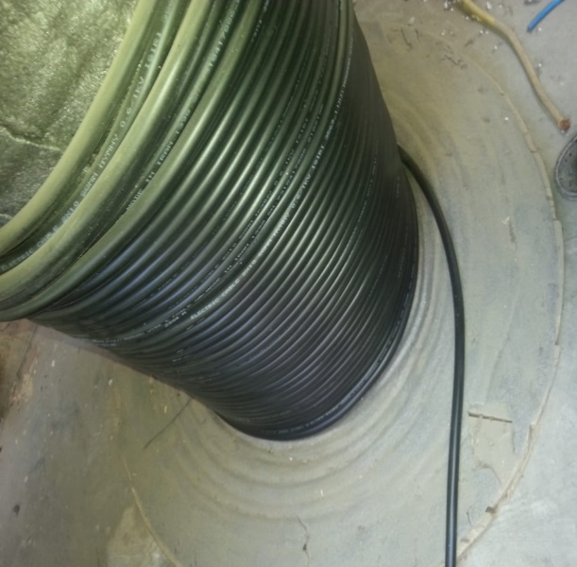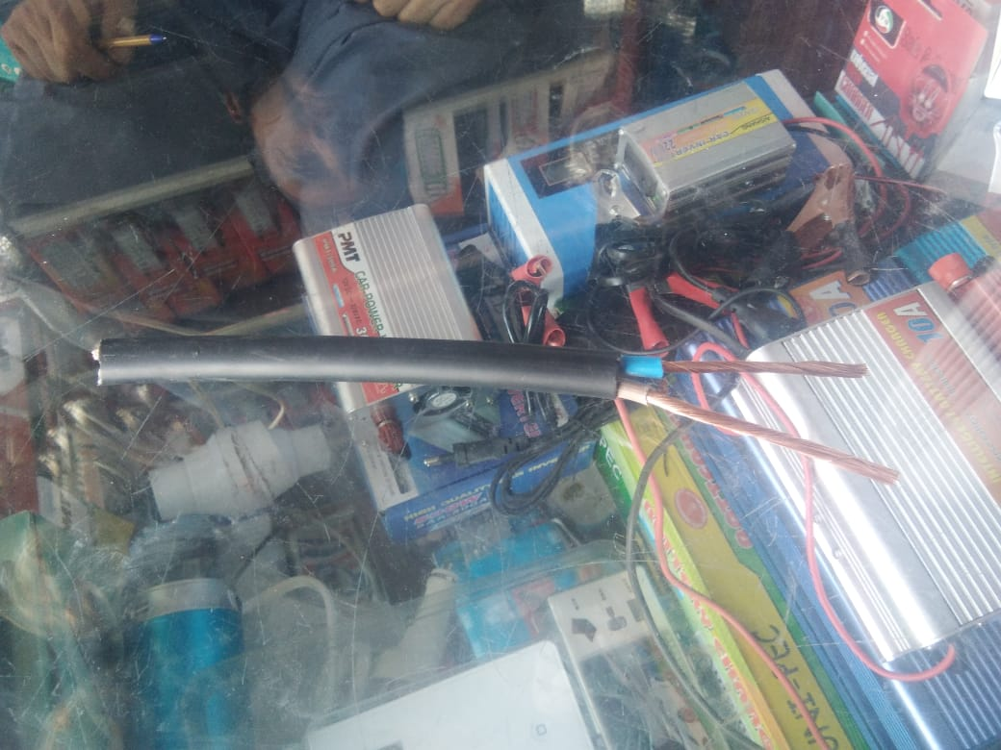 | Meter | 5000
2 | Battery Terminal Made in China (Large Size)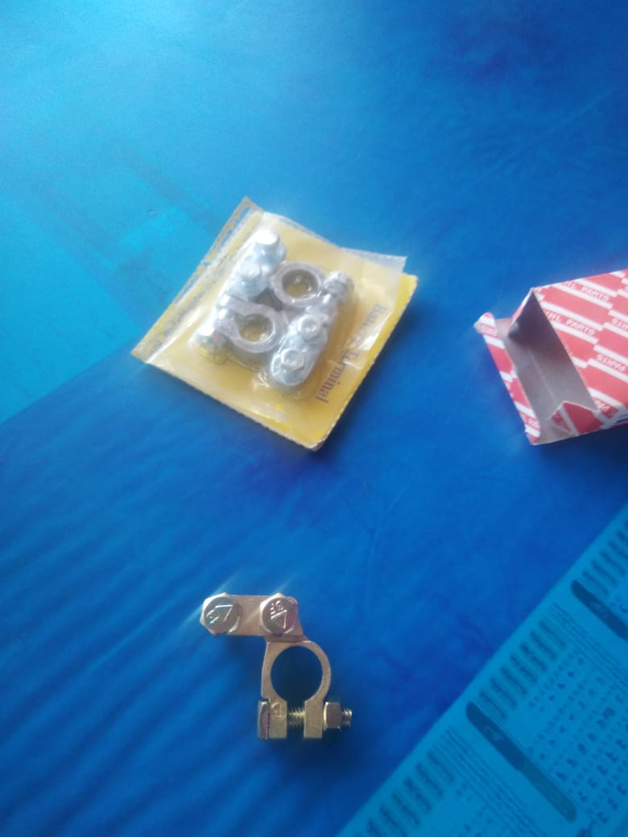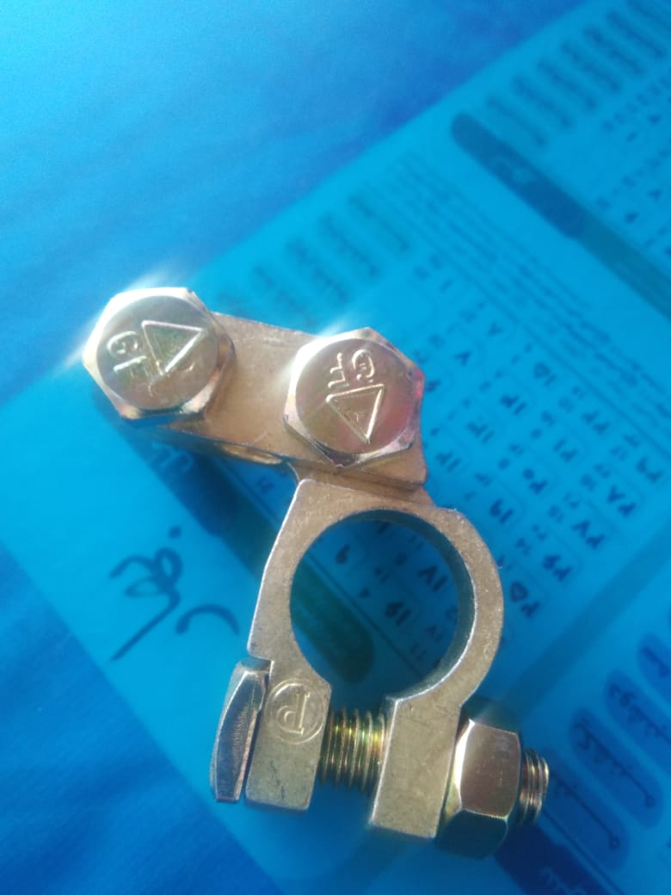 | EACH | 2000 | Each
Total amount with Tax
Deductible Tax (%)

Total Amount without Tax

Name: Company Name:

Position: Stamp

Signature:

Date:

