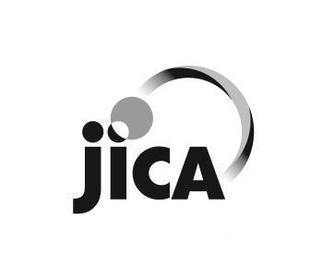
JAPAN INTERNATIONAL COOPERATION AGENCY

Notice of Consulting Service Procurement

Japan international cooperation agency (JICA) AfghaNISTAN office intends to contract the following services under the technical cooperation of the Government of Japan.
- Name of Project: Data Collection Survey on Kabul Urban Transport in Afghanistan
- Name of Services: Consulting Service for Preliminary Design for the Rehabilitation of Bridges on Main Roads in Kabul
The details are as attached Request for Proposal.
- Expected Date of Commencement of Services: 10th January 2021
- Expected Contract Terms: from 10th January to 31 May 2021
- Eligible Firms:
- Those who are duly registered under the law of Afghanistan and must have a business permit from the Government of Afghanistan,
- Those who has strong working knowledge of English (including writing), Dari and Pashto languages,
- Those who has good communication skills in various stakeholders,
- Those who has had minimum 5 years working experiences in bridge design and supervision,
- Those who has had minimum 1 project experience in bridge design and supervision after 2010,
- The balance sheets for the last 3 years must demonstrate the current soundness of the Applicant’s financial position and indicate its prospective long-term profitability,
- Minimum average annual turnover of USD 300,000 calculated as total certified payments received for contracts in progress and/or completed, within last 3 years,
6. Interested and qualified firms are kindly requested to submit the proposal by email at jicaan-procur@jica.go.jp from 3rd to 24th December 2020.
7. Any communication/inquiry must be through by email to JICA Afghanistan Office.

JICA Afghanistan Office has a Zero Tolerance Policy on fraud or corruption. To report allegations of fraud and corruption relating to JICA procurements, please contact the below address: jica-compla@jica.go.jp;

