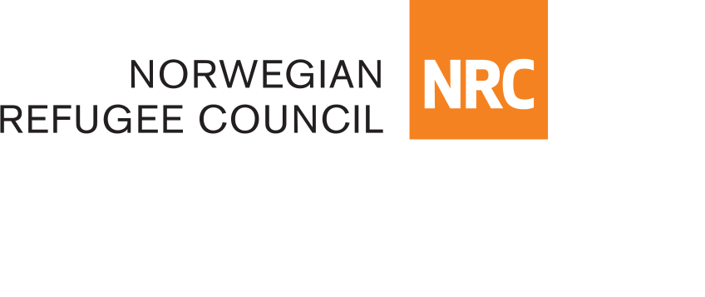

TENDER NOTICE

Date: 23rd December 2020

Reference: Open Tender for Consulting Services:

Business consultancy for selection, monitoring and provision of technical support to SMEs in Herat and Mazar Provinces funded by KfW under Project ID BMZ No: 2017 67 771

Reference Number: CO-AFFM1911-01/2020

The Norwegian Refugee Council (NRC) is a non-governmental, humanitarian organization with 60 years of experience in helping to create a safer and more dignified life for refugees and internally displaced people.

NRC advocates for the rights of displaced populations and offers assistance within the shelter, education, food security and livelihood, water, sanitation and legal assistance.

NRC has been present in Afghanistan since 2003, gradually expanding their presence and the organization currently maintains presence in 18 provinces, with five key regional offices in Kabul, Kandahar, Herat, Jalalabad and Mazar-e-Sharif with adjacent field offices in Badghis, Faryab, Tirin Kot, Khost, Maimana, Kunduz, Saripul and Nimroz.

Project

NRC will provide financial and technical support to small companies, who plan on expanding their businesses in a way that creates new jobs, over a period of one year. In exchange, these companies must commit to hiring NRC’s target population, i.e. IDPs, returnees, and vulnerable host communities. NRC will support new SMEs every year – i.e. four cycles of support over the four-year project duration. Each company will be financially supported for up to one year, but may receive technical support for longer. Companies will be required to guarantee they will employ beneficiaries for at least one year, whilst their employment and business performance will be monitored for two years (starting from the signature of the contract between NRC and the supported SME). Companies will also be required to contribute at least 40% of the total budget required for the business set-up/ expansion in order to be eligible- and will be required to place this capital in a new bank account, which NRC is allowed to monitor, and where NRC will also deposit its funding

The Norwegian Refugee Council (NRC) would like to invite qualified consultants to submit bids for Supply of Construction of materials for Durable Shelter Construction in Kabul and Kandahar Provinces funded by KfW Development Bank.

Requested Service:
The service provider will be required to support NRC to establish:
- Supporting NRC to assess and identify MSMEs which will be supported:
- Help NRC design MSME assessment tools
- Help NRC identify appropriate local formal and informal advertisement channels for the project (e.g. business associations, radios, newspapers etc.), and advertise within the business community in Mazar and Herat.
- Help NRC to assess/ screen the MSMEs who apply for the project, including through reviewing written applications, carrying out interviews with MSME staff and assessing their management structure, carrying out company site visits, reviewing financial documents, speaking with suppliers and clients to understand past performance and growth potential, etc.

Providing technical support to the selected MSMEs:
- Help MSMEs develop a business plan and funding strategy for growth.
- Help MSMEs identify areas where they need technical support to reach the business growth and job creation targets outlined in their contract with NRC.
- Provide technical support to each MSME as per the specific needs identified (e.g. increasing the efficiency of the production chain, diversifying suppliers, finding new markets/ clients, improving advertising and communications, improving company management structure and practices, improving budgeting and accounting systems, etc.). This technical support should in particular include:
- Support MSMEs to access loans from banks or microfinance institutions
- Support MSMEs to develop a basic, adequate HR policy (employment contracts, attendance management, regular paydays, sick leave and holiday allowances etc.) and workplace health and safety policies (use of safety and hygienic equipment etc.).

Monitoring and Evaluation of supported MSMEs
- Help NRC develop monitoring tools, templates and processes, to evaluate each MSME’s performance:
- Business performance/ growth
- Job creation/ employment performance
- Use of any financial support received from NRC
- Produce a baseline report on each selected MSME, capturing current business situation (profits and losses), current employment situation (number of people employed, in what types of positions), and assessment of technical and financial support needed for business growth and job creation.
- Provide three monitoring reports for each MSME (3, 9 and 14 months after signature of the contract between the MSME and NRC).

The consultant will be expected to complete/implement the project within two years (March 2021 to March 2023)

A firm will be selected in accordance with the procedures described in the KfW Guidelines for
the Procurement of Consulting Services, Works, Goods, Plant and Non-Consulting Services in
Financial Cooperation with Partner Countries, which can be found on the website
www.kfw-entwicklungsbank.de

The contract will be awarded to an independent eligible and qualified consultant/consulting
firm who has:

Must have at last two years of demonstrated experience working in/ with the private sector in Afghanistan, preferably including Mazar and Herat, in particular with companies involved in:
- Production or processing of agricultural/ livestock products
- Processing or manufacturing of food and non-food items (including clothing and textile)
- Service industries with high employment potential (e.g. restaurants, hotels, etc.)
- Construction (including energy infrastructure, production of construction materials and equipment, housing construction etc.).

The consultant/firm should demonstrate:
- Should have a minimum annual turnover of USD 200,000 (Two Hundred Thousand) or its equivalent in other currency over the last 2 years.
- Experience in SME’s
- The employment service company must possess an in-depth and up-to-date understating of the dynamics and key actors involved in these sectors, as well as have good contacts in the business community in Mazar and Herat to facilitate decent job placements

Information:
Further information concerning the tender is available and can be requested through af.procurement@nrc.no

RfP’s and other tender related documents will be distributed electronically upon written request. The request must clearly state. “Request for Proposal Ref. Number CO-AFFM1911-01/2020: Implement private sector development and job creation activities in Herat and Mazar Provinces BMZ No: 2017 67 771

Application as well as all correspondence must be submitted in English
The number of type of copies to be submitted with the Application is:
1 (One) original hard copy (technical and financial offers) and 1 (One) photo copy (technical and financial offers), all in one envelop (must be sealed)

Submission of Application
The Original Application must be submitted not later than:
Date: 24th January 2021
Time: 15:00 (Local time)

Delivery of the Application should be addressed to:
Norwegian Refugee Council (NRC) Kabul
3rd Street, Qale-Fatullah, PD 10, Kabul Province, Afghanistan

Questions related to office location/direction should be enquired through telephone number: 0728932799

NRC reserves the right to select/reject without any explanation, any bids, in part or full, as it may deem necessary. No liability or claim in that respect would be admissible or entertained whatsoever.

