

**Afghanistan Value Chain (AVC) – High Value Crops**

Request for Quotation (RFQ)

No. REQ-KBL-21-0146

**Sesame Seed Processing Line**

Issue Date: April 05, 2021

**WARNING**: Prospective Offerors who have received this document from a source other than the AVC-HVC Project, should immediately contact [avc-c_procurement@dai.com](mailto:avc-c_procurement@dai.com) and provide their name and mailing address in order that amendments to the RFQ or other communications can be sent directly to them. Any prospective Offeror who fails to register their interest assumes complete responsibility in the event that they do not receive communications prior to the closing date. Any amendments to this solicitation will be issued and posted via email.

# Synopsis of the Request for Quotation

DAI, implementer of the USAID funded Afghanistan Value Chain (AVC) – High Value Crops project, invites qualified vendors to submit quotations for Provision of Sesame Seed Processing Lineas following:

|  |  |
| --- | --- |
| 1. RFQ No. | REQ-KBL-21-0146 |
| 1. Issue Date | April 05, 2021 |
| 1. Title | Provision of Sesame Seed Processing Line |
| 1. Issuing Office & Email/Physical Address for Submission of Quotes | [avc-c_quotation@dai.com with](mailto:avc-c_quotation@dai.com) subject: **Bidder Company Name REQ-KBL-21-0146. Sending to other e-mail address may lead to disqualification of your bid.** |
| 1. Deadline for Receipt of Questions. | Deadline for submission of questions is **Tuesday April 13, 2021 by 4:00 PM** local time in Afghanistan. |
| 1. Deadline for Receipt of Quotes. | Please submit proposals by **Monday April 19, 2021 by 4:00 PM** Local time in Afghanistan [avc-c_quotation@dai.com](mailto:avc-c_quotation@dai.com) |
| 1. Anticipated Award Type | DAI anticipates issuing a Firm Fixed Price Purchase Order. This is only the anticipated type of award and may be changed as a result of negotiations. Issuance of this RFQ in no way obligates DAI to award a subcontract or purchase order and Bidders will not be reimbursed for any costs associated with the preparation of their quote. |
| 1. Basis for Award | An award will be made to the responsible bidder whose bid is responsive to the terms of the RFQ and is most advantageous to DAI, considering price or/and other factors included in the RFQ. To be considered for award, bidders must meet the requirements identified in Section 12, “Determination of Responsibility”. No discussions or negotiations are permitted with bidders, and therefore bidders shall submit their best and final price. |
| 1. Minimum Bid Validity | 90 days after closing date |

*Interested Bidders may obtain a full copy of the RFQ which contains detailed instructions for preparation of the quote. The RFQ may be collected from the address and/or contact person above.*

# Request for Quotation

|  |  |
| --- | --- |
| 1. General Instructions to Bidders | Offerors wishing to respond to this RFQ must submit proposals**, in English**, in accordance with the following instructions. Offerors are required to review all instructions and specifications contained in this RFQ. Failure to do so will be at the Offeror’s risk. If the solicitation is amended, then all terms and conditions not modified in the amendment shall remain unchanged.  Issuance of this RFQ in no way obligates DAI to award a subcontract or purchase order. Offerors will not be reimbursed for any costs associated with the preparation or submission of their proposal. DAI shall in no case be responsible for liable for these costs.  Offers are due no later than **(Monday April 19, 2021 by 4:00** **PM** **local time in Afghanistan**), to be submitted to [avc-c_quotation@dai.com](mailto:avc-c_quotation@dai.com) with subject: **Bidder Company Name REQ-KBL-21-0146**  Late offers will be rejected except under extraordinary circumstances at DAI’s discretion.  Sending to other e-mail address may lead to disqualification of your bid, Late offers will be rejected except under extraordinary circumstances at DAI’s discretion. The submission to DAI of a proposal in response to this RFQ will constitute an offer and indicates the Offeror’s agreement to the terms and conditions in this RFQ and any attachments hereto. DAI reserves the right not to evaluate a non- responsive or incomplete proposal.  Please note the following:  **Delivery terms:** Offerors that can deliver to Herat, Afghanistan will be looked upon favorably.  **Installation and Training:** Offeror must be able to install and commission the equipment in Herat, Afghanistan  **Warranty:** Parts and labor for a minimum period of 12 months |
| 1. Questions Regarding the RFQ | Each Bidder is responsible for reading very carefully and understanding fully the terms and conditions of this RFQ. All communications regarding this solicitation are to be made solely through the Issuing Office and must be submitted via email or in writing delivered to the Issuing Office no later than the date specified above. All questions received will be compiled and answered in writing and distributed to all interested Bidders.  Any questions regarding this RFQ should be sent to:  [avc-c_procurement@dai.com](mailto:avc-c_procurement@dai.com) |
| 1. Offer Format | Offerors are required to format their submissions in accordance with the instructions and requirements described in this RFQ. Failure to adhere to these instructions or requirements may lead to disqualification of a quotation from evaluation:   * Company Information * Company Name. * Company Address. * Name of Company’s Authorized Representative. * Authorized Representative’s Email, Phone Number. * Copy of their official registration or business license. * Summary of Relevant Capability, Experience and Past Performance. * Financial Offer (as a separate document) * Indicate fixed costs in the categories given. * Indicate overall costs. * **Prices quoted in response to this RFQ must be priced in US Dollars.** * Proposed Payment Terms. * Installation and commissioning terms. * Warranty Terms and Conditions. * Lead time for delivery to pick-up location. * Validity period for quotation (min. 90 days) * Specifications for Shipping Cost Estimates * Technical offer (as a separate document) * Detailed specifications of the goods offered (preferably with photos). * List of spare parts (if applicable).   A checklist for the above requirements is provided in **Attachment A** |
| 1. Pricing | All prices presented in a quotation should be firm, fixed and all-inclusive. No additional sums will be payable for any change or escalation in the cost of materials, equipment, packaging or labor, warranty-related costs and charges, and, any and all other costs and charges of whatever description or amount in connection with, necessary for, or resulting from the Offerors’ required performance.  Price(s) must include all taxes required by the country in which the factory or assembly plant works. DAI will not accept any additional taxes or charges after any resulting award.  Where installation of the Goods is provided by the Offeror as a related service, DAI will require a larger proportion of the payment to be deferred until installation is completed and accepted by DAI and/or Beneficiary. |
| 1. Technical Specifications and requirements for Technical Acceptability | Goods and related services offered in the quotation must fully comply with the technical specifications cited in this RFQ. Quotations must contain detailed specifications of the goods offered. **Bids that simply cut and paste the specifications provided in this RFQ will be deemed non-responsive.**  Offerors are encouraged to submit photographs and product literature or technical documentation to support their quotations.  Please see **Attachment C** for the full technical specifications. |
| 1. Determination of Responsibility | DAI will not enter into any type of agreement with a vendor prior to ensuring the vendor’s responsibility. When assessing an vendor’s responsibility, the following factors are taken into consideration:   1. Provide copies of the required business licenses to operate in the host country. 2. Evidence of a DUNS number (explained below and instructions contained in the Annex). 3. The source, origin and nationality of the services are not from a Prohibited Country (explained below). 4. Ability to comply with required or proposed delivery or performance schedules. |
| 1. Geographic Code | Under the authorized geographic code for its contract DAI may only procure goods and services from the following countries.  **Geographic Code 935:** Goods and services from any area or country including the cooperating country but excluding Prohibited Countries.  DAI must verify the source and nationality of goods and services and ensure (to the fullest extent possible) that DAI does not procure any goods or services from prohibited countries listed by the Office of Foreign Assets Control (OFAC) as sanctioned countries. OFAC sanctioned countries may be searched within the System for Award Management (SAM) at www.SAM.gov. The current list of countries under comprehensive sanctions include: Cuba, Iran, North Korea, Sudan, and Syria. Goods may not transit through or be assembled in comprehensive sanctioned origin or nationality countries nor can the vendor be owned or controlled by a prohibited country. DAI is prohibited from facilitating any transaction by a third party if that transaction would be prohibited if performed by DAI.  By submitting a proposal in response to this RFQ, Offerors confirm that they are not violating the Source and Nationality requirements of the goods or services being offered and that the goods and services comply with the Geographic Code and the exclusions for prohibited countries outlined above. |
| 1. Data Universal Numbering System (DUNS) | All U.S. and foreign organizations which receive first-tier subcontracts/ purchase orders with a value of $30,000 and above **are required** to obtain a DUNS number prior to signing of the agreement. Organizations are exempt from this requirement if the gross income received from all sources in the previous tax year was under $300,000. DAI requires that Bidders sign the self-certification statement if the Bidder claims exemption for this reason.  For those required to obtain a DUNS number, you may request **Attachment D**: **Instructions for Obtaining a DUNS Number.**  For those not required to obtain a DUNS number, you may request **Attachment E**: **Self-Certification for Exemption from DUNS Requirement** |
| 1. Compliance with Terms and Conditions | Bidder shall be aware of the general terms and conditions for an award resulting from this RFQ. The selected Bidder shall comply with all Representations and Certifications of Compliance listed in **Attachment F.** |
| 1. Procurement Ethics | DAI conducts business under the strictest ethical standards to assure fairness in competition, reasonable prices and successful performance or delivery of quality goods and equipment. **DAI does not tolerate the following acts of corruption:**   * Any requests for a bribe, kickback, facilitation payment or gratuity in the form of payment, gift or special consideration by a DAI employee, Government official, or their representatives, to influence an award or approval decision. * Any offer of a bribe, kickback, facilitation payment or gratuity in the form of payment, gift or special consideration by an offeror or subcontractor to influence an award or approval decision. * Any fraud, such as misstating or withholding information to benefit the offeror or subcontractor. * Any collusion or conflicts of interest in which a DAI employee, consultant, or representative has a business or personal relationship with a principal or owner of the offeror or subcontractor that may appear to unfairly favor the offeror or subcontractor. Subcontractors must also avoid collusion or conflicts of interest in their procurements from vendors. Any such relationship must be disclosed immediately to DAI management for review and appropriate action, including possible exclusion from award.   These acts of corruption are not tolerated and may result in serious consequences, including termination of the award and possible suspension and debarment by the U.S. Government, excluding the offeror or subcontractor from participating in future U.S. Government business.  Any attempted or actual corruption should be reported immediately by either the offeror, subcontractor or DAI staff to:   * Toll-free Ethics and Compliance Anonymous Hotline at (U.S.) +1-503-597-4328 * Hotline website – www.DAI.ethicspoint.com, or * Email to [ethics@dai.com](mailto:ethics@dai.com) * USAID’s Office of the Inspector General Hotline at hotline@usaid.gov.   By signing this proposal, the offeror confirms adherence to this standard and ensures that no attempts shall be made to influence DAI or Government staff through bribes, gratuities, facilitation payments, kickbacks or fraud. The offeror also acknowledges that violation of this policy may result in termination, repayment of funds disallowed by the corrupt actions and possible suspension and debarment by the U.S. funds disallowed by the corrupt actions and possible suspension and debarment by the U.S. Government. |

## 

## Attachment A: Checklist

* Submit signed and dated offers to [avc-c_quotation@dai.com](mailto:avc-c_quotation@dai.com)
  + Indicate the RFQ number in the subject line of the email.
  + Submit documents in PDF format.
* Document 1: Company Information
  + Company Name.
  + Company Address.
  + Name of Company’s Authorized Representative.
  + Authorized Representative’s Email, Phone Number.
  + Summary of Relevant Capability, Experience and Past Performance: *References of at least three past clients, providing contact details (name of the client, the client’s representative, a contact telephone number and email address) and details of the goods and related services provided to those clients.*
  + Copy of their official registration or business license.
* Document 2: Financial Offer
* Indicate fixed costs in each category in the table.
* Indicate Overall costs.
* **Prices quoted in response to this RFQ must be priced in US Dollars.**
* Proposed Payment Terms.
* Installation and commissioning terms.
* Warranty Terms and Conditions: *A warranty is required for all goods under this RFQ and must be valid for a minimum period of 12 months after delivery and acceptance of the goods. The warranty should cover defects resulting from defective parts, materials or manufacturing, if such defects are revealed within 24 months of equipment commissioning.*
* Lead Time for delivery to pick-up location.
* Duration of Quotation Validity (min 90 days).
* Specifications for Shipping Cost Estimates: *Indicate the number of 20’ or 40’ containers necessary to transport the equipment, or if less than one full container, the dimensions of the equipment once packaged.*
* Document 3: Technical offer
* Detailed specifications of the goods offered (preferably with photos).
* List of spare parts (include details of any expendable or spare parts that will likely be required within the first twelve months of equipment operation).

## Attachment B: Financial Offer Format

|  |  |  |  |  |  |
| --- | --- | --- | --- | --- | --- |
| **#** | **Sesame** | **QTY.** | **Items Offered** | **Unit Price (US$)** | **Total Price (US$)** |
| 1 | **Sesame Seed Processing Line** | **1** |  |  |  |
| 2 | **Spare Parts** | **1** | **As required** |  |  |
| 3 | **Delivery (Herat, Afghanistan)** | **1** | **(Optional)** |  |  |
| 4 | **Installation & Training** | **1** | **Mandatory** |  |  |
| **Total** | | | | |  |

Offerors are also requested to provide **ALL** information requested below:

* Proposed payment terms
* Proposed delivery term
* Installation and commissioning terms
* Warranty Terms and Conditions
* Lead Time for delivery to pick-up location (in calendar days):
* Duration of Quotation Validity (minimum of 90 calendar days):

* Offeror must clearly state that they are willing to send their personnel to Afghanistan to undertake installation and training.

## Attachment C: Detailed Technical Specification

**Complete Sesame Seed Processing Line**

General Requirements:

**Input:** Raw sesame seeds

**Output:** Destoned, cleaned & graded sesame seeds

**Capacity:** Min: 0.3 TPH per hour

* All equipment should use food-grade materials, and stainless steel when applicable.
* All electrical components should be of reputable international brands.

Note: Power supply in Afghanistan is 220V 3 phase, 50-60 Hz

**The sesame processing and packaging line should consist of the following elements or achieve the same end-product with an equivalent process:**

|  |  |  |
| --- | --- | --- |
| **Equipment Name** | **QTY** | **Description** |
| Seed Grader: | 1 | * Vibro-type with Aspirator & Cyclone Dust Collector * Capacity: Min: 0.3 TPH Sesame Seed * Separators: 3-4 * Material: Contact parts SS 304– main body painted/powder coated |
| Destoner | 1 | * With Centrifugal Fan & Cyclone Dust Collector * Capacity: Min. 0.3 TPH Sesame Seed * Separators: Min. 2 * Material: Contact parts SS 304– main body painted/powder coated |
| Gravity Separator (Optional) | 1 | * Triangular Deck Type & Cyclone Dust Collector * Capacity: Min. 0.3 TPH Sesame Seed * Material: Contact parts SS 304 – main body painted/powder coated |
| Magnetic Separator | 1 | * Belt type – Rare Earth Magnet * Intensity: Approx. 12000 Gauss * Capacity: Min. 0.3 TPH Sesame Seed * Material: Contact parts SS 304– main body painted/powder costed |
| Gravity Feed Metal Detector | 1 | * Air compressor included * Capacity: Min. 0.3 TPH Sesame Seed * Continuous process – Accept/Reject * Sensitivity: Min. Fe 0.8mm, N. Fe. 1.2mm, SS 1.4mm * Material: Contact parts SS 304 |
| Centralized Dust Collection System | 1 | * Compatible with above processing line |
| Centralized Electronic Control Panel | 1 | * Reputable components * Functions: Emergency on/off, Starters, MCBs, Phase Indicators RBY, Voltmeter and Ammeter |
| Weighing & Bagging System |  | * Capacity: 25-50KG * Continuous bucket elevator * Packaging machine with silo * Mechanical Scale * Automatic sewing machine (optional) |
| Accessories |  | * As required |

Goods and related services offered in the quotation must fully comply with the technical specifications cited in this RFQ. Quotations must contain detailed specifications of the goods offered. **Bids that simply cut and paste the specifications provided in this RFQ will be deemed non-responsive.**

Offerors are encouraged to submit photographs and product literature or technical documentation to support their quotations.

We, the undersigned, provide the attached quote in accordance RFQ # _______dated _________Our attached quote is for the total price of _____________________ (figure and in words)

I certify a validity period of ___days for the prices provided in the attached Price Schedule/Bill of Quantities. Our quote shall be binding upon us subject to the modifications.

We understand that DAI is not bound to accept any quotes it receives.

Authorized Signature:

Name and Title of Signatory:

Name of Firm:

Address:

Telephone:

Email:

Company Seal/Stamp:

## Attachment D: Instructions for Obtaining A Duns Number

**Note: There is a Mandatory Requirement for your Organization to Provide a DUNS number to DAI**

**I. SUBCONTRACTS/PURCHASE ORDERS:** All domestic and foreign organizations which receive first-tier subcontracts/ purchase orders with a value of $30,000 and above are required to obtain a DUNS number prior to signing of the agreement. *Your organization is exempt from this requirement if the gross income received from all urces in the previous tax year was under $300,000. Please see the self-certification form attached.*

**II. MONETARY GRANTS:** All foreign entities receiving first-tier monetary grants (standard, simplified and FOGs) with a value equal to or over $25,000 and performing work outside the U.S. must obtain a DUNS numberprior to signing of the grant.All U.S. organizations who are recipients of first-tier monetary grants of any value are required to obtain a DUNS number; the exemption for under $25,000 applies to foreign organizations only.

**NO SUBCONTRACTS/POs ($30,000 + above) or MONETARY GRANTS WILL BE SIGNED BY DAI WITHOUT PRIOR RECEIPT OF A DUNS NUMBER.**

*Note: The determination of a successful offeror/applicant resulting from this RFQ/RFQ/RFA is contingent upon the winner providing a DUNS number to DAI. Organizations who fail to provide a DUNS number will not receive an award and DAI will select an alternate vendor/subcontractor/grantee*.

***--------------------------------------------------------------------------------------------------------------------------***

**Background:**

**Summary of Current U.S. Government Requirements- DUNS**

The Data Universal Numbering System (DUNS) is a system developed and managed by Dun and Bradstreet that assigns a unique nine-digit identifier to a business entity. It is a common standard world-wide and users include the U.S. Government, European Commission and the United Nations. The DUNS number will be used to better identify related organizations that are receiving U.S. federal funding, and to provide consistent name and address data for electronic application systems.

**Instructions detailing the process to be followed in order to obtain a DUNs number for your organization begin on the next page.**

**THE PROCESS FOR OBTAINING A DUNS NUMBER IS OUTLINED BELOW:**

1. Log on to the D&B (Dun & Bradstreet) DUNS registration website to begin the process of obtaining a DUNS number free of charge.

<http://fedgov.dnb.com/webform/index.jsp>

Please note there is a bar on the left for Frequently Asked Questions as well as emails and telephone numbers for persons at Dun & Bradstreet for you to contact if you have any questions or difficulties completing the application on-line. DAI is not authorized to complete the application on your organization’s behalf; the required data must be entered by an authorized official of your organization.

1. Select the Country where your company is physically located.
2. You will first be asked to search the existing DUNS database to see whether a DUNS number already exists for your organization/entity. Subcontractors/grantees who already have a DUNS number may verify/update their DUNS records.
3. Potential DAI subcontractors/vendors/grantees who do not already have a DUNS number will be shown the screen below. To request a new DUNS Number, the “Request a New D-U-N-S Number” button needs to be selected.

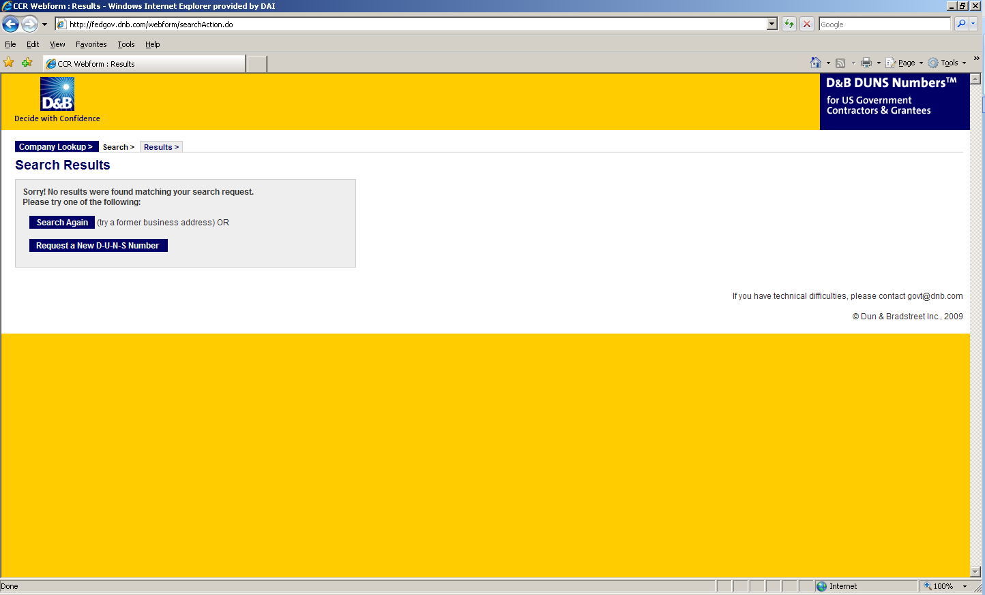

1. Enter the information regarding your organization listed on the next three screens. (See screen shots below.) Make sure you have the following information available (in English) prior to beginning the process of entering this section in order to ensure successful registration.

* Legal Business Name (commas are allowed, periods are not allowed)
* Address
* Phone
* Name of Owner/Executive
* Total Number of Employees
* Annual Sales or Revenue (US Dollar equivalent)
* Description of Operations

1. Note that some fields are Optional, however all other fields must be completed to proceed further with the application process. For example, all applicants must complete the Organization Information sections. The Company Name and Physical Address fields are self-populated based on information previously entered during the initial DUNS search. The question marks to the left of the field provide additional information when you click on them.

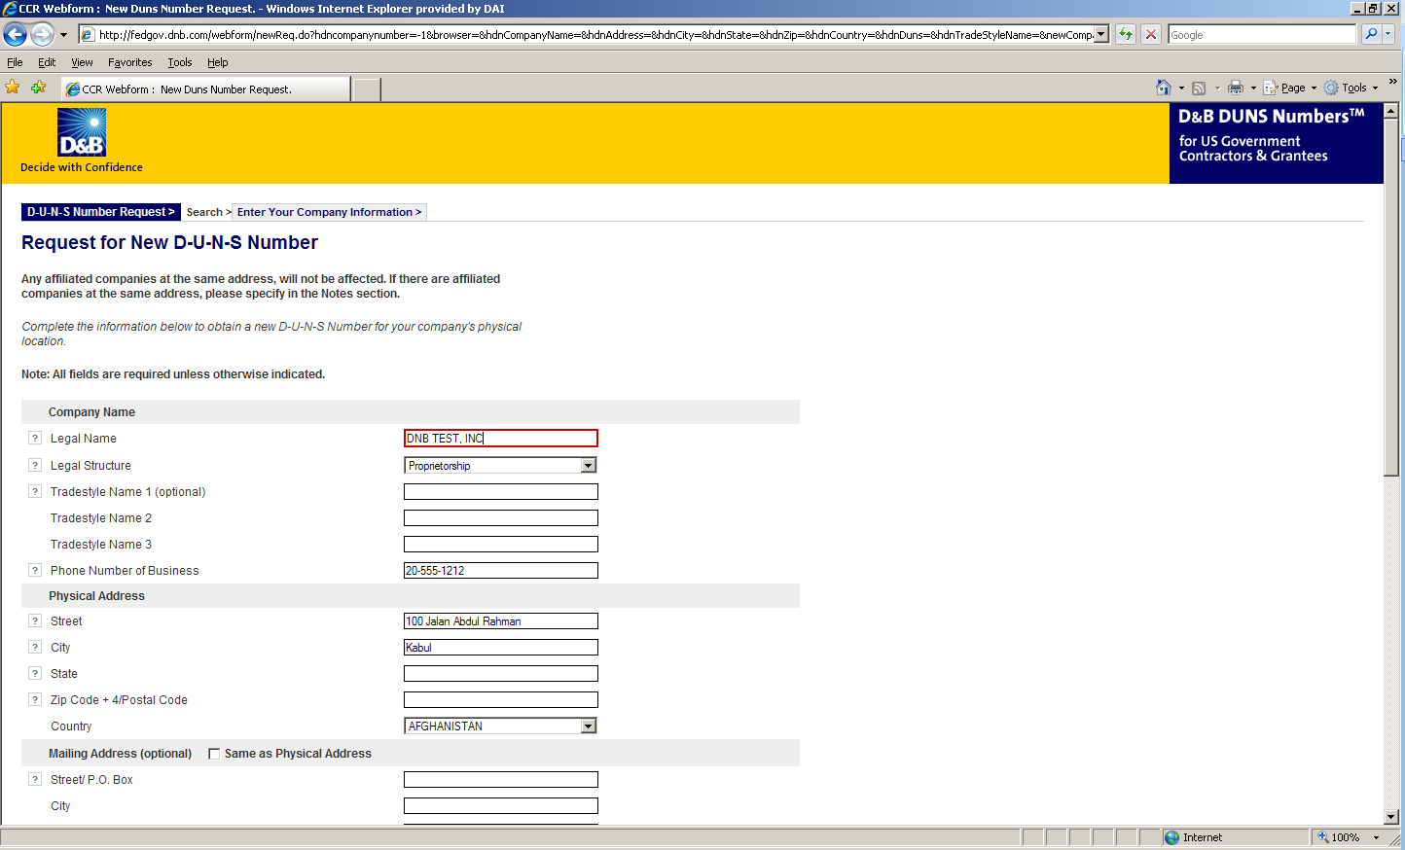

1. You must select the legal structure of your organization from the pull-down menu. To assist you in selecting the appropriate structure that best represents your organization, a brief description of the various types follows:

* **Corporation –** A firm that meets certain legal requirements to be chartered by the state/province in which it is headquartered by the filing of articles of incorporation. A corporation is considered by law to be an entity separate and distinct from its owners. It can be taxed; it can be sued; it can enter into contractual agreements.
* **Government** - central, province/state, district, municipal and other U.S. or local government entities. Includes universities, schools and vocational centers owned and operated by the government.
* **Limited Liability Company (LLC) -** This is a type of business ownership combining several features of corporation and partnership structures. It is designed to provide the limited liability features of a corporation and the tax efficiencies and operational flexibility of a partnership. Its owners have limited personal liability for the LLC’s debts and obligations, similar to the status of shareholders in a corporation. If your firm is an LLC, this will be noted on the organization’s registration and licensing documents.
* **Non-profit -** An entity which exists for charitable reasons and is not conducted or maintained for the purpose of making a profit. Any [money](http://www.investorwords.com/3100/money.html) earned must be retained by the organization, and used for its [own](http://www.investorwords.com/3563/own.html) [expenses](http://www.investorwords.com/1842/expense.html), [operations](http://www.investorwords.com/3467/operation.html), and [programs](http://www.investorwords.com/3890/program.html). Most organizations which are registered in the host country as a non-governmental organization (NGO) rather than as a commercial business are anon-profit entities.

**Community based organizations, trade associations, community development councils, and similar entities which are not organized as a profit-making organization should select this status, even if your organization is not registered formally in country as an NGO.**

* **Partnership-** a legal form of operation in which two or more individuals carry on a continuing business for profit as co-owners. The profits and losses are shared proportionally*.*
* **Proprietorship**-These firms are owned by one person, usually the individual who has day-to-day responsibility for running the business. Sole proprietors own all the assets of the business and the profits generated by it.

1. One of the most important fields that must be filled in is the Primary SIC code field. (See screen shot below.) The Primary Standard Industrial Code classifies the business’ most relevant industry and function.

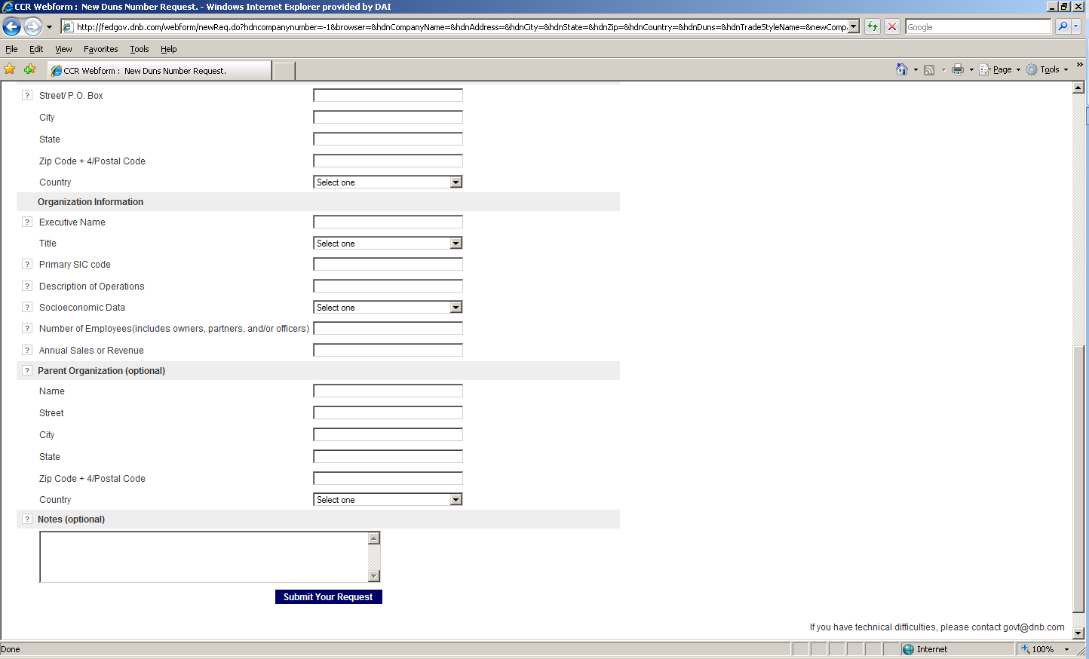

1. If you are unsure of which SIC Code your organization’s core business falls under, please refer to the following website: <http://www.osha.gov/oshstats/sicser.html>

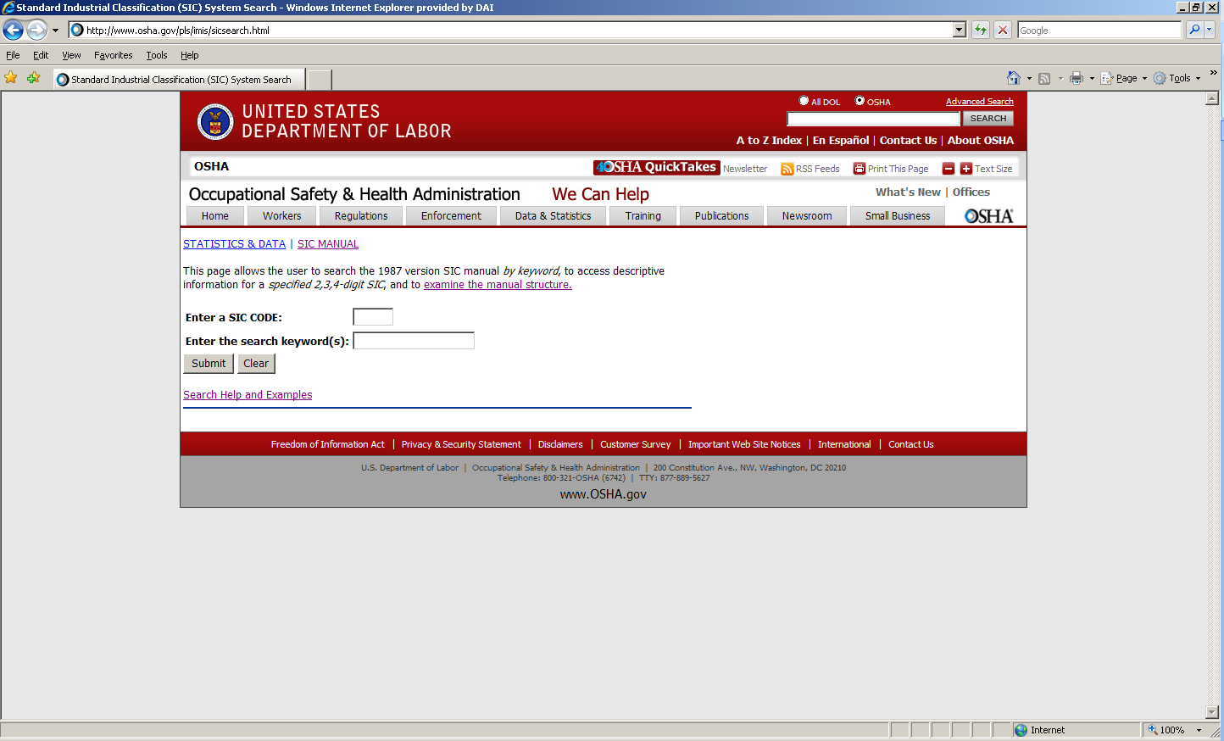

You will need to enter certain keywords to bring up the potential SIC Codes. In the case above, “Research” was entered as the keyword, and resulted in the following:

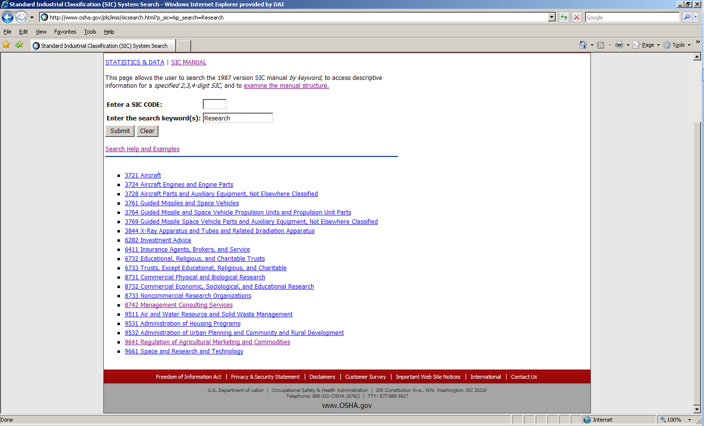

PLEASE NOTE: Many of the DAI subcontractors and grantees fall under one of the following SIC codes:

**8742** Management Consulting Services

1542 General Contractors-Nonresidential Buildings, Other than Industrial Buildings and Warehouses or one of the codes within:

|  |
| --- |
| Industry Group 357: Computer And Office Equipment  Industry Group 355: Special Industry Machinery, Except Metalworking  Industry Group 356: General Industrial Machinery And Equipment  Industry Group 359: Miscellaneous Industrial And Commercial |

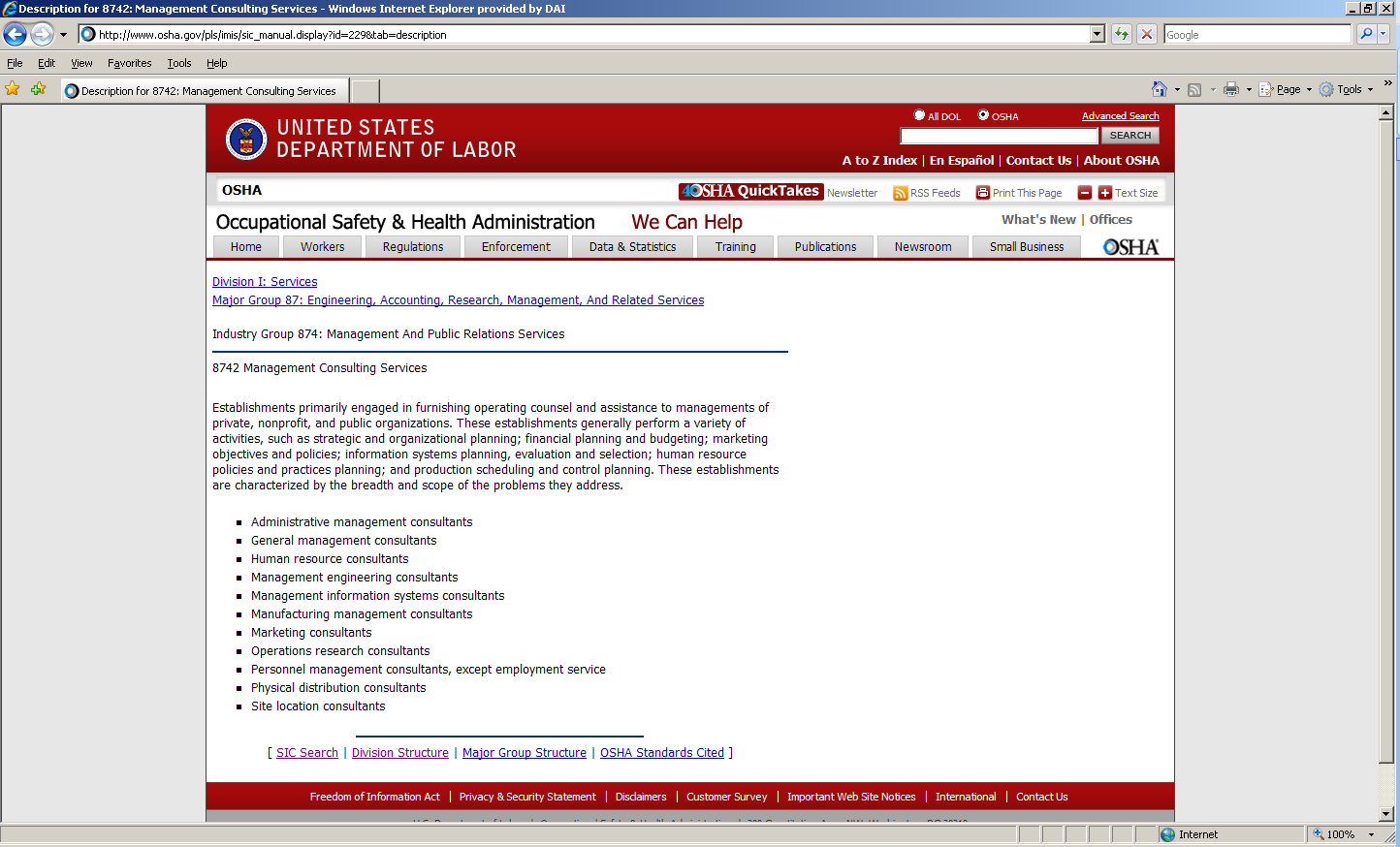

1. Description of Operations- Enter a brief description of the primary services you provide the example below, “agricultural technical assistance” was chosen as the primary function of the business.

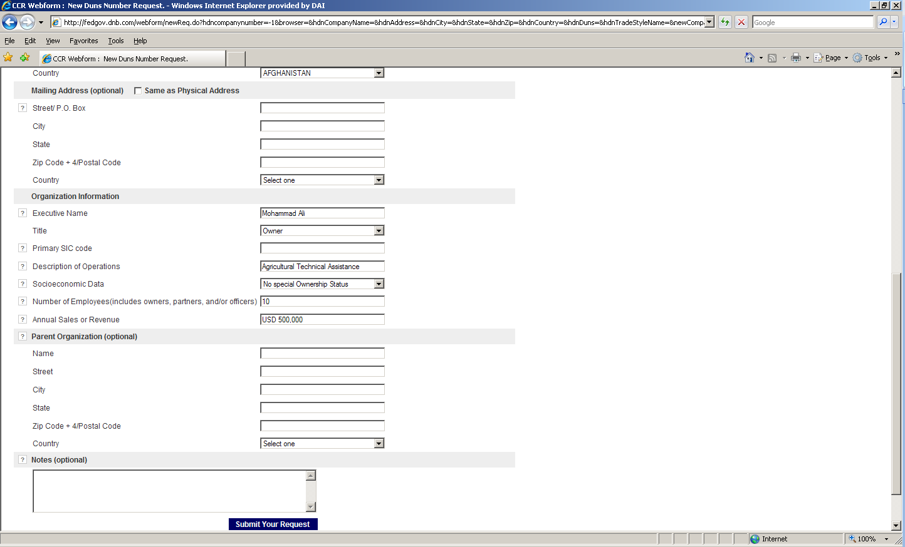

1. The Annual Sales or Revenue figure should be provided in USD (US Dollar) equivalent.
2. Once all of the fields have been completed, click on “Submit Your Request” to be taken to the Verification page.
3. Note: Representative (Principal, Owner or Officer) needs to verify and provide affirmation regarding the accuracy of the data under criminal or civil penalties as per Title 18, Section 1001 of the US Criminal Code.
4. Once “Yes, Continue” button is clicked, the registration application is sent to D&B, and a DUNS number should be available within 24-48 hours. DUNS database can be checked in 24-48 hours by entering the Business Information in the Search window – which should now display a valid result with the new DUNS number for the entity.

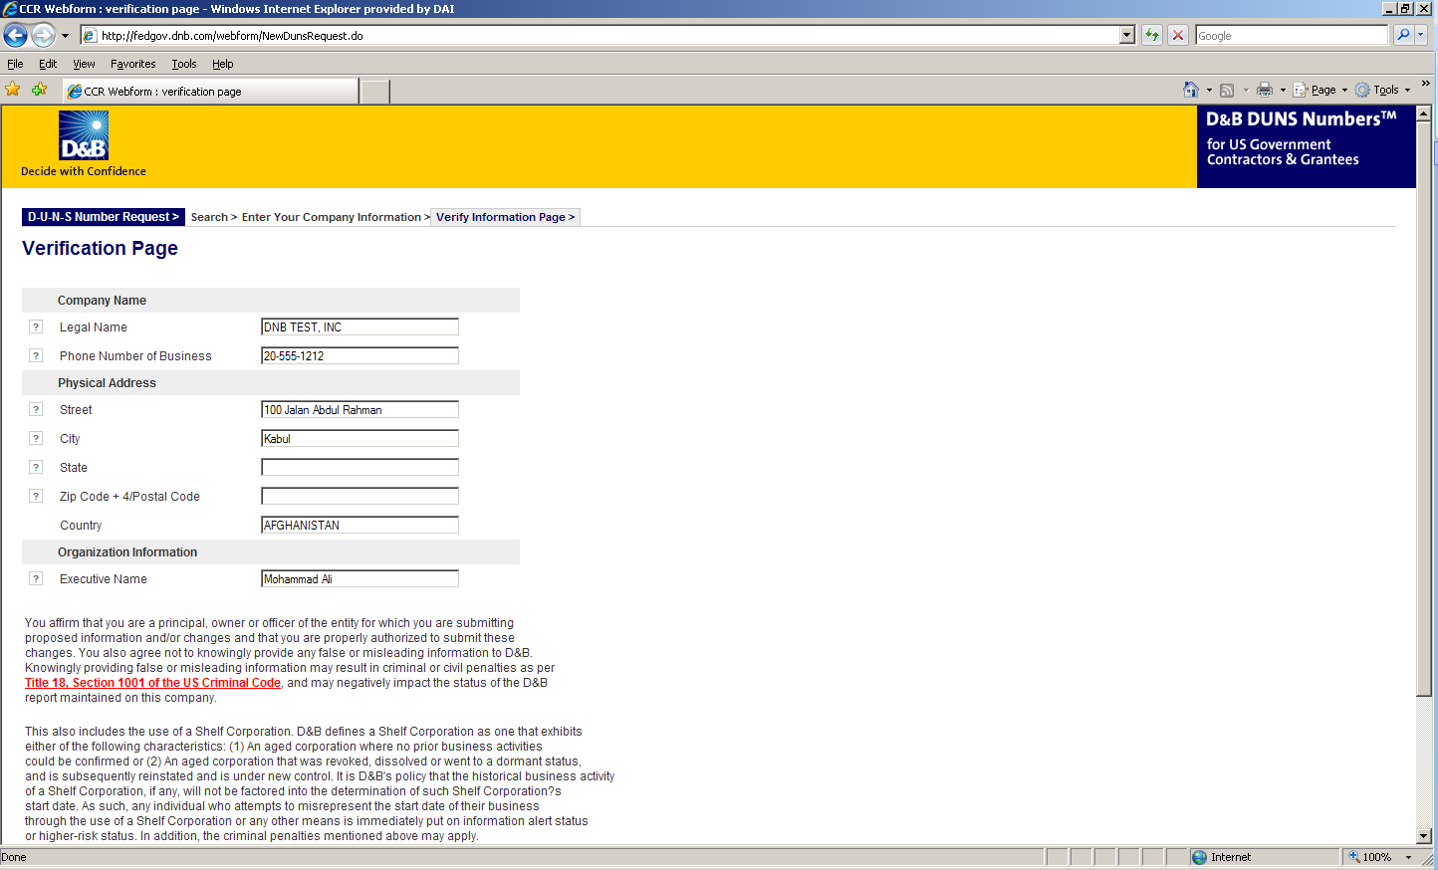

## Attachment E: Self Certification for Exemption from DUNS Requirement

**SELF CERTIFICATION FOR EXEMPTION FROM DUNS**

|  |  |
| --- | --- |
| Legal Business Name |  |
| Physical address of Company |  |
| Physical Country |  |
| Signature and stamp of certifier |  |
| Full Name of Certifier |  |
| Title of Certifier |  |
| Date of Certification |  |

## Attachment F: Representations and Certifications of Compliance

1. Federal Excluded Parties List - The Bidder Select is not presently debarred, suspended, or determined ineligible for an award of a contract by any Federal agency.
2. Executive Compensation Certification- FAR 52.204-10 requires DAI, as prime contractor of U.S. federal government contracts, to report compensation levels of the five most highly compensated subcontractor executives to the Federal Funding Accountability and Transparency Act Sub-Award Report System (FSRS)
3. Executive Order on Terrorism Financing- The Contractor is reminded that U.S. Executive Orders and U.S. law prohibits transactions with, and the provision of resources and support to, individuals and organizations associated with terrorism. It is the legal responsibility of the Contractor/Recipient to ensure compliance with these Executive Orders and laws. Recipients may not engage with, or provide resources or support to, individuals and organizations associated with terrorism. No support or resources may be provided to individuals or entities that appear on the Specially Designated Nationals and Blocked persons List maintained by the US Treasury (online at [www.SAM.gov](http://www.SAM.gov)) or the United Nations Security Designation List (online at: http://www.un.org/sc/committees/1267/aq_sanctions_list.shtml). This provision must be included in all subcontracts/sub awards issued under this Contract.
4. Trafficking of Persons – The Contractor may not traffic in persons (as defined in the Protocol to Prevent, Suppress, and Punish Trafficking of persons, especially Women and Children, supplementing the UN Convention against Transnational Organized Crime), procure commercial sex, and use forced labor during the period of this award.
5. Certification and Disclosure Regarding Payment to Influence Certain Federal Transactions – The Bidder certifies that it currently is and will remain in compliance with FAR 52.203-11, Certification and Disclosure Regarding Payment to Influence Certain Federal Transactions.
6. Organizational Conflict of Interest – The Bidder certifies that will comply FAR Part 9.5, Organizational Conflict of Interest. The Bidder certifies that is not aware of any information bearing on the existence of any potential organizational conflict of interest. The Bidder further certifies that if the Bidder becomes aware of information bearing on whether a potential conflict may exist, that Bidder shall immediately provide DAII with a disclosure statement describing this information.
7. Equal Opportunity – The Bidder certifies that it does not discriminate against any employee or applicant for employment because of age, sex, religion, handicap, race, creed, color or national origin.
8. Labor Laws – The Bidder certifies that it is in compliance with all labor laws..
9. Federal Acquisition Regulation (FAR) – The Bidder certifies that it is familiar with the Federal Acquisition Regulation (FAR) and is in not in violation of any certifications required in the applicable clauses of the FAR, including but not limited to certifications regarding lobbying, kickbacks, equal employment opportunity, affirmation action, and payments to influence Federal transactions.
10. Employee Compliance – The Bidder warrants that it will require all employees, entities and individuals providing services in connection with the performance of an DAI Purchase Order to comply with the provisions of the resulting Purchase Order and with all Federal, State, and local laws and regulations in connection with the work associated therein.

By submitting a quote, bidders agree to fully comply with the terms and conditions above and all applicable U.S. federal government clauses included herein, and will be asked to sign these Representations and Certifications upon award.

## Attachment G: Terms of Contract

**Scope of Work and Conformity Requirements:**

* Conformity: the line should be able to process the desired product/type of product/varieties available in Afghanistan without requiring additional adjustments.
* At its discretion DAI may commission a professional inspection company to visit the Sellers premises before the equipment is delivered to the Buyer to verify that the equipment meets the specifications as outlined in the RFQ and is in good condition prior to final payment. If any defects or issues are identified, the Seller will promptly begin to correct any such non-compliance at the vendor’s expense and again notify the buyer when these works are complete.
* Installation and commissioning: the vendor shall be responsible to install and commission the equipment in its best shape.
* Following the delivery of the Machinery, the Seller shall send its personnel (in the number of persons and for the period he deems enough) to the site of installation of the Machinery, in order to assemble it. Such activity of installation and assembling shall be performed by the Seller.
* After installation, the Seller shall start the machinery and upon completion of such starting the Seller (in person of the appointed technician) shall issue a starting report attesting the execution of the starting procedure of the machinery
* Capacity building: The vendor should provide trainings on operating, routine fine-tuning and servicing the equipment.
* Troubleshooting: The vendor should also provide on the job training on troubleshooting the common problems in the equipment along with indictors and beeps.