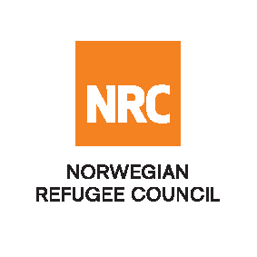

OPEN NATIONAL TENDER
NRC-CO-2021-002 – Framework Agreement for hawala services
The Norwegian Refugee Council (NRC) would like to invite competent companies to submit bids for Hawala Services for the below mentioned Provinces. NRC are looking to enter into a fixed rate, 1-year framework agreement, extendable for two additional years.
Required service | rEQUIRED PROVINCES INCLUDING ALL DISTRICTS
Hawla sERVICES | badakhshan, badghis, balkh, bamyan, daykundi, farah, faryab, ghazni, GHOR, HELMAND, HERAT, JAWOZJAN, KABUL, KANDAHAR, KAPISA, KHOST, KUNAR, KUNDUZ, LAGHMAN, LOGAR, MAIDAN WARDAK, NANGARHAR, NIMROZ,NURISTAN,PAKTIA,PAKTIKA,PANJSHIR,PARWAN,SAMANGAN,SAR-E-PUL,TAKHAR,UROZGHAN,ZABUL

Essential criteria for bidders:
Interested national and international companies should have previous experience of Hawla Services for international organisations (IOs), national or international non-governmental organisations (NGOs) or United Nations (UN) agencies.
Collection of tender documents:
Prospective bidders can download the tender documents from ACBAR websites or may request through af.procurement@nrc.no to receive the tender documents. For any clarification, you can call via +93728932799.

Bids must be delivered in a sealed envelope before the deadline at 04: PM on Wednesday 21 April 2021.
NRC reserves the right to select/reject without any explanation, any bids, in part or full, as it may deem necessary. No liability or claim in that respect would be admissible or entertained whatsoever.

