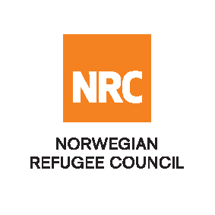

OPEN INTERNATIONAL TENDER
NRC-CO-2021-001 – Framework Agreement to supply and deliver of Educational & HYGIENE KITS
The Norwegian Refugee Council (NRC) would like to invite competent companies to submit bids for the Supply of Educational Kits (Learning, Classroom, Teaching, Items per Project Cycle, BLP and Hygiene Kits) for the below mentioned NRC field offices. NRC are looking to enter into a fixed rate, 1-year framework agreement, extendable for two additional years.
Required Items | Quantity | unit | nrc field offices
Learning kits FOR grade 1-3  (CBC,ALP1 & alp2) | 1 | kit | Kabul, Nangarahar, Khost, kunar,
Learning kits fOR grade 4-6  (CBC,ALP1 & alp2) | 1 | kit
Class KITS | 1 | kit
Teacher kits | 1 | kit
BLP KITS | 1 | kit
HYGIENE KITS | 1 | kit
ITEMS PER PROJET CYCLE | 1 | kit
Essential criteria for bidders:
Interested national and international companies should have previous experience supplying comparable or identical Educational Kits for international organisations (IOs), national or international non-governmental organisations (NGOs) or United Nations (UN) agencies.
Collection of tender documents:
Prospective bidders can download the tender documents from ACBAR and NRC websites or may request through af.procurement@nrc.no to receive the tender documents or, kindly call through +93728932799 for any clarification.

Bids must be delivered in a sealed envelope before the deadline at 04: PM on Tuesday 27 April 2021.
NRC reserves the right to select/reject without any explanation, any bids, in part or full, as it may deem necessary. No liability or claim in that respect would be admissible or entertained whatsoever.

