Blanket
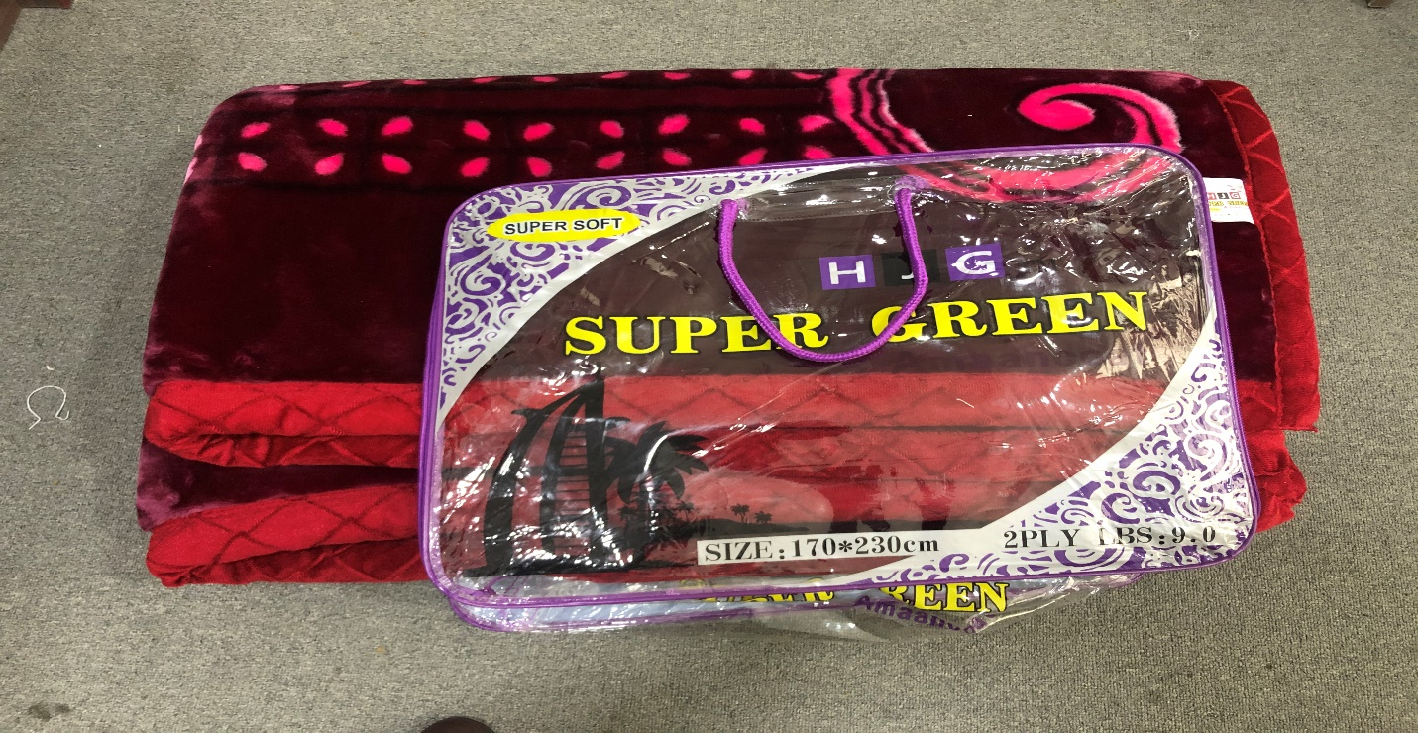
Size 170*230cm, weight, 4 or 4.5 Kg different color

Pillow
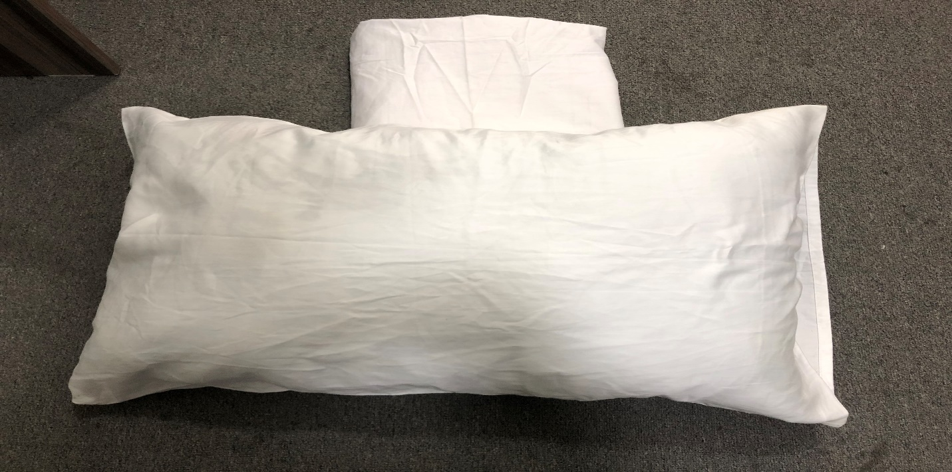
Pillows and bids sheet as attached picture for signal person

Mattress
Size: ½ and height is 15cm made of foam.

