Request for Quotation (RFQ)!
NO: FEDO RFQ 03-2022-Solar Cookers

Friends of Environment and Development Organization, would like to issue the RFQ no. FEDO RFQ 03-2022-Solar Cookers. Therefore, we are kindly inviting you to submit your bid for the above RFQ number through this invitation letter.
RFQs should read these instructions carefully before submitting their responses to the request to quotation (RFQ).
Failure to comply with these requirements for completion and submission may result in the rejection of your RFQ response. RFQs should acquaint themselves fully with the extent and nature of the requirement and contractual obligations and are deemed to have done so before submitting an RFQ.

With Sincerely,
FEDO Procurement Department

Submission Guideline:
Please submit your sealed Quotation to Main office until Aguste 24, 2022 04:00pm. After the deadline the quotation will not be considered. Please clearly mark envelope with RFQ no. indicated in an invitation number and if submit it through fanwari.fedo@gmail.com email address, please write the RFQ no. in subject line, otherwise your RFQ will not be considered.
The RFQ should submit sealed hard copy to the FEDO Organization main office located at, Ahmad Sha Baba Mina, Sirdar Dawad Khan Squire (Arzan Qumat) Ninth Block, Kabul City
RFQ submitting through email also acceptable.
Contact No: +93 783292437
Basic of Award:
Award will be made to the responsible bidder whose bid is responsive to the terms of the RFQ Low Price Technically, Standardly Acceptable. To be considered for award, bidders must meet the requirements of the RFQ Requirements.

Solar Cookers must be in good condition and according to given information the quality must be have good condition. Solar cookers must have warranty and guaranty documents.
Note: 4% withholding tax for those who has valid commercial license and 7% tax is applied for individual. FEDO possess the right to withhold tax from the contractor at the time of payment.
Please put your price in the above price schedule and return back to us by data and time specified above.

Delivery Time: During one month after contract singing.

Put the Solar Cookers Specifications and Quote Price in the bellow table.

Item | Unit | Quantity | Rate
1. Solar Cooker Type: Parabolic type 17Kg  2. Cooking Time: Providing food for 10 people in 2hrs  3. Packaging Box Size: (LxWxH) 48x16x4 inch  4. The solar cooker should have a horizontal cooking pan which should connect to a strong potholder and it should be at the center of the sun rays.  5. The cooking pan should be strong with the size of 25cm. The cooking pan is 25cm and very strong having the bearing capacity of over 50 Kg  6. All the pipes of cookers should be galvanized (to be rust-proof) and strongly welded  7. All the pipes should be welded well for at least 50Kg load bearing capacity.  8. Solar cooker should easily move around the house in rainy & snowy season as this initiative is not common in local area. (for more info, two photos are attached).  9. Steel, Iron, iron profile, Mirror, Frame Stand and others required materials should be high quality. | Package | 850

Shape Photos:

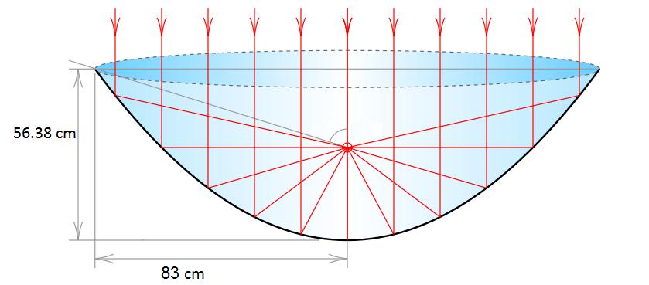

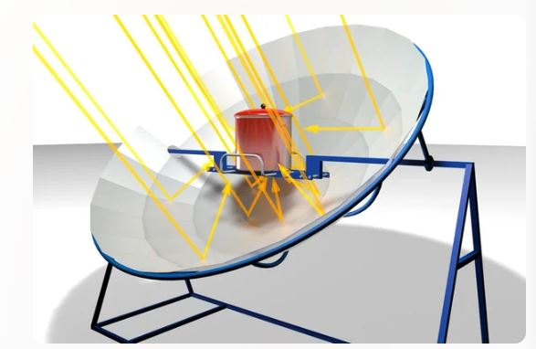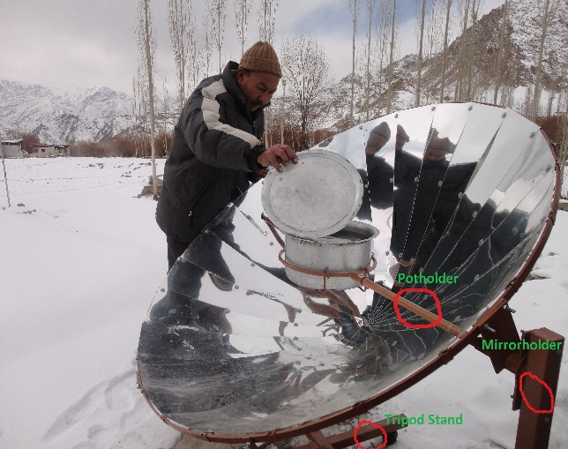

Authorized Signature: ________________ Location: _____________________

Name: _____________________ Telephone: _____________________

Name of Company: ______________________ Email Add:_______________________

Company Stamp

Please attach your valid business license and profile of your company in case individual quote attach the your Tazkira or national ID Card.

