AFGHANISTAN SPECIAL REPORT: Pre-Harvest Assessment | June 2016
Wheat production expected to be similar to slightly higher than last year in most areas

KEY MESSAGES
Figure 1. The Normalized Difference Vegetation Index (NDVI) for May 11 to 20, 2016, compared to the 2001-2010 average across Afghanistan.

Source: USGS / FEWS NET
Note: The NDVI is a satellite-based measurement of vegetative greenness. Positive values (green) indicate above-average greenness, whereas negative values (brown) indicate below-average greenness.

- National wheat production in Afghanistan is likely to be the same or slightly above that of last year, due to relatively favorable weather and precipitation conditions, which has resulted in increased cultivation of both rain-fed and irrigated wheat at the national level.
- The recent winter wheat harvest in Pakistan and the upcoming spring wheat harvest in Kazakhstan are both expected to be sufficient to allow normal trade flows of wheat and wheat flour into Afghanistan at stable prices.
- The incidence and severity of spring flooding has been less than last year, and the impact on national cereal harvests is expected to be lower. However, floods have had significantly adverse impacts in affected areas.
- Although agricultural production is expected to be the same or slightly above that of last year, many IDPs affected by conflict, as well as returnees and households affected by natural disasters such as flash floods, plant diseases, and pests, will experience acute food insecurity.
- Although fluctuations in staple food prices have been minimal, reduced labor wages and livestock prices in some areas during the lean season have likely impacted the purchasing power of households who mostly rely on labor and livestock production for income and food access.
- Timely availability and accessibility of quality agricultural inputs (Improved seed, fertilizer, hand tools and chemicals) are crucial. Also, further improvement and strengthening of veterinary and agricultural extension services is required.
- Evidence of average wheat production, stable food prices, increased coverage and continued support of nutrition services indicate that the national level of acute malnutrition will remain the same or be negligibly different than that of last year. However, an increase in the level of Global Acute Malnutrition (GAM) is expected in Kunduz, Baghlan, Helmand and Nangarhar provinces as a result of continued conflict which limits health and nutrition services and food accessibility.
- This pre-harvest assessment, with information collected in April and May 2016 reflects cropping progress and conditions at the time of data collection, and the expected outlook for the upcoming harvests. The Ministry of Agriculture, Irrigation, and Livestock (MAIL) will provide specific wheat production estimates in its post-harvest report, expected by the end of July 2016.
SEASONAL CALENDAR FOR A TYPICAL YEAR
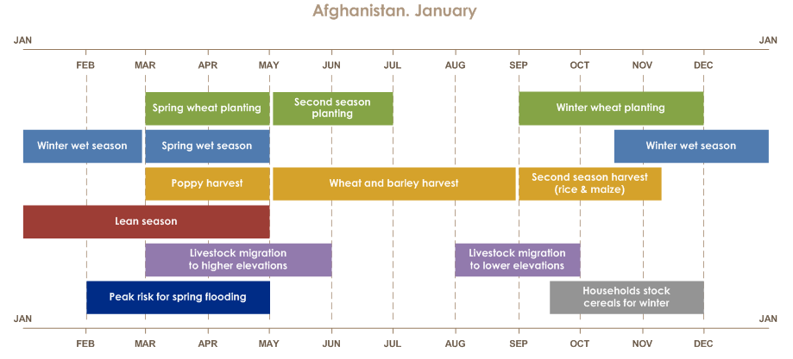

Source: FEWS NET
Figure 2. Precipitation from October 1, 2015 to May 31, 2016 compared to the 2002 to 2011 average
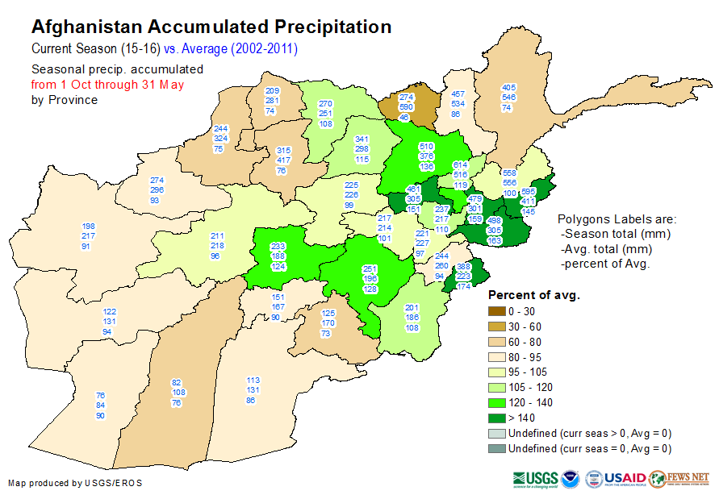

Source: U.S. Geological Survey/FEWS NET

NATIONAL OVERVIEW

Current Situation

Although there was strong early precipitation for the 2015/2016 wet season in October, this was followed by an extended dry spell. Lack of precipitation, especially snow, delayed the rainfed wheat cultivation. More than the dry spell, the overall timing and frequency, and distribution of precipitation during the season were conducive to agricultural production. Accumulated precipitation from October 2015 to February 2016 was below the long-term average (2002-2011) in most parts of the country except four provinces. In late February, large storms hit Afghanistan, bringing significant snow accumulation in higher elevations. Although precipitation totals during the spring have been average to above-average, total accumulated precipitation for the October – May season remained below-average in eight provinces, and below that of the previous season in three provinces, particularly in northern, northeastern and southern Afghanistan (Figure 2).

Afghanistan experienced a mild winter with higher temperatures throughout the wet season. Higher temperatures resulted in less frost damage, which helped with orchard output especially in almond production when compared to previous years.

Areas planted with wheat during the 2015/2016 season increased more in irrigated and rainfed regions compared to the 2014/2015 season. The increased planted area on irrigated land is mainly located in the northeastern, north central, western and south eastern parts of the country. While rainfed wheat cultivation increased at the national level, the planted area for rainfed wheat decreased in some provinces in the north eastern, north central, south central and southern parts of the country due to a two month dry spell at the beginning of the wet season/ cultivation season.

In terms of regional production, Pakistan is expected to harvest 27.5 million metric tons (MMT) of wheat, which is higher than last year and average. Kazakhstan’s wheat production was similar to average and six percent above the 2014/15 production output. In most areas, labor wages are currently lower than that of last year especially in the south eastern region where it has deteriorated significantly by 24%. The northern region had an increase and the eastern, north eastern and western regions show similar labor wage to that of 2015. Decreased labor wages are primarily due to a lower demand from the construction and other industrial sectors. Increased conflicts and the withdrawal of the International Security and Assistance Force (ISAF) has also been a contributing factor to reduced investments in new construction.

Late, but well distributed, spring rains not only provided favorable conditions for crops, but also led to good pasture conditions. This has resulted in seasonally improved livestock health and helped maintain livestock prices above last year.
Higher livestock prices are likely to increase the agro-pastoralists’ and pastoralists’ (Kuchis’) purchasing power for procuring food. The sheep to wheat ToT ratio has improved in six regions (northeastern, northern, south-central, western, south-western and central highlands) due to good livestock and pasture conditions, while deteriorating in three regions (eastern, south-eastern, and north-central).

The incidence and severity of spring flooding has been less than last year, and the impact on national cereal harvests is expected to be minimal. However, floods have had an adverse impact in the areas and valleys where they occurred, particularly in some parts of northern, north-eastern, north-central, south-central and central Afghanistan. Spring rains also caused flooding and some landslides. According to the United Nations Office for the Coordination of Humanitarian Assistance (OCHA), spring floods from localized spring flooding, which has taken place in 26 of 34 provinces, has had devastating impacts for households in some of the affected valleys. Based on estimations by UN OCHA, flooding between April 1 and May 18, 2016 has killed 83 people and destroyed 1,956 homes, affecting a total of 6,969 households. However, the impact on the national-level cereal harvest is likely to be minimal.

Overall, external food assistance in most areas that was observed or reported during the assessment was less than in 2015, mainly due to reduced funding and a lack of resources. The limited resources are mainly prioritized for assisting acutely food insecure people.

Rural households who rely on their own production will have greater stocks of staple foods and increased cash from crop and fruit sales especially for almonds produced northern and northeastern provinces due to improved harvests as compared to the previous year. Relatively stable food prices and a normal supply of wheat and wheat flour from Pakistan and Kazakhstan are favorable factors for households who rely on market purchases. However, reduced labor wages and livestock prices in some areas during the lean season have likely impacted the purchasing power of households who mostly rely on labor and livestock production as their main income source.

The pre-harvest assessment 2016 desk review and the flash field visit conducted in the east, north and northeast regions for nutrition prospects reveal that the national acute malnutrition situation this year remained similar to that of last year, because of the average harvest, strength of health, particularly nutrition services, and increased coverage of nutrition service availability. But security constraints which fluctuated by seasons, was identified as a factor of concern that prevented improvements in the country’s nutrition status.

Food Security Outlook

With production from the wheat harvest between June and September 2016 expected to be the same or negligibly greater than last year, most sources of food and income would be available the same or at slightly higher levels than last year. The wheat harvest will increase food availability at the household level and drive down prices in markets. Wheat-producing households are likely to be able to store the same or slightly higher amounts of stock in the 2016/2017 consumption year when compared to last year. Sharecroppers and agricultural laborers paid in-kind are likely to have the same or slightly higher amounts of food for the period.

With adequate supplies of wheat and wheat flour likely to remain available from Kazakhstan and Pakistan, and the near average domestic harvest, wheat and wheat flour prices are likely to remain generally stable through September in rural Afghanistan, after which they may rise due to a seasonally increased demand for households and traders to purchase stocks for the coming winter and 2017 lean season.

Due to a mild winter there was no frost at all for Stone fruit and other orchard crops this year, in the northern region, while the western, south-western and central regions were in a much better condition than last year. This is likely to improve income from sales of horticulture productions.

Livestock prices are likely to remain higher than last year in most parts of the country (except for the south-eastern and east central regions where livestock price decreased). With more money to purchase food, and/or higher stocks from household self-production, the February to April 2017 lean season is likely to be not as severe as usual. However, the typical seasonal reduction in dietary diversity for most poor and for chronically food insecure households, in the winter and lean season, will still occur.

Pastoral households’ economic access to food has already increased in most parts of the country due to higher livestock prices, particularly for sheep, while poor and landless households continue to depend primarily on agricultural labor wages, which are generally similar to last year, although with some variability across the country. This will provide similar or slightly lower economic access to food in some areas due to rising food prices in those locations. Labor wages are expected to seasonally increase in the coming months, and will be slightly higher than the seasonal average. Wages generally peak during the wheat harvest, when a laborer is likely to earn AFN 600 - 1000 (USD 8.7 – 14.7) per day in northern wheat-growing areas. With the increase in planted area this year, labor demand will be higher during the harvest, further increasing wages.

Conflicts, small-scale flooding, and crop diseases and pests are common shocks that were reported almost all over the country. Wheat rust was reported and observed in the eastern region, west and south-west, wheat smut was observed in north-central region. These factors may reduce yields to some extent in these areas. However, these shocks are limited in terms of area affected and severity. In most cases, they are not likely to prevent crops from reaching maturity or cause damage to the wheat grain.

Internally displaced people (IDPs) and some returnees are likely to be acutely food insecure. The newly displaced IDPs are likely to require assistance, as many of them have lost their homes, access to land, and other assets. From January 1to April 30, 2016, 117,976 individuals fled their houses due to conflict around the country. 24 of 34 provinces recoded some level of forced displacements. Returnees from Pakistan, particularly those who have been unable to return to their places of origin, are also likely to be acutely food insecure due to their limited access to secure livelihoods in their new locations. However, in some cases, these households have received some assistance for returning. At least 5,164 individuals were affected by natural disasters including floods across the country. These households have lost homes, assets, and crops, and will likely be acutely food insecure as many will be unable to harvest this year. Many of these households are already receiving assistance from the Government of the Islamic Republic of Afghanistan (GIRoA) and humanitarian organizations.

In Afghanistan, floods are among the most frequent and costly natural disasters in terms of human hardship and economic loss. As much as 80 percent of the damage related to all natural disasters is caused by floods and associated debris flows. Several factors contribute to flooding. Two key elements are intensity and duration of rainfall. Topography, soil conditions, and ground cover also play important roles. Most flash flooding is caused by slow-moving thunderstorms, thunderstorms repeatedly moving over the same area, or heavy rains from hurricanes and tropical storms. Floods, on the other hand, can be slow- or fast-rising, but generally develop over a period of hours or days.

Forecasts do not anticipate abnormally heavy or long rains during the coming months, which will limit the extent of floods and flash flooding.

The national level of acute malnutrition is expected to remain similar to that of last year through the year 2016 as a result of average wheat production, staple food price stability, continued health & nutrition support programs, enhanced capacity of implementing NGOs, and increased awareness of people on age appropriate feeding. However, as a result of continued conflicts in Kunduz, Baghlan, Helmand and Nangarhar provinces, which limits health & nutrition services and food accessibility, deterioration of the nutrition situation is expected over the same period.

BACKGROUND AND OBJECTIVES

Figure 3. Assessed areas, April and May 2016
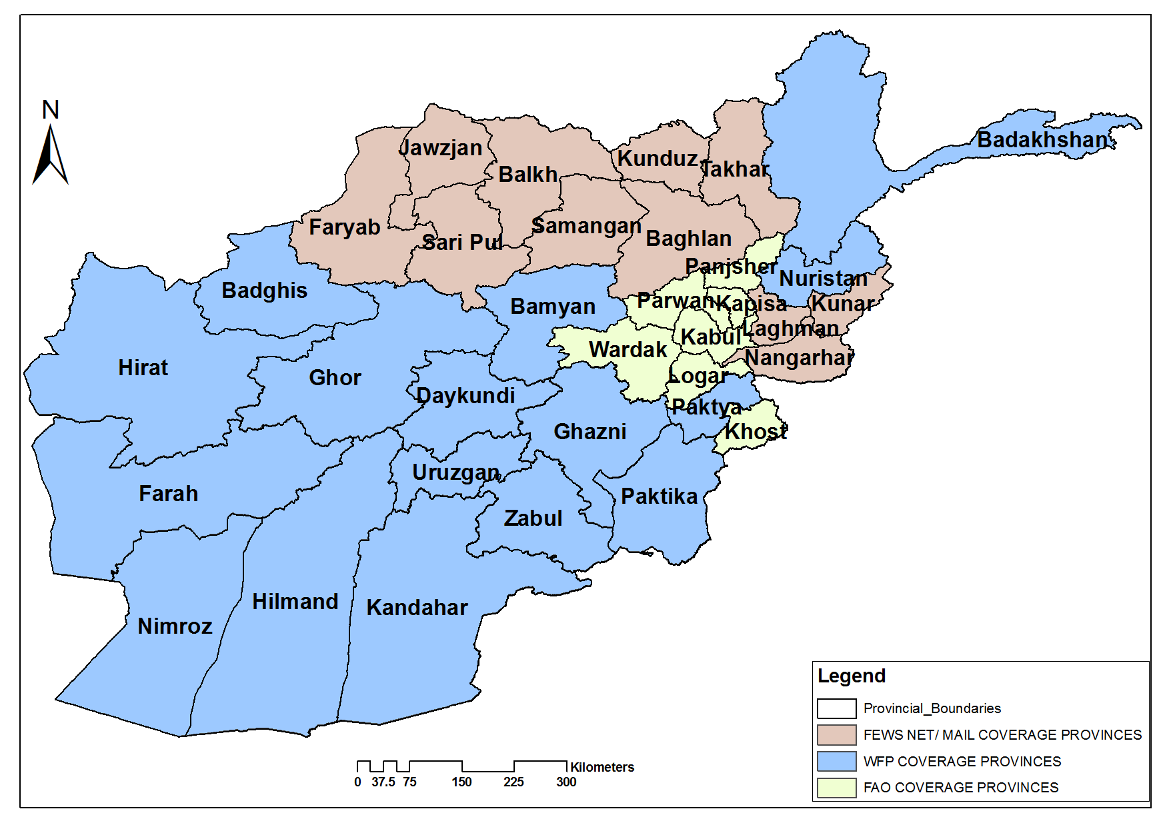

Source: FEWS NET

Since 2008, the pre-harvest assessment - which has also been referred to as the food security appraisal in some years, has become a tool for filling the information needs for timely programming and decision-making regarding the food insecurity response in Afghanistan.

Similar to the previous pre-harvest assessments, the 2016 assessment’s primary purposes are to: i) pre-determine key areas of concern that may likely affect the food security outcomes; ii) identify types of shocks that may cause acute food insecurity; and iii) perceive the status of upcoming wheat harvests.

By undertaking the pre-harvest assessment, the World Food Program (WFP), the Food and Agriculture Organization of the United Nations (FAO) and the Famine Early Warning Systems Network (FEWS NET) with support from the Ministry of Agriculture, Irrigation, and Livestock (MAIL), are collaborating to provide information to the Government of the Islamic Republic of Afghanistan (GIRoA), as well as other stakeholders and donors to gain a greater understanding of the progress of the agricultural production season, including recent or potential shocks that are likely to impact food security over the coming consumption year. In cases where below-average production is expected, the pre-harvest assessment helps define which areas are most affected and in which areas require further monitoring and investigation to determine the likely severity and prevalence of acute food insecurity.

Specific objectives:

1- Observe standing crop conditions, current and potential shocks to crops, and stakeholders’ perceptions about 2016 harvests.

2- Assess factors relevant to food access, including any changes in wages and availability of labor opportunities, as well as Terms of Trade (ToT) of labor to wheat, and sheep to wheat.

In addition to its focus on domestic agricultural production, the assessment also provides information on other key determinants of food access from markets, especially major sources of income in rural areas such as livestock prices and agricultural labor wages. The assessment examines the livelihood options available to poor and food insecure households to better inform how humanitarian response can complement existing livelihoods and coping strategies.

METHODOLOGY

The assessment has been conducted in 70 districts of all the 34 provinces in Afghanistan during the two weeks of April and two weeks of May 2016 (Figure 3). In each province, two districts are covered - usually one district with intensive irrigated land and another primarily rain-fed. Due to the highly diverse livelihoods and high chronic levels of food insecurity in Badakhshan, four districts in this province were assessed. In each of the selected districts, two communities/villages are surveyed – usually one is located on an upstream area that is likely to have better water access and another mostly in a downstream area. In total, 140 communities are covered.

The assessment consists of three survey modules. The first module is for interviews with the Department of Agriculture, Irrigation, and Livestock’s (DAIL) provincial offices, with a total of 34 questionnaires completed. The second module is for interviews with the staff of non-governmental organizations (NGOs), United Nations (UN) agencies, or other organizations working in humanitarian relief, development, or agriculture, with a total of 54 questionnaires completed. The third module is for community-level/village-level focus group discussions based on the rapid rural appraisal (RRA) methodology’s reliance on self-reporting by communities, with 140 questionnaires completed.

Activities and Level of Effort:

A combination of techniques were used in this assessment:

- Data collection. Data was collected from farmer focus groups, MAIL provincial departments, local NGOs, UN agencies, and district development councils. In addition, direct observation was used for verification of the collected data, and remote sensing data was matched with the ground situation. Data collection took place from April 15 to May 10, 2016.

- Trainings and workshops. In each region, training was provided to field monitors and data collectors where pre-harvest assessment objectives, methodology, and tools were explained in detail. This training included role plays with data collectors to familiarize them with the data collection techniques and assessment tools.

Figure 4. Eastern provinces
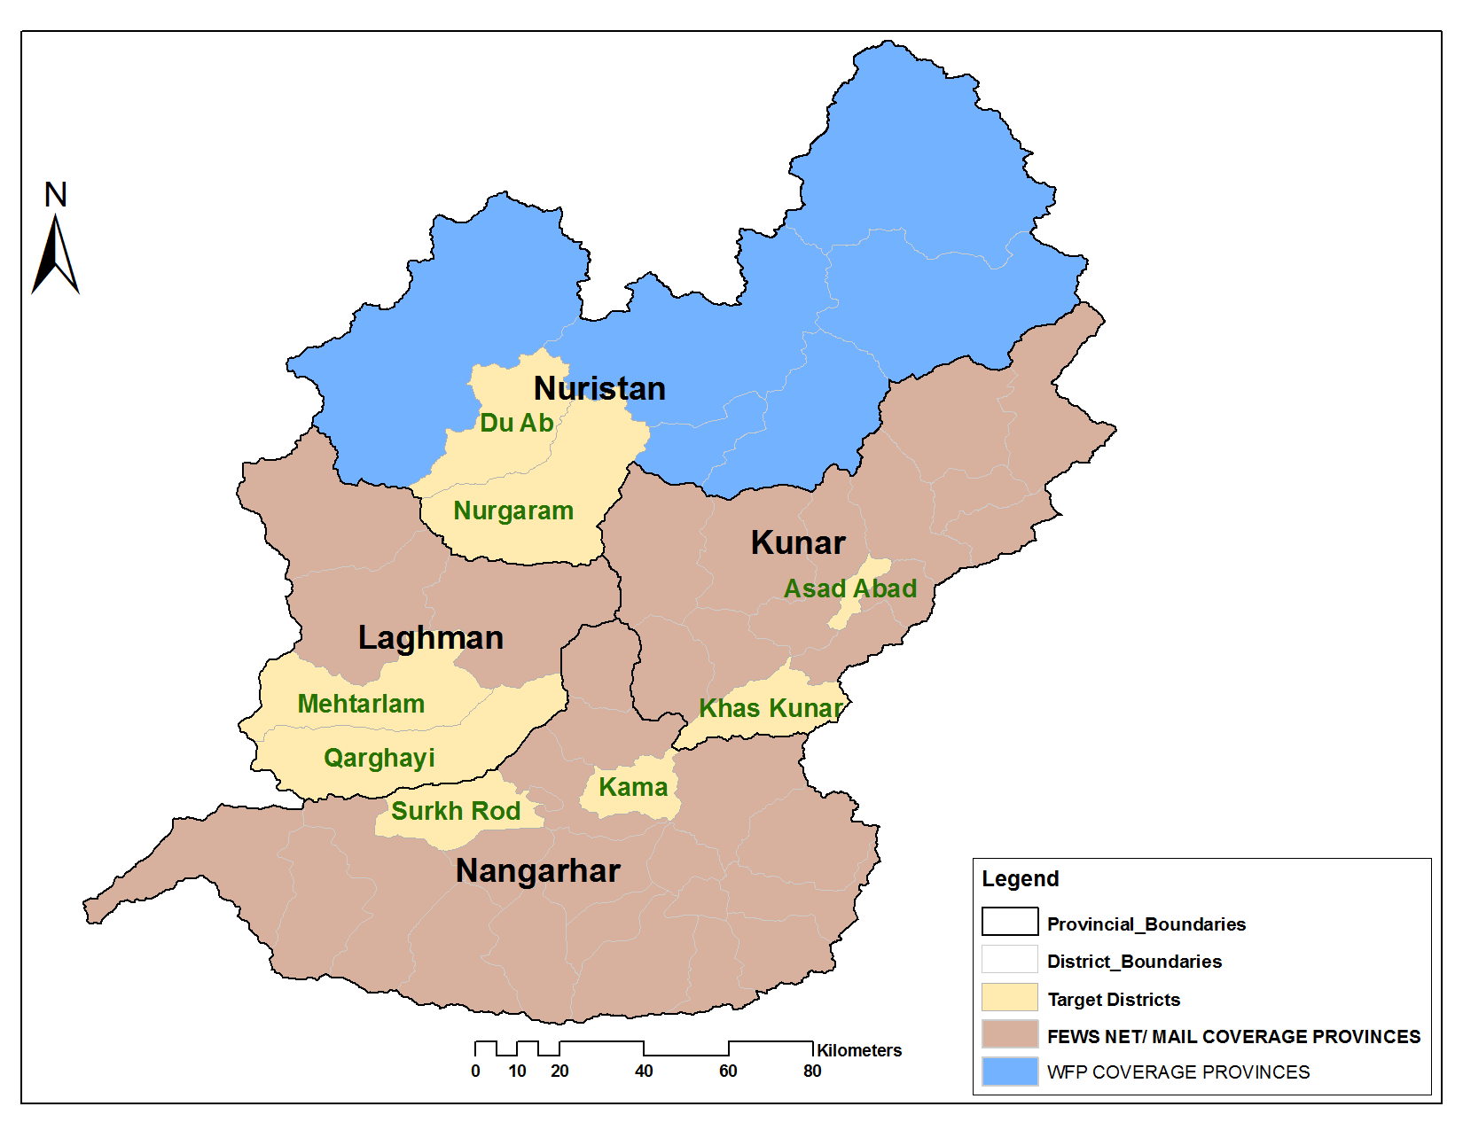 Source: FEWS NE T

MAIN FINDINGS

Eastern Provinces: Kunar, Nangarhar, Laghman, and Nooristan

(Urban population: ~257,355 people, rural population: ~2,349,536 people)

Current Situation

Livelihoods in eastern Afghanistan (Figure 3) largely depend on irrigated agriculture. Only 6,000 hectares (ha) of rainfed land are typically cultivated in the Sarkano and Marawara Districts of Kunar Province. The Kabul, Kunar, and Laghman rivers supply most of the irrigation water in this region. Vegetable production provides the largest source of cash income in the intensive irrigated areas. The share of land used for vegetable production has increased considerably over the last 11 years because of the high profit margin compared to wheat grain production, and due to the short distance to major urban markets including Kabul and Jalalabad. Although households cultivate wheat for their own consumption, they tend not to sell it. In Jalalabad, the Pakistani rupee (PKR) is the primary currency for cash transactions, while in Kabul, the Afghani (AFN) is the means of payment. As PKR is the most commonly used currency in much of eastern Afghanistan, vegetable producers take advantage of both better prices and the favorable AFN to PKR exchange rates by selling in Kabul.

Above-normal precipitation led to localized and mild wheat stem rust in some areas especially in Laghman province that almost 20% of their wheat fields were affected by yellow rust. The impact was localized and did not significantly affect a substantial area.

Arable land is limited in high-elevation areas. The primary income source in these areas is from formal employment, typically in the security fields of the Afghanistan National Army (ANA), the Afghanistan National Police (ANP), and the Afghanistan Local Police (ALP). Formal employment is an important secondary source of cash income in the intensive irrigated areas. The second major source of cash income is agricultural labor. During the year, this income source was the same as last year due to good production and high demand for agricultural labor. Agricultural production is a major source of food in both intensive irrigated and high-elevation areas with almost all crop production in high elevation areas being for self-consumption. In some the districts in Nangarhar, Kunar, Laghman and Nooristan provinces, is poppy production is a good source of income. Poppy planted areas are reported to have increased.

Poor households consume primarily from their own production during the summer and fall, but purchase staple food items from markets in the winter and spring. Currently, households are primarily consuming their own production of vegetables and livestock products along with purchased wheat. Planted area under wheat cultivation is similar to that of last year with insecure districts of Nangarhar being exceptions as poppy has replaced wheat on many farms. Crops are generally in better condition when compared to the last two years because of the above normal spring, March to May, rains.

According to the nutrition rapid field visit conducted in the eastern provinces, the level of acute malnutrition has slightly decreased when compared to the same time last year, because of significantly increased health and nutrition service coverage, community mobilization services, case identification and admission service. Also, a decrease in the level of morbidity, particularly the malnutrition associable diseases, has been an influential factor. Desk review findings for levels of acute malnutrition were significantly higher in Laghman and Nuristan provinces when compared to Kunar and Nangarhar provinces. Poor WASH and IYCF practices and inaccessibility to adequate nutritious food were recognized as major causes of malnutrition in the eastern region.

Food Security Outlook

The wheat harvest is underway. Many farmers and other observers expect it to be slightly below last year in terms of total volume. The harvest can typically last a household six months in high-elevation areas and 10 months at lower elevations. As winter approaches, poor households switch to market purchases. This year, households are expected to be able to make normal market purchases, as major sources of income are likely to be higher than in a normal year. Agricultural labor wages are expected to be higher than last year due to seasonally normal crop development and above-average livestock prices. The level of formal employment with ANA, ALP, and ANP is stable.

Favorable cropping conditions and food security outcomes are likely to continue, but potential shocks such as flooding and conflicts could change food security outcomes for affected households. Floods often occur between June and August, associated with very heavy rains during the Indian Monsoon, though this may be less of a risk this year due to an expectation for suppressed monsoon rains.

Humanitarian access to rural areas continues to decline, primarily due to civil insecurity. The Norwegian Refugee Council (NRC) and International Rescue Committee (IRC) are the leading agencies serving IDPs, and their local staff indicated that they have sufficient funds to deal with potential displacement if it occurs at levels similar to recent years. Currently, acute food insecurity is concentrated among IDPs, returnees, and households affected by small-scale floods.

Figure 5. Northeastern provinces

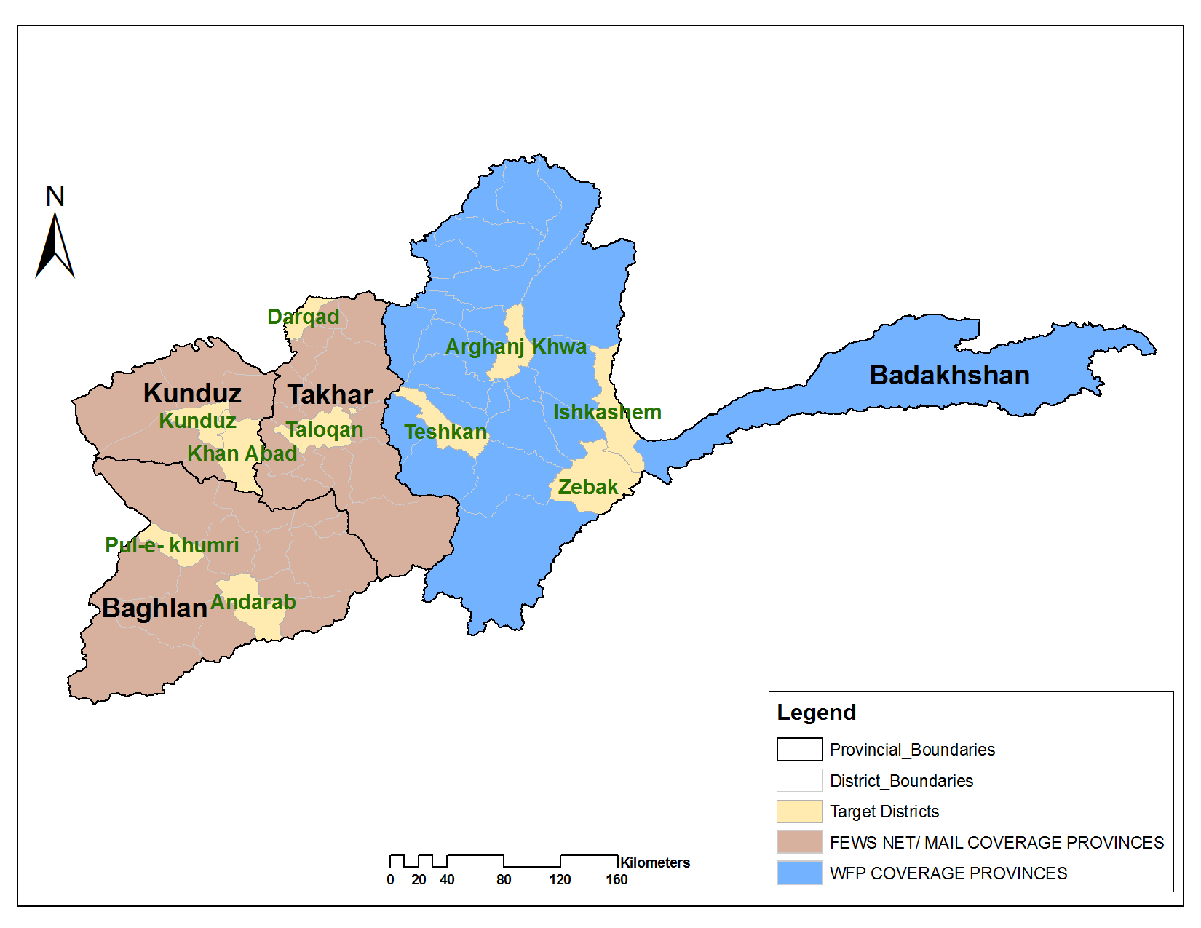 Source: FEWS NET
Northeastern Provinces: Baghlan, Kunduz, Takhar, and Badakhshan

(Urban population: ~625,338 people, rural population: ~3,298,229 people)

Current Situation

Northeastern Afghanistan (Figure 4) has many areas that produce an agricultural surplus, particularly wheat production. The arable land of this region is a mixture of irrigated and rainfed, but the population is mostly concentrated in irrigated areas.

Some household members from the poor wealth group who live in the highlands migrate to large farms in the lowlands during the wheat harvest and during rice planting in search of day labor opportunities, which provides a significant source of income. When the harvest is complete in the lowlands, they return to their villages in the highlands to harvest their own crops, which typically takes place two and a half months later. Other major sources of income and food in this region include sharecropping, livestock production, and formal employment with the ANA, ANP, and ALP. Labor migration to neighboring countries especially Iran is another major source of income for the poor households of this region.

Current labor wages are similar to last year. Areas planted under wheat are reported to be higher than last year, particularly on rainfed land. Crop conditions are generally better than during the previous year, and livestock prices are higher, by approximately AFN 500 per head in the case of sheep.

There are over 38 flood-affected households in the northeast. In the entire north, including the provinces of the northeastern region. Many of these people are acutely food insecure or require close monitoring of their food security.

The rapid field review and the desk review on nutrition prospect as a part of PHA 2016 report found that the nutrition situation had deteriorated in the northeast provinces particularly of Kunduz province due to the extremely high security constraints. The level of acute malnutrition was significantly higher in Kunduz province followed by Takhar province when compared to the rest of the provinces in the northeast region.

The rural people of Wakhan district are having chronic food insecurity problem with rural poverty and cultured agriculture combined with livestock husbandry appropriate to their tough environment, they also find it difficult to produce sufficient grain to last from one harvest to the next. Some nutritional use is made seasonally of wild plants, particularly common field weeds and a variety of wild onions.

During the winter of last year people of Wakhan were faced to grim hitches and in order to assess the situation there, on April 27 2016, Rupani Foundation (RF), FOCUS, Mission East and Badakhshan DAIL conducted a rapid assessment in Wakhan district which includes 24 villages from Qala- e Panja to Sarhad-e brughel and the two Pamirs to assess the impact of heavy snowfalls and following food emergency situation in Pamir and Upper Wakhan region. Initial information in this regards was received by DAIL through its district sources that indicated of acute food shortage and livestock loss. One of the main findings of this assessment was that substantial loss to the livelihoods of local people, especially the ones with less livestock holding.

The main problem was an unprecedented heavy snowfall through winter and early spring this year; communities are reportedly losing large number of livestock which is seriously affecting livelihoods of communities in Pamir. Heavy snowfall has caused a second problem by severing trail access linking Pamir and Wakhan and further cutting road access of the border districts with the Provincial capital of Badakhshan. Besides travel difficulties and related problems it has also caused food shortage and resulted in high commodity price in all border districts.

It is also important to note that last summer the wheat crops in the border areas were badly affected by pest and diseases that had brought down the crop yield which has also contributed to serious food security situation in the area.

Communities in Wakhan and Pamir purchase food and other household items from mobile traders that travel to Wakhan with trucks loads of goods. Purchases are made on credit, against livestock that are kept with the owner for a whole season, looked after and fattened and only collected by traders in fall. However the livestock against which food items where purchased and consumed through this winter have died now. That is worrying the local livestock owners the most.

Food Security Outlook

Poor households in the highlands are likely to have more income than normal from labor opportunities in the lowlands. During the wheat harvest, which started in June, and rice cultivation, which started in May, agricultural labor wages could reach up to AFN 600 per day during these periods when demand for agricultural labor is highest. In addition, poor households at higher elevations will have their own, likely above-average harvest in September. With above-average yields and production likely across the region, even sharecroppers (Dekhan) in the lowlands are likely to be able to stock more food than usual for winter and the lean season.

Northwestern Provinces: Samangan, Balkh, Sar-e-Pul, Jawzjan, and Faryab
Figure 6. Northwestern provinces

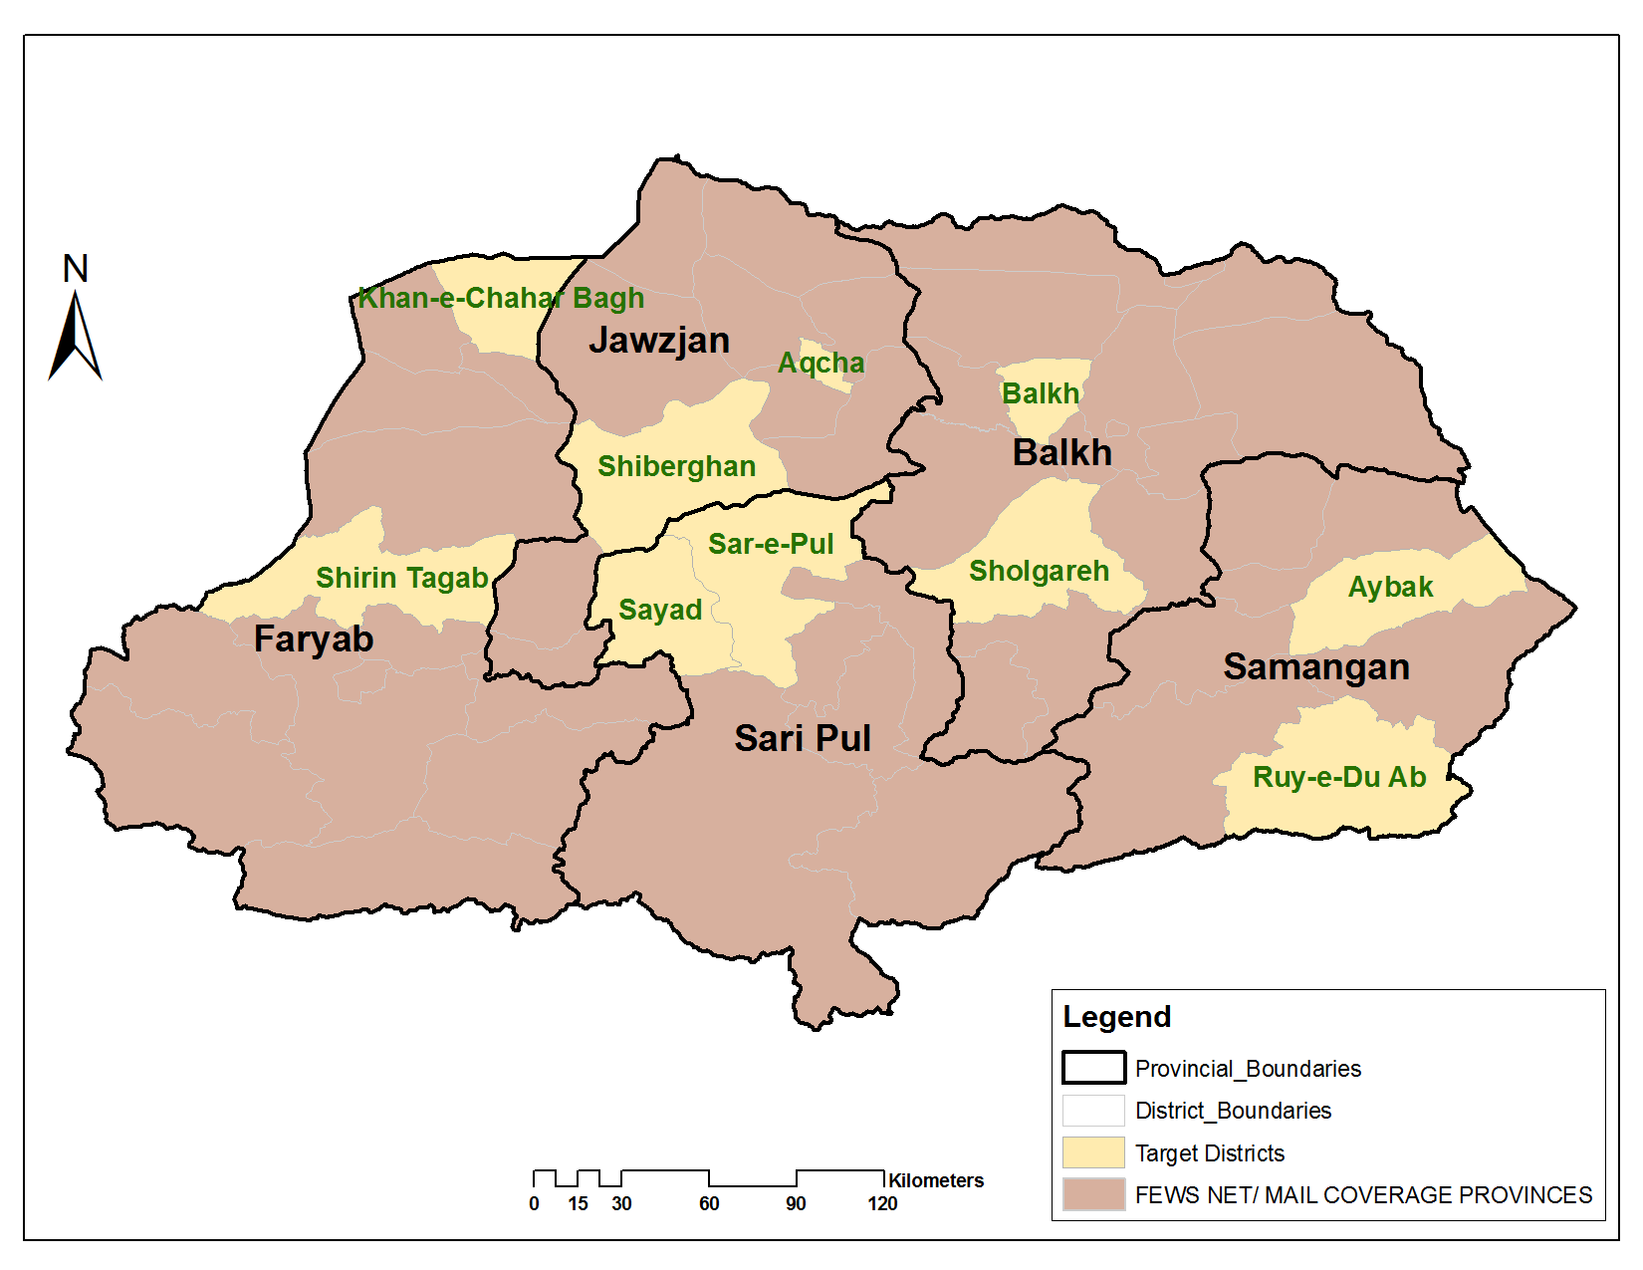 Source: FEWS NET

(Urban population: ~824,688 people, rural population: ~3,057,703 people)

Current Situation

Although the northwest area’s arable land is a mixture of irrigated and rainfed, far more land is rainfed than irrigated. Thus, this region’s agricultural production is more dependent on spring rainfall than any other part of the country. Fortunately, spring rainfall in this region has been above-average over the past four years.

When spring rains are normal in terms of frequency and volume, these provinces produce surplus wheat for sale to other regions. In a drought, the region usually has a wheat deficit, and households must buy imported wheat from other regions or countries. In addition to the potential for insufficient spring rainfall, other recurrent shocks include high levels of salt in drinking water, erosion along the Amu River, and small-scale flooding.

The major sources of food and income are agricultural and livestock production in irrigated areas. In high-elevation or downstream irrigated areas, the sources of food and income for poor households are labor migration to the intensive irrigated areas during the harvest, own production, and livestock production. Employment in the ANA, ANP, and ALP, as well as sharecropping, are other key sources of food and income for poor households in both highland and irrigated areas. Labor migration to neighboring countries especially Iran is another major source of income for the poor households of this region. Wages for agricultural and non-agricultural day labor in April and May were higher than in 2015.

Crop conditions are generally better than last year, and there has been a slight expansion in planted area. Usually, not much of the hillsides are occupied with spring wheat, as most of the cultivation is along the river valleys or on flatter, rainfed land. This year, many farmers expanded their planting onto the hillsides in response to good spring rainfall. Thus, some of the wheat which is not performing as well would not be planted in a more typical year.

Planted area under wheat on rainfed land is greater than last year. In irrigated areas, planted area under wheat is similar to last year. Contributing factors to the generally good crop conditions include the above-average spring rains and above-average availability of irrigation water.

In Samangan as well as in other provinces of this region, almond trees are in a better shape when compare to recent years due to reduced frost damage in the spring. Last year, almond trees in these areas suffered from frost damage, but this year no frost was observed. Other tree crops, including stone fruit, were also in a good shape when compared to last year.

Small-scale flooding occurred in April and May. Flood damaged crops and structures were localized and affected relatively few households. The floods also provided irrigation water and flood water to some downstream farms which helped bolster crop growth in those areas.

The PHA 2016 findings reveal that the level of acute malnutrition was similar to last year in the north region. The level of acute malnutrition was significantly high in Sar-e-Pul province when compared to the rest of the northwestern provinces.

Food Security Outlook

With above-average spring rainfall, an above-average harvest is likely for the third year in a row.

In Samangan as well as in other provinces of this region, almond and other fruit trees are in a better shape than in recent years, which may lead to higher yields this year in comparison to last year.

Due to crop conditions that are better than last year, labor wages are expected to peak during the June/July harvest time when daily wage rates are likely to reach AFN 800 per day. Thus, poor households in the highlands are likely to obtain higher than normal income from labor migration to the lowlands during the harvest for a third consecutive year. Moreover, poor households are likely to have an above-average harvest. Sharecroppers in the irrigated areas are likely to obtain more food than usual due to higher expected wheat yields. In a year with above-average agricultural production, even households in rainfed areas who are often unable to stock enough wheat for a full year’s household consumption may be able both to fully stock for the coming year and to earn some cash income from wheat sales. Due to good fodder availability and pasture conditions, livestock body conditions and prices are likely to remain near their current high levels for the rest of the year, which will strengthen the purchasing power of poor households and agro-pastoral households.

Many flood-affected households, particularly those households who lost their houses and key tools or other assets, necessary for their livelihoods, are acutely food insecure. Currently humanitarian assistance received by affected households should provide for a month or two of food, and it is expected that assistance will continue for a couple of months. Local government and humanitarian partners have pledged to assist in reconstruction of houses before the start of winter. However, priority will probably be given to northeastern provinces where winter starts earlier. Affected households will not be solely relying on assistance. They will cope with lost income in other ways. For example, they are likely to seek more labor opportunities where the grain harvest is being conducted or to work in rice cultivation, increase internal and external labor migration, and reduce expenditures on non-staple food and on non-food purchases. In addition, second crops or late planted crops could be cultivated in areas where waters have receded and fields are ready for cultivation. However, demand for agricultural tools and seed for second crops may be much higher than typical. Second crops could include sesame, mung beans (green grams), melons, and sunflower, among others.

Figure 7. Western provinces
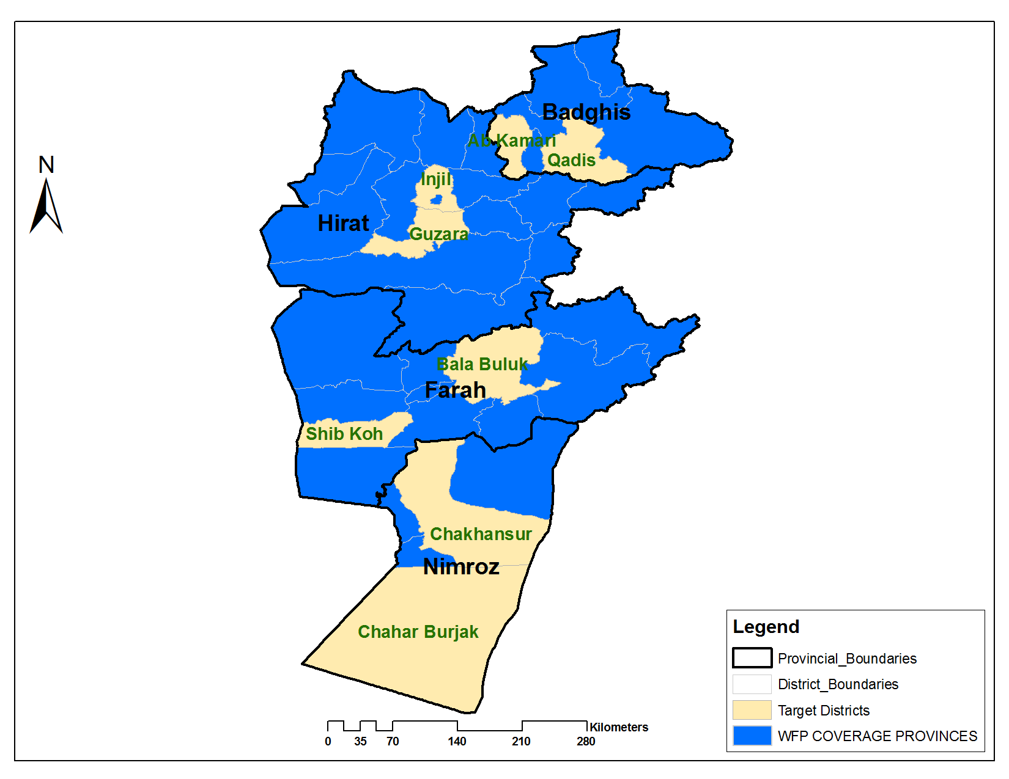
Source: FEWS NET

Western Provinces: Herat, Badghis, Farah and Nimroz

(Urban population: ~624,593 people, rural population: ~2,433,950 people) with total population of 3, 058, 543.

Current Situation

The western region of Afghanistan borders three countries, Iran, Turkmenistan, and Pakistan, the cross-border trade is more important than in other areas of Afghanistan. The primary livelihood strategies include agriculture, animal husbandry, labor migration, and cross-border trade. Herat and Badghis provinces produce both irrigated and rainfed wheat, while Farah and Nimroz provinces purely rely on irrigated wheat production. In rainfed areas, years of poor total rainfall or poor rainfall distribution usually experience poor wheat production.

The level of accumulated precipitation from October 1, 2015 to May 10, 2016 in comparison to the Long Term Average (LTA) was lower for the entire region, while in comparison to the same time in the previous year was more or less the same for Badghis and Nimroz provinces, and lower for Hirat and Farah provinces. Despite lower accumulated precipitation, the good interval of rainfall in the spring which is the needing time, and favorable weather condition supported better growth for the wheat crop. Frost which was one of the main problems, especially for orchards in the previous years, did not appear this year.

Herat and Badghis provinces experienced cycles of surpluses and deficits over the past 10 years depending on the level of precipitation received. Badghis Province produces surplus wheat even in average years, and it has a deficit only when there is an extended dry spell or drought. Farah Province had only one year of surplus in the last 10 years. In recent years, this Province has had a decline in wheat cultivation due to a corresponding increase in poppy cultivation, which performs well in the semiarid conditions.

Nimroz province produced a tiny surplus in 8 out of the last 10 years. While the main livelihood strategies in Nimroz province are agriculture and livestock production, labor migration and cross-border trade are also important to provide additional sources of income for people residing in central Nimroz and near the borders with Iran and Pakistan.

Self-production is the primary source of staple food in this region, followed by market purchases. Self-production outputs usually last four to six months for the average households in Herat, Farah, and Nimroz provinces, while it lasts almost eight to 10 months in Badghis province in a year with above-average production. Poor households mainly rely on agricultural wage labor, construction work in cities, and migration to Iran in search of work as well as some in-kind agricultural labor wages and, in some cases, sharecropping (dekhani). This year, due to good harvest prospects, there will probably be an overall positive change in the sources of food for households in this region with improved stocks that will last longer than last year.

This year, planted areas under wheat cultivation in both irrigated and rainfed lands have significantly increased over the region, except in Nimroz province where there was precipitation and rainfall shortfalls during the cultivation season. Therefore, the harvest prospect for the region is expected to be higher than last year, even for Nimroz. Distribution of improved wheat seed has increased in the region which will likely have a positive impact on production, except in Nimroz where improved seed distribution was reduced. The production of saffron has significantly increased in Herat Province and reached 4-4.5MT covering over 1,000 ha of land, at the same time, cultivation has also increased in Farah province. In addition to saffron cultivation increases in Farah province, palm seed production occupies 40 ha of land, with support from Qatar Government, in the Pestaliq area of Khashrod district it is expected that local palm production will contribute to the economy in the near future.

Salma dam is the main source of irrigation for three districts in Hirat Province (Gulran, Pashton Zarghon & Chesht-e-sharif). Currently, the dam is closed when the population of these areas is in need of irrigation, and if this situation continues their agriculture production will be negatively impacted. The districts of Fersi, Adraskan, and Kushk-e-Kuhan are suffering from remoteness, access problems. They are mainly rain-fed producing areas and are, therefore, highly vulnerable to food insecurity. In Nimroz province, crops produced by the Chakhansor district have suffered due to a lack of water, while in the Charborjak district floods have caused damage to an estimated 30 percent of all wheat cultivated land.

This year plant pest and diseases have not been a major problem in the region and the wheat crop condition is generally better than last year, except for localized rust infestation throughout the region and a wider occurrence in Badghis due to warmer weather and April rainfall. In Nimroz province, the main limiting factor for wheat crop reported has been a weed locally called Zoz. This year, due to favorable weather condition, frost has not been reported to affect orchards, except for some localized aphid infestations. Localized flood has affected some wheat crop fields and its impact was reported to be higher in the Charborjak district of Nimroz province.

Pasture conditions are better than last year and currently livestock have good body conditions. This reduces the pressure on livestock raising households to sell out sheep to the market. As a result, the supply of sheep in the market decreases while demand remains unchanged leading to increased livestock prices. Sheep prices are significantly higher by AFN 500-1,000/head compared to the same time of last year. Cow prices also increased significantly due to good pasture conditions and prospects for better fodder availability, except in Nimroz where livestock prices remain unchanged compared to last year. The increased livestock prices and stabilized and/or up to slight increase in wheat will likely increase the Sheep-to-Wheat (i.e. purchasing power) of pastoralists and agro-pastoralists in the region. It is estimated that overall this Sheep-to-Wheat ToT is significantly improved by 17 percent in the region.

Since May 2012, the Iranian Rial (IRR) has depreciated against the US$ and the Afghani (AFN). Thus, poor households reported that their income from labor migration and remittances has dropped. In addition to this issue, difficulties in taking Iranian visa and its high cost and long processing time have also caused a decrease in labor migration to Iran and an increased labor supply to already saturated local labor markets.

The average agricultural labor wage for the region remains the same as last year, while in Hirat and Farah there is some improvement, but declines were seen in Badghis and Nimroz provinces. Despite increased cultivation work, partially because of reduced non-farm labor demand in increasingly over-saturated labor markets due to declines in the construction and other sectors as a result of reduced aid contributions in the country, there is no improvement in agricultural labor wages. Regionally, agricultural labor wages are the same while the regional average wheat price is slightly higher compared to the same time last year causing a slight deterioration by 3 percent in the Agricultural Labor Wage to Wheat Terms of Trade (ToT).

Food Security Outlook

Unless there is a major shock or a rapid change in agro-climatic conditions between now and the harvest in June, food security will likely seasonally improve after the good harvest starts. The harvest for the entire region would be likely higher than last year in terms of yield and total production, and household’s reliance on purchase from the market would be reduced.

The good harvest outlook this year will increase food availability at the household and regional level. The current stable staple food prices and likely stable supply would favorably help households who need to purchase food from the market. With increased demand for agricultural wage labor during the harvest, poor households will likely have more income, but considering the current decreased labor wage and deteriorated Labor-to-Wheat ToT, their economic access to food during upcoming winter and the lean season is still worrisome. Continued satisfactory pasture conditions will support livestock production and improve the quality of consumption of households who have access to milk. Milk and livestock products will also serve as significant income sources in some areas. The areas and population groups concern are in Nimroz province where livestock prices remains unchanged and agriculture labor wage declines as compared to last year, and Badghis where agricultural labor wage decreases causing reduced purchasing power among those engaged in livestock production and among agricultural laborers.

Currently, no new shocks are anticipated, except in Badghis province where the level of impact of rust on the wheat harvest is still unclear and some unexpected disasters might change the scenario.

The current wheat price is slightly higher than last year. If the level of production is significantly less than anticipated and the price of imported food commodities increases food insecurity will likely increase among households who heavily rely on market food purchases. The purchasing power of poor households mainly engaged in labor wage as a main income source would further deteriorate due to unimproved wages which make these households more susceptible to even slight increase in prices. Since the rainfed harvest is still at risk to various unpredictable natural hazards, close monitoring for new shocks or hazard events, including changes in prices or market behaviors, will remain to be necessary.

Acute food insecure people includes are primarily newly IDPs (natural and man-made disaster’s), new returnees and household in Chakhansoor and Charburjak district of Nimroz affected by flood and low precipitation. Possibly poor and medium households in the 3 districts of Hirat (Gulran, Pashtoon Zarghon and Chesht-e-Sharif) will be affected if the harvest fails due to the closure of Salama Dam. Also the impact of rust in Badghis will probably cause some new acute food insecure households.

Southwestern Provinces: Kandahar, Helmand, Zabul, and Uruzgan
Figure 8. Southwestern provinces
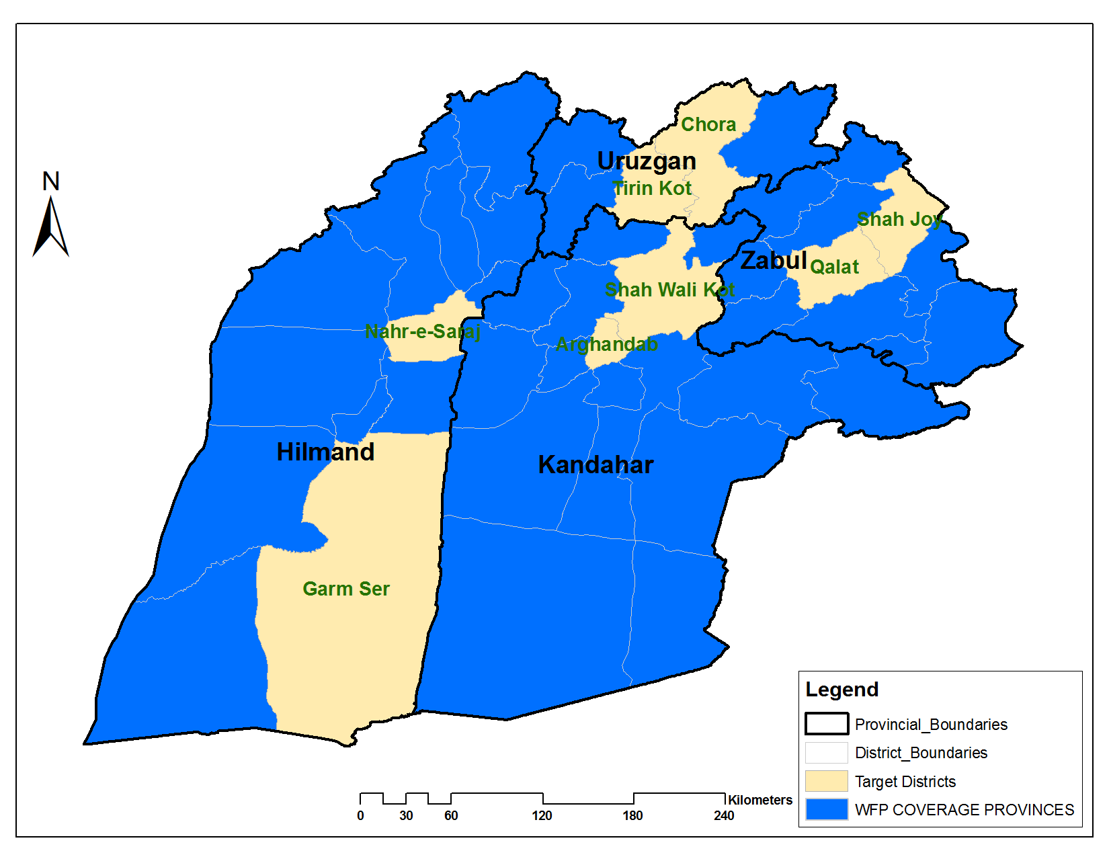
Source: FEWS NET

(Urban population: ~516,422 people, rural population: ~2,325,826 people) with total population of 2, 842, 248.

Current Situation

South-western region borders Pakistan and has a high level of civil insecurity. The main livelihood strategies include agricultural production of orchard, cereal, and poppy crops, livestock husbandry, wage labor, and some cross-border trade. This region is one of the highest-volume poppy-producing areas. Except Helmand all provinces of this region have a wheat deficit. The arable land in this zone is almost all irrigated, except in Zabul where there is around 3,000 hectares (ha) of rainfed arable land. Kandahar province also has a very small rainfed area of around 300 ha.

The sources of staple food in this region during summer and fall include self-produced cereals, which typically lasts four to six months. In Helmand, households supply themselves for eight to 10 months with wheat from their own production. Market purchases also occur in the winter and spring, and much of the cash income for the purchases comes from orchard crop sales. During fall, winter and spring seasons, the primary source of staple food is purchases of stocks from summer and fall production. Poor households in this region rely primarily on market purchases for most of the year, for which they spend their cash income earned from agricultural labor wages during the cereal, poppy, and orchard harvests and from construction work. For the poor, self-production and sharecropping may provide food only for two to three months.

The accumulated precipitation from October 1, 2015 up to May 10, 2016 which is the wet period in the seasonal calendar was lower in all provinces compared to the Long Term Average (LTA), while it was higher compared to the same period of last year in Kandahar, Zabul and Helmand -provinces, and lower in Uruzgan province.

Helmand province is the main surplus province for wheat production in this region, while Zabul and Kandahar provinces were experiencing deficits during the last 10 years, and Uruzgan province mostly had a deficit, but in some years produced surplus wheat as well.

Generally, irrigated wheat cultivation in this region is slightly increased compared to the last year. Though rainfed is not dominant in this region and Zabul province is the only province with considerable rainfed land, its cultivation this year will decrease significantly due to a lack of rainfall during cultivation season. Wheat crop during the assessment was in good shape, but rust infestation in wheat crop was reported especially in fields with local wheat seed cultivation, except in Helmand where no rust was reported. In Dand and Daman districts of Kandahar province, infestation of yellow rust was reported to be present in 70-80 percent of wheat fields. Orchards are one of the most important cash crops in this zone and are currently in good shape. However, aphid infestations have been widely reported. Localized floods occurred during the spring wet season, and it was significant in the Chinarto district of Uruzgan province. Wheat and orchard harvest prospects for the entire region are higher than last year.

Pasture conditions are slightly better than last year and livestock body conditions are better as well. The price of livestock (Sheep and cattle) increased significantly due to good pasture conditions and prospects for better fodder availability.

Overall, agriculture labor wage slightly decreases compared to same time last year. The only province where the labor wage improves was Helmand province, while the rest of the region indicates a decrease in the agriculture labor wage due to reduced working opportunities in other sectors like construction and reduced NNGOs and INGOs activities as a result of reduced funding and access problems related to security in this region.

Wheat average prices for the region significantly increased compared to the same time last year, though the level of change varies by province.

ToT between agriculture labour wage and wheat will deteriorate significantly (by 14 percent) due to a slightly decreased labor wage and significant increase in the wheat price putting agriculture laborers at risk of reduced purchasing power and possibly affecting their food security and nutritional status. Luckily, on the other side, Sheep-to-Wheat ToT will improve significantly (by 13 percent) due to significant increases in sheep prices which will support pastoralists to buy more food against their livestock sales.

Food Security Outlook

Food security at the household level might improve during the harvest period. This year’s potentially good harvest prospect, as a result of the current good crop wheat and orchard conditions, will likely improve household sources of food and income. The potentially good harvest prospect and crop condition will also increase agricultural labor opportunities for poor households during harvesting season. But deteriorated Agriculture Labor Wage-to-Wheat ToT is of concern during the winter and early spring season which may affect food security of households who heavily rely on this unstable source of income.

Fairly good pasture and livestock body conditions and prices will support pastoralists and agro-pastoral households to increase their purchasing power and rebuild livestock herds.

Acute food insecure populations in this region include IDPs (Conflict and natural disaster affected) and households affected by localized floods, especially those in the Chinarto district of Uruzgan province and as well as households in the Dand and Damand districts of Kandahar Province whose wheat crop is heavily affected by yellow rust.

Figure 9. Southeastern provinces 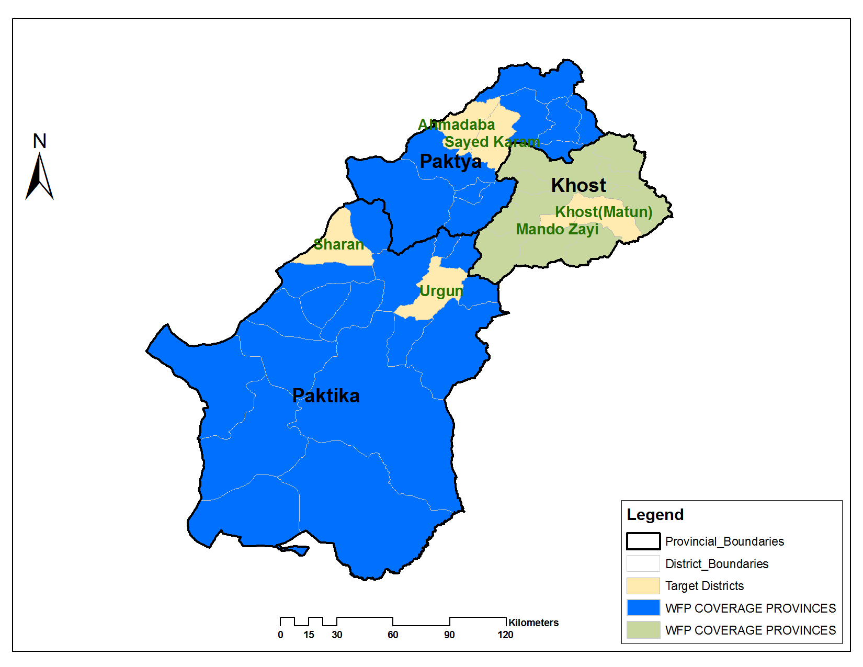
Source: FEWS NET
Southeastern Provinces: Paktya, Paktika, and Khost

(Urban population: ~39,401 people, rural population: ~1,521,910 people) with total population of 1, 561, 311.

Current Situation

This region borders Pakistan and has a high level of civil insecurity. Each province of this region mainly has irrigated land, and there is only a negligible amount of rainfed cropping. Despite the presence of irrigation, the entire region has a wheat deficit, even in years with average or above-average production. The primary livelihood strategies are agriculture, livestock husbandry, remittances primarily from the Gulf countries, and short-term labor migration within Afghanistan.

Own cereal production as a source of staple foods lasts from four to six months. Market purchases make up the other source, using cash income from remittances and labor. The poor also collect and sell firewood as a source of income. Poor households in this region mostly rely on market purchases of food.

Accumulated precipitation in this region from October 1, 2015 to May 10, 2016 showed an increase in Paktika and Khost provinces, and a decrease in Paktya province compared to same time last year and LTA.

On average, the wheat planted area in this region seems to be significantly increased compared to last year. The level of increase in Paktika province which has more irrigated and rainfed land compared to two other provinces is very significant, while there is only a slight increase Khost and Paktya provinces. Although the rainfed cultivation this year slightly increases than last year due to increased rainfall, it should be mentioned that rainfed land, cultivation and production in this region is tiny. Improved wheat seed distribution in this region is generally reduced (increased in Khost province and reduced in both Paktya and Paktika provinces). The amount of improved seed distributed is much lower than the current demand.

Currently, the irrigated and rainfed wheat crop condition in the entire region is good. No major agriculture shock is reported this year, except for localized flooding in some areas. The wheat harvest prospect for this year is to be better than last year.

Pasture conditions are generally better than last year and consequently livestock body conditions are also better than last year. Only in Khost province due to conflict, the households’ access to pasture is reduced. The sheep price significantly decreased in the region due to reduced livestock selling to the market as a result of improved fodder availability, while cattle prices, which is the main type of livestock in the region, remains unchanged.

In general, the availability of local labor opportunities and labor wage are reduced in the region. The labor wage in Khost province has been significantly reduced and is likely attributed to the oversaturation of the labor market as a result of a displacement influx to the region from the conflict in northern Waziristan of Pakistan during the last two years.

Wheat regional price is slightly increased when compared to last year, while there is a significant increase in wheat flour price. This increase in wheat and wheat flour prices is more apparent in Paktika and Khost provinces where recent refugees have settled. Pakistan’s restriction on wheat flour import and the closure of illegal borders with Pakistan which is the main supply route to this region are impacting these prices.

Consequently, Agriculture labour Wage-to-Wheat ToT in the region significantly deteriorated by 25-30 percent compared to last year. The influx of refugees in Khost and Paktika provinces have also impacted on the labour wage due to limited working opportunities and oversaturated labor supply. If the current situation does not improve, food security situation of households relying on agriculture labor wage will be of greater concern and need special attention since their purchasing power will be further reduced and become heavily reliant on market purchases which will make them increasingly susceptible to already high prices. Due to an increase in wheat prices and a reduced sheep price, the Sheep-to-Wheat ToT in the region will also be significantly lower by 13% than last year.

Food Security Outlook

The potentially good harvest prospect this year due to generally satisfactory precipitation and low level of plant pest and diseases will probably increase household cereal stock and access to food, and reduce their market dependence for food consumption.

The upcoming harvest will increase labor demand for agriculture and might positively impact the labor wage. However, an influx of refugees and over-saturated labor market will further decrease labor opportunities and reduce the purchasing power of households who mainly rely on this source of income. Significantly decreased livestock prices and a deteriorated Sheep-to-Wheat ToT will negatively affect the food security of households who are mainly engaged on livestock production.

The acute food insecure population in this region are refugees from northern Waziristan of Pakistan and households affected by natural disasters, household entirely rely on daily wage labor and livestock due to their deteriorated purchasing power. As some refugees stay with local residents in Khost and Paktika provinces, special attention needs to be also paid to host households because their staple stocks may likely deplete faster to meet increased food consumption. In addition to them, those households internally displaced due to conflict and natural disaster are also of concerns.

Figure 10. South-central provinces
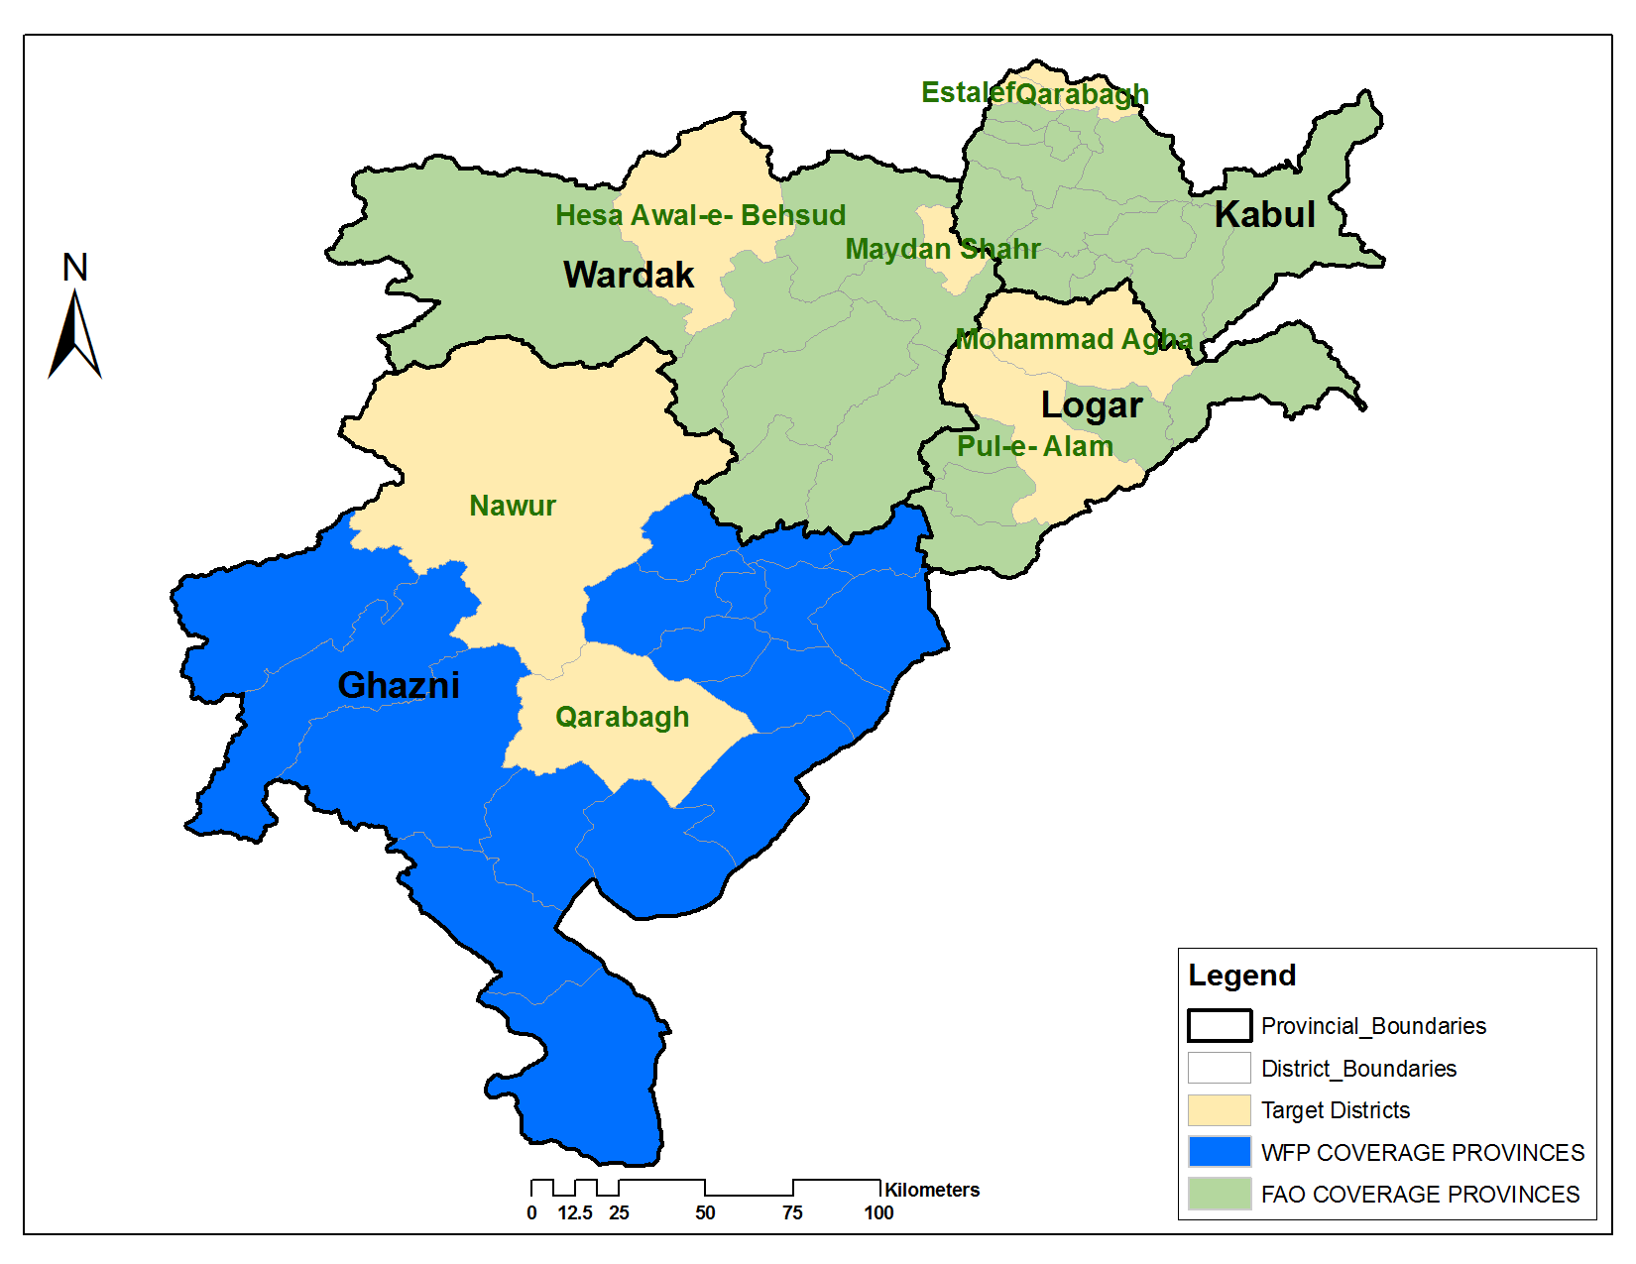
Source: FEWS NET

South-Central Provinces: Kabul, Logar, Maidan Wardak and Ghazni

Urban Population: 3,773,371 people (98% in Kabul)
Rural Population: 2,816,769 people

Current Situation

The Population density in these provinces is the highest of any other region in the country with 56.33% of the country’s total urban population. 98% of this region’s population lives in the metropolitan area of the capital city Kabul which is approximately 55.22% of the country’s total inhabitance. As a result of the high population figure, all the provinces (except Logar in 2014 and 2015) have shown in the last consecutive three years a wheat deficit. The deficit is especially pronounced due to the large, urban population who do not cultivate wheat. The main livelihood strategies in this region are agriculture including orchard and cereal production, livestock husbandry, and both formal and informal labour. Kabul Province has the highest number of formally employed people, working in the government, the private sector, and at non-governmental institutions. Irrigated wheat production is the main form of agriculture in this region.

The main source of staple food in this region varies in these areas particularly in Kabul. The large sectors of the population make market purchases, but in Logar and Ghazni farmers produce enough wheat to provide six months’ supply. In Wardak, self-produced wheat lasts a maximum of four to five months, but for the remaining six to seven months households must rely on market purchases.

Poor households in the region include the landless, small-scale sharecroppers, and the socially disadvantaged which include widows, households headed by the disabled, and households headed by the elderly. The largest group of poor is labor-dependent households who typically do informal labor both inside and outside the country. The poor mostly rely on market purchases for food, so price fluctuations of wheat flour and their labor wage rates can have a large impact on their food security. The most vulnerable people are the poor who work as daily wage laborers and rely on Charity and donation of the community during the winter. The conditions of these people are severe because in general the economy has declined due to insecurity and a reduction in investments by the private sector and development partners. In prior years government has distributed some wheat during winter but this has been discontinued.

Irrigated wheat planted areas are negligible increased in Ghazni and Kabul and decreased negligibly in Logar and Wardak while the planted area of rain-fed wheat decreased negligibly in Logar and significantly in Kabul, and negligibly increased in Wardak and Ghazni provinces compared to last year. Distribution of improved wheat seed has decreased when compared to past years, and no fertilizer was distributed to farmers by the MAIL, but in some cases it was late, which may contribute to improved yields. Timely spring rains were the primary factor leading to increased wheat planting. Currently, the only observed shocks to agriculture were localized shortages of water, floods, precipitation, plant diseases and weed infestation which have affected crop performance up to some extent in the region.

In general, due to recent precipitation both irrigated and rain-fed crop performance is better than the last two years. The harvest will be negligibly better in the whole region.

Pasture conditions have improved in Kabul, Logar and Ghazni when compared to the previous two years, but has partially worsened in Wardak Province in the same two year span. Livestock prices have increased significantly in the whole region compared to 2014 and 2015 due to no market controls by the government, a high unemployment rate, and good pasture conditions, which caused people to turn to livestock keeping in this region. Veterinary services were provided by private sector and were available on call and on a user pay basis. The rates charged were higher and often forced farmers to buy medicines and vaccines directly from suppliers in district bazars, at the provincial capital or in Kabul City. The lack of sufficient veterinary services, low quality medicine and vaccines, and a lack of awareness had negatively impacted health and milk and meat production and prices as well as the farmer household incomes.

Agricultural labor wage to wheat ToT slightly deteriorated by 7 percent over the last year and Sheep to wheat ToT improved by 11 percent. The acute food insecure population includes 55,507 conflict affected individuals displaced during 01 Jan 2015 and 30 April 2016, and 8,393 natural disaster affected individuals affected during 01 Jan to 30 April 2016 in the central region.

Food Security Outlook

With continued seasonally normal conditions, food security will likely be seasonally improved with the harvest. Overall, the harvest is likely to be slightly better than the last two years.

In general, despite a reduced demand for labor in the development sector, the labor wages have slightly decreased compared to the last two years. This is in part due to a high demand for agricultural labor during the harvest. The agriculture sector’s additional labor opportunities should help replace the decreased demand in the development sector due to reduced construction levels.

The largest potential shocks that could have a large impact on food security in the region are localized floods, dry spells and pest & diseases, which damage crops at critical phases of development. Of course, further, unanticipated shocks in the agricultural or construction labor markets could also greatly decrease food security as this region is highly dependent on both types of labor.

Figure 11. East-central provinces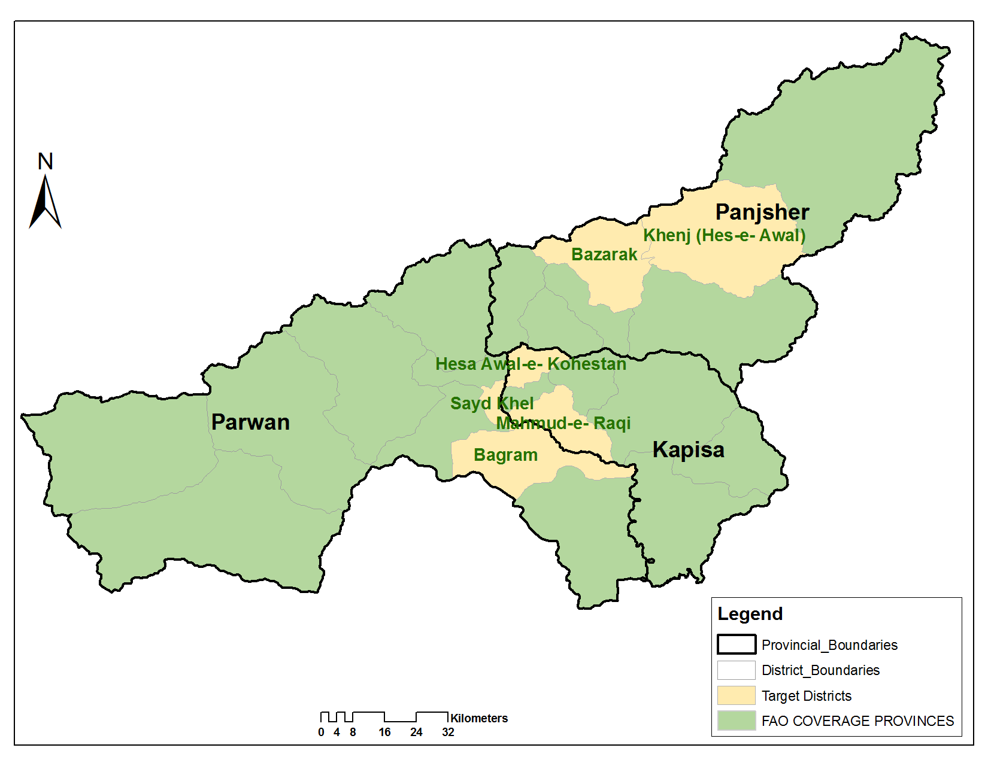

Source: FEWS NET

East-Central Provinces: Parwan, Kapisa, and Pansher

Urban Population: 61,104 people
Rural Population: 1,197,895 people

Current Situation

The east-central region‘s arable land is predominately irrigated. Irrigation water comes primarily from the Salang, Panshir, and Ghorband Rivers. Even during a drier year, this region tends to have enough irrigation water to support the first cropping season, which consists primarily of wheat. The major source of income is formal employment in the ANA, ANP, and the National Directorate of Security (NDS), which has a higher dependence on formal employment than in other parts of Afghanistan, largely due to the close proximity to Kabul’s large formal employment market. Following formal employment, agriculture is the second and livestock is the third most important source of income during the spring and summer. The source of agriculture income consists both of agricultural labor and of crops sales. Their agriculture production has changed positively due existing of improved seeds, fertilizer, machinery system, and medicine.

The main sources of staple food throughout the year are self-production, market purchases, exchanges (barter) and loans. Food is obtained during the summer and fall from self-production, but during the winter and spring poor households rely on market purchases that are primarily funded by formal employment and community donation. In addition, we have seen floods, unemployment and earthquakes but it is predicted that floods, water shortages, and insecurity could affect their livelihoods.

The current planted areas for irrigated wheat has negligibly increased in Pawan and Kapisa but decreased in Panjsher compared to last year, but crop conditions are better than in 2015. Rain-fed planted areas significantly increased in Kapisa but decreased in Parwan Province, but according to DAIL information there was no rain-fed crops in the Panjsher. The current adverse factors that could affect upcoming localized harvests are floods, hail, rust, weeds and a shortage of water, but the potential factors are pest, diseases, and natural hazards. The late arrival of improve seeds could affect production.

Pasture conditions have improved in Parwan, but the situation is the same in Kapisa and Panjsher when compared to the last two years. Livestock prices for cows have negligibly decreased in Parwan and Kapisa but remain the same in Panjshir. Sheep prices have decreased in Parwan and remain the same as last year in Kapisa and Panjsher. Insecurity and the lack of job opportunities will affect livestock prices and numbers further. Veterinary services are provided by the private sector, which are available on call and on a user pay basis, but the high prices for services often forces farmers to buy medicines and vaccines directly from local shops in the district center, provincial capitals or in Kabul City. The lack of sufficient veterinary services, low quality medicine and vaccines, lack of awareness and the presence of animal diseases had a negative impact on health, milk and meat production, prices, and farmer household incomes. It is worth mentioning that DAIL extension officers are functioning at the district level but due to a lack of transportation facilities they cannot cover the whole district.

Labour wages and livestock prices are lower than in the last two years. Agricultural labour wage and sheep prices to wheat ToT, measured using the regional averages for wages and sheep prices against wheat prices, deteriorated by 14 percent and slightly deteriorated by 6 percent, respectively, over the last year.

The acute food insecure population includes 14,867 conflict affected individuals displaced during 01 Jan 2015 to 30 April 2016 and 1,456 natural disaster affected individuals affected during 01 Jan to 30 April 2016.

Food Security Outlook

All sources of income and staple food in 2016 are likely to be better than the last year. Agricultural production is likely to be higher in volume than the last year and casual labor wages are expected to be lower than the previous year, which is likely to remain at that level or be higher through the harvest. As livestock prices are also lower than last year, agro-pastoralists in the region should be able to source food from livestock sales.

Localized floods, hail, dry spells and pest & diseases, which could still damage crops at critical phases of development. Further unanticipated shocks, in the agricultural or construction labor markets, could also greatly decrease food security as this region is highly dependent on both types of labor.
Figure 12. Central highland provinces
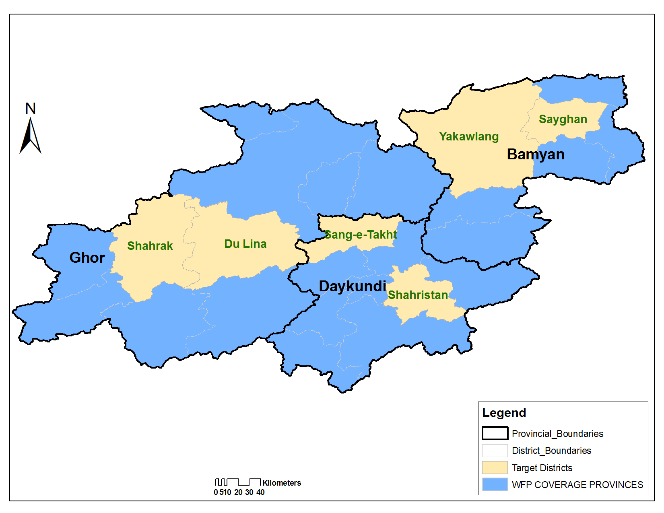
Source: FEWS NET

Central Highland Provinces: Bamyan, Daykundi, and Ghor

(Urban population: ~20,023 people, rural population: ~1,541,830 people) with total population of 1,561,853.

Current Situation

The central highlands are a mountainous region. There are high levels of poverty, and this area has a very high level of chronic food insecurity due, in part, to vulnerability to many natural and market-related shocks. There are fewer economic opportunities in this region, and the difficult terrain hampers trade and transportation. Civil insecurity tends to be fairly low compared to other parts of the country, and there are very few IDPs present. The main livelihood strategies include agricultural production of cereals, potatoes, fruits, and tree nuts, along with livestock husbandry, local labor, labor migration within Afghanistan, and international labor migration, often to Iran. All Provinces of this region have a wheat deficit, even in years with average or above-average wheat production. Bamyan Province produces a surplus of potatoes, which provides over half of the national supply. In all three provinces, there are significant areas of both rainfed and irrigated production. Land holdings tend to be very small in this region.

Self-production as a source of staple food in this region lasts for three to four months. Market purchases are the major source of staple food using cash income earned from the sale of orchards crops, potatoes and livestock, from migratory and local labor, and remittances within the country and from abroad. Poor households mainly consume market purchased food items which must usually be bought in September and October before winter starts.

Accumulated precipitation from October 1, 2015 to May 10, 2016 was higher in all provinces compared to last year, but compared to LTA only Daykundi got higher, while Bamyan and Ghor had almost the same level of precipitation.

Planted area for irrigation is the same as last year in the region. However, given the high elevation of these areas, they have a different cropping calendar. The assessment was conducted before the end of the planting season, and hence, and additional areas could be planted as the planting is still ongoing.

Improved wheat seed distribution is not reported in this region this year, except for 4 MT of soybean, 2 MT of urea and 8 MT DAP in Daykundi Province. No fertilizer distribution is reported this year, either.

Irrigated wheat crops are developing normally in most parts of the region, while rainfed areas are not good due to cold weather which delayed growth, and in some areas the cultivation is still ongoing. Hence, further monitoring of crop performance is needed.

Wheat harvest prospects for the whole region is expected to be the same or slightly better than last year. At provincial levels the harvest for Ghor and Daykundi provinces should be the same or slightly higher than last year, but lower in Bamyan province due to damage to irrigation canals by floods.

Pasture conditions are expected to be better than last year in Ghor province, but due to cold weather it has seasonally worsened in Bamyan and Daykundi provinces. Consequently, livestock body conditions do not seem to be good due to seasonally poor pasture conditions in Daykundi and Bamyan provinces. It is good in Ghor province due to good pasture conditions. Livestock prices also increased in Ghor province, while they remain the same as last year in Bamyan and Daykundi provinces. The average price of sheep and cattle in the region slightly increased by 7 percent and 3 percent, respectively, keeping in mind that the increase is only limited to Ghor province.

Agriculture labor wage for the region has slightly decreased by 5 percent. At provincial level, Ghor province shows a slight increase, while there is no change in Daykundi province and a significant decrease in Bamyan province. Despite the regional average wheat price being decreased, the Agricultural Labor Wage-to-Wheat ToT remains as the same as last year. The Sheep-to-Wheat ToT has improved significantly by 17 percent due to increases in sheep prices and a slightly decreased wheat price in Ghor province. Bamyan and Daykundi provinces the prices remained the same as last year.

No shocks and adverse factors have been reported in Ghor province, but flood and cold weather have been reported in Bamyan and Daykundi provinces. Flood damage to irrigation canals in Bamyan Province might affect the upcoming irrigated harvest.

Food Security Outlook

The food security situation will likely temporarily improve in the region during August-September harvest. As the harvest and production prospect for this year is lower than last year in Bamyan province, household cereal stocks will most likely be depleted faster than last year and dependence on market purchases will increase. Further deteriorated purchasing power will make poor households more vulnerable to food insecurity. For Daykundi and Ghor provinces, where the prospect for the harvest is the same or slightly higher than last year, the situation should be slightly better than Bamyan.

The current Agriculture labour Wage-to-Wheat ToT in Bamyan and Daykudi provinces is worrisome and might affect household food security and nutrition status. For Ghor province, it is better now and hopefully the good harvest prospect will create more agricultural labor opportunities during the harvesting time.

The largest and likely potential shocks that may have a significant impact on food security in the region will be plant or livestock disease outbreaks, unusual cold weather, and other pests, such as rats that consume food stocks and crops. These Provinces will require close monitoring since the time between now and the end of the September harvest is longer than in other regions, and hence, the potential for unforeseen shocks is higher. Acute food insecure population in this region are flood and heavy rainfall affected households.

